Plains Region Assessment of aTaxi Ridesharing and Empty Vehicle Management
Jason Fu, Nicholas Yang, Wesley Yuan
Executive Summary 1
Population Analysis 1
Description of Data 1
Population Analysis 2
PersonTrips Analysis 4
Data Outputs 7
aTaxi Analysis 7
Person-Segment Analysis 7
Ridesharing Analysis 9
aTaxi Repositioning and Usage 12
Data 14
Business Case 14
Cars and Replacements 15
Cost of Infrastructure 15
Electricity Demands 16
Miscellaneous Costs 17
Cost Breakdown 18
Revenue Model 18
Future Projections 19
Recommendations for Further Analysis 20
aTaxi Recommendations 20
Business Recommendations 21
Team Member Responsibilities 21

Executive Summary
This goal of this report is to examine the feasibility of an autonomous taxi (aTaxi) system throughout the plains region, which encompasses the states of CO, KS, MT, NE, NM, ND, OK, SD, TX, and WY. To accomplish this, we have broken up this task into three components.

First, we will conduct an analysis on simulated data of trips made by plains regions residents. This involves a look at the population distribution and average trip length on the state and county level. Both of these factors are important in determining the potential quantity and nature of ridesharing demand across the region. An examination of this data also helps validate the data as reasonable and representative of real life trips made.

Second, we will attempt to see the degree of ridesharing available to residents of our region using simulated data of all trips originating from the plains region. This involves an analysis of the distribution of quantity, time, and length of all trip segments originating in the region utilizing aTaxis. We run a simulation to group riders together according to a specified level of service, and examine the passenger occupancy of autonomous taxi (aTaxi) trips. We also examine various repositioning cases to determine theoretical upper and lower bounds of the aTaxi fleet size and perform some sensitivity analysis for the size of the fleet.

Lastly, we will present a potential business case for an aTaxi system throughout the region. This case includes an assessment of the vehicular, infrastructural, energy, labor, and other miscellaneous costs necessary to undertake and operate a ridesharing business in the plains region. A tiered revenue model is also included, with projected net profit.

The plains region encompasses some of the most populous as well as least populous counties in the United States. This wide population range allows us to analyze ridesharing in a diverse range of settings. While one might initially assume that ridesharing is most lucrative in densely populated urban areas, our later analysis shows that this is not always the case with varying trip lengths. Hopefully, this report sheds some light not only on regional ridesharing, but also on how less populated areas lend themselves to a different nature of ridesharing.

Population Analysis

Description of Data
The NN Files contain simulated trip data in a given day for all trip-taking residents of each county in all 50 states. For the Plains States, the NN data set encompasses 746 counties across 10 states. As per the simulated data, each resident is identified by a unique 11 digit Person ID Number and undertakes between 0 and 6 trips per day. Each row in the dataset corresponds to a county resident and contains all of their trip data. Residents start the day at home in their respective counties and undertake trips to destinations across the county, state, and nation (including Alaska and Hawaii). The data contains the starting and ending LatLong of every trip, as well as the trip-taker’s departure and arrival times.

Population Analysis
Because each row of the NN Files represents a unique resident, the Plains states population can be obtained by simply summing the total number of rows in all of the Plains NN files. This gives a total population of 36,079,181. The population is distributed as follows:

State | Population
Colorado | 4,761,453
Kansas | 2,853,013
Montana | 989,359
Nebraska | 1,804,272
New Mexico | 1,056,917
North Dakota | 672,538
Oklahoma | 3,751,274
South Dakota | 814,114
Texas | 18,961,336
Wyoming | 414,905

The population breakdown can be examined at a higher level of granularity by examining the county level. Predictably, the largest counties contain major cities—for example, the largest is county in the Plains region is Harris County in Texas whose county seat is Houston.

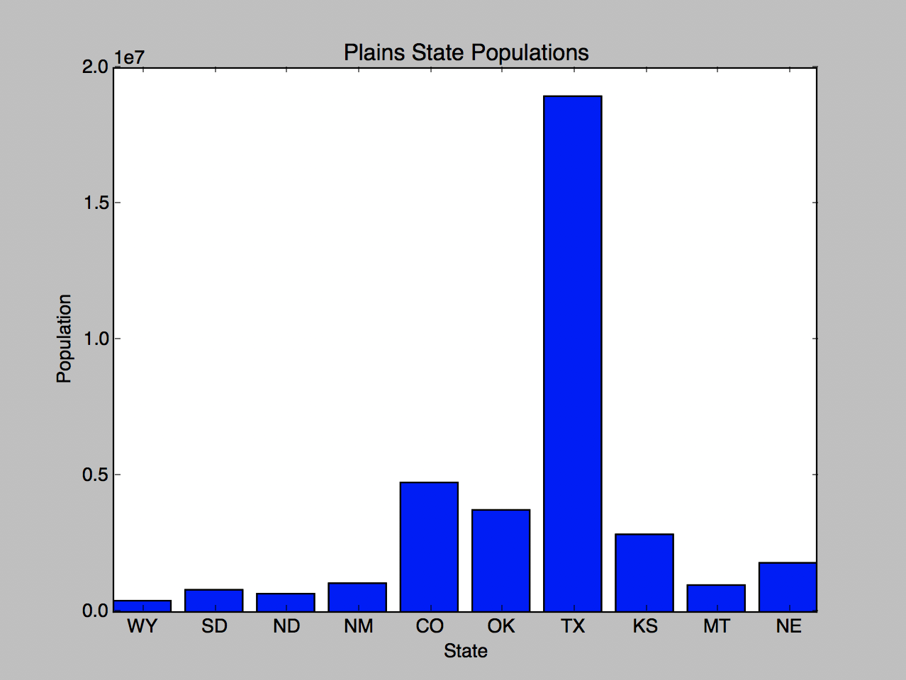
Figure:

Number of residents in each state.

Texas dominates the Plains states in term of population, containing over half of the region’s total population.

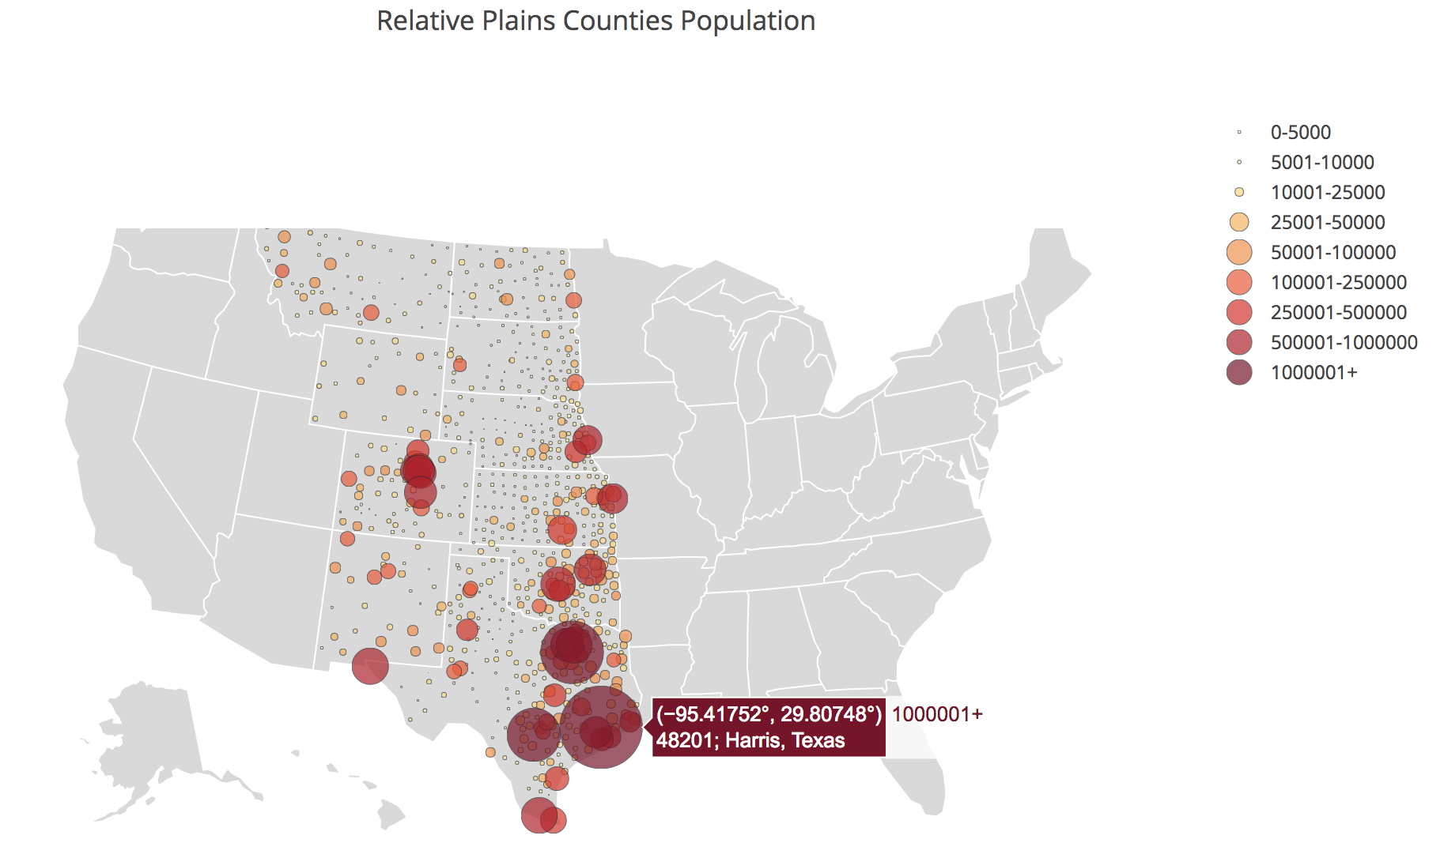
Figure: Bubble plot of populations of the Plains counties. An interactive version can be found at: https://plot.ly/~JasonFu/20/relative-plains-counties-population/

PersonTrips Analysis
A PersonTrip can be defined as any trip undertaken by a resident. As previously stated, the NN file data was generated such that each resident undertook between 0 to 6 trips. There were a total of 120,001,029 PersonTrips. This gives an average PersonTrips per resident count of 3.32. The PersonTrips are distributed as follows:

State | Number of PersonTrips
Colorado | 15,791,235
Kansas | 9,257,368
Montana | 3,144,909
Nebraska | 6,031,871
New Mexico | 3,515,967
North Dakota | 2,108,271
Oklahoma | 12,167,187
South Dakota | 2,685,018
Texas | 64,002,490
Wyoming | 1,296,713

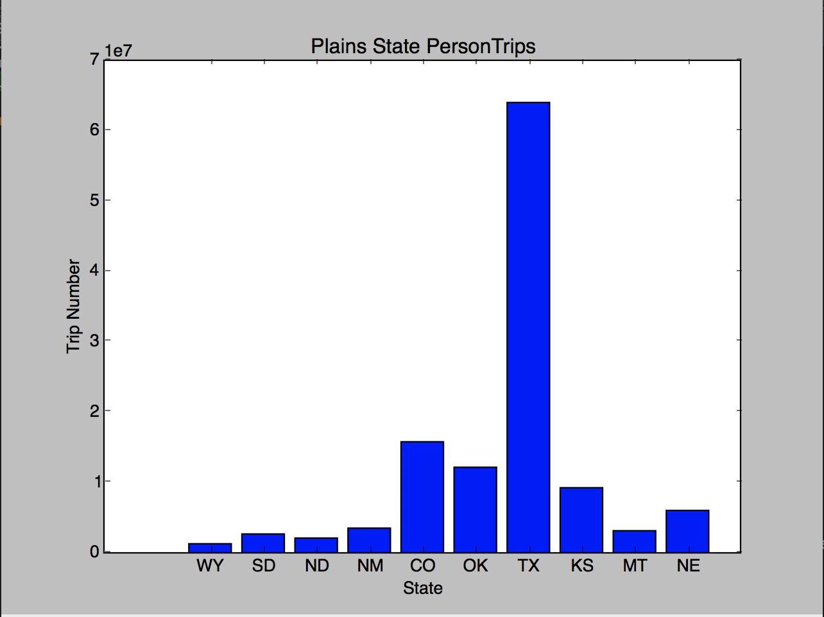

Figure:

Number of PersonTrips in each state

Note the similarity in shape to the State Population bar graph.

Along with quantity, we also wish to analyze the lengths of the PersonTrips. We calculated the length of a PersonTrip as 1.2x the great circle distance between the starting and ending points. The average lengths of the PersonTrips across all trips was 21.7 miles. The per-state average is as follows:

State | Average PersonTrip Length (miles)
Colorado | 12.42
Kansas | 13.42
Montana | 17.97
Nebraska | 12.43
New Mexico | 18.14
North Dakota | 17.34
Oklahoma | 13.23
South Dakota | 19.78
Texas | 27.38
Wyoming | 12.01

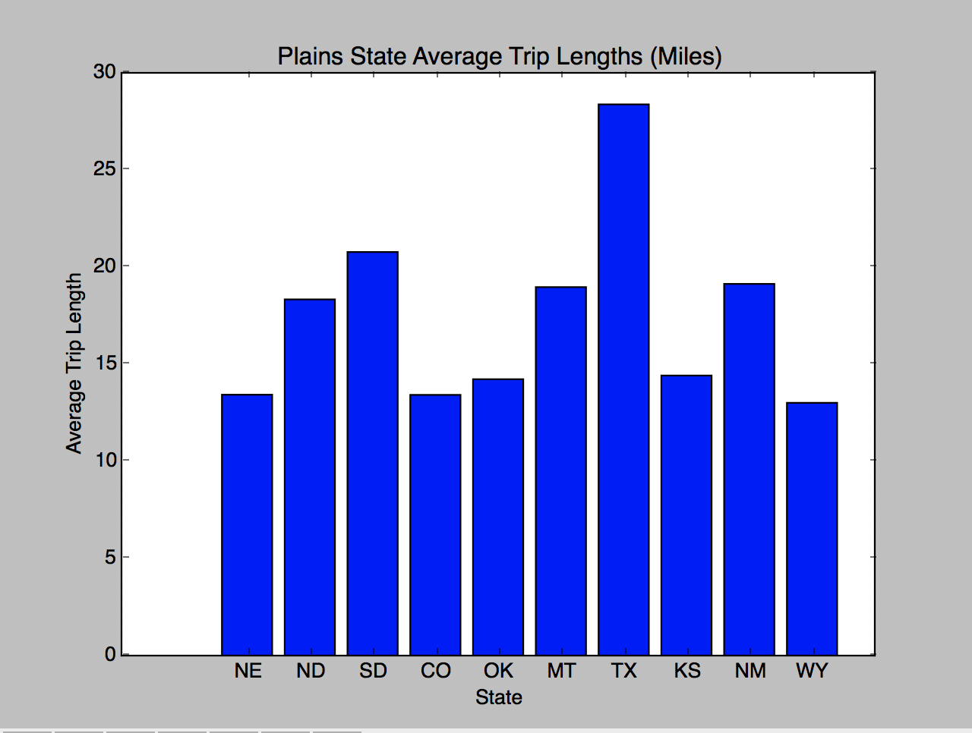

Figure:

Average PersonTrip Lengths in Plains States

The average PersonTrip Length seems to be fairly consistent across the states with the exception of Texas.

Again, we look to the county level for a more nuanced view:
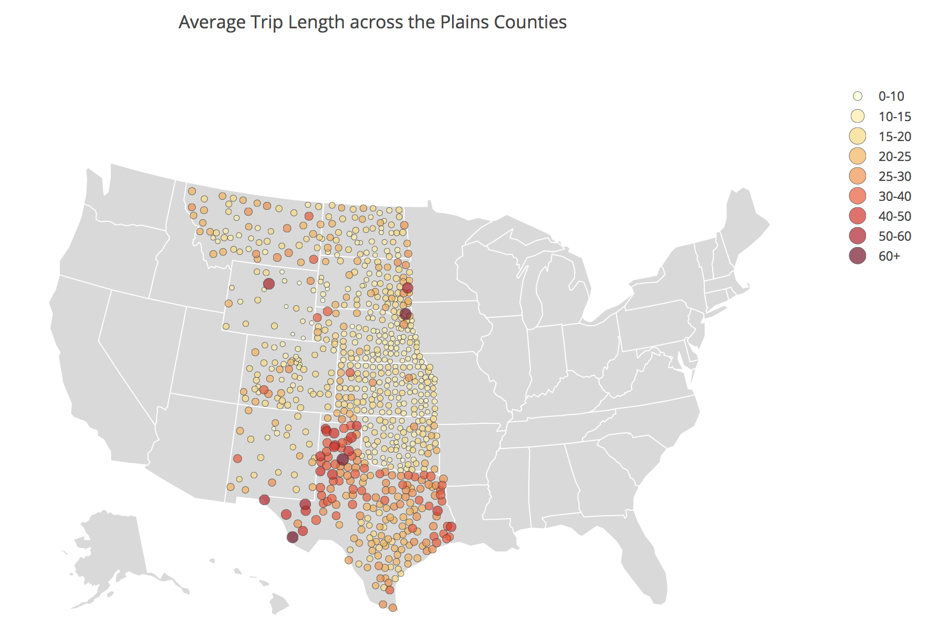
Figure: Bubble plot of average PersonTrip length across Plains Counties. Note longest average trip counties are scattered across northern Texas. An interactive version of this plot can be found at https://plot.ly/~JasonFu/22/average-trip-length-across-the-plains-counties/

Finally, we can examine the distribution of PersonTrip lengths. The median PersonTrip length across all states is 5.5 miles. This is much shorter than the average PersonTrip length, implying that the distribution of trip lengths is skewed right.
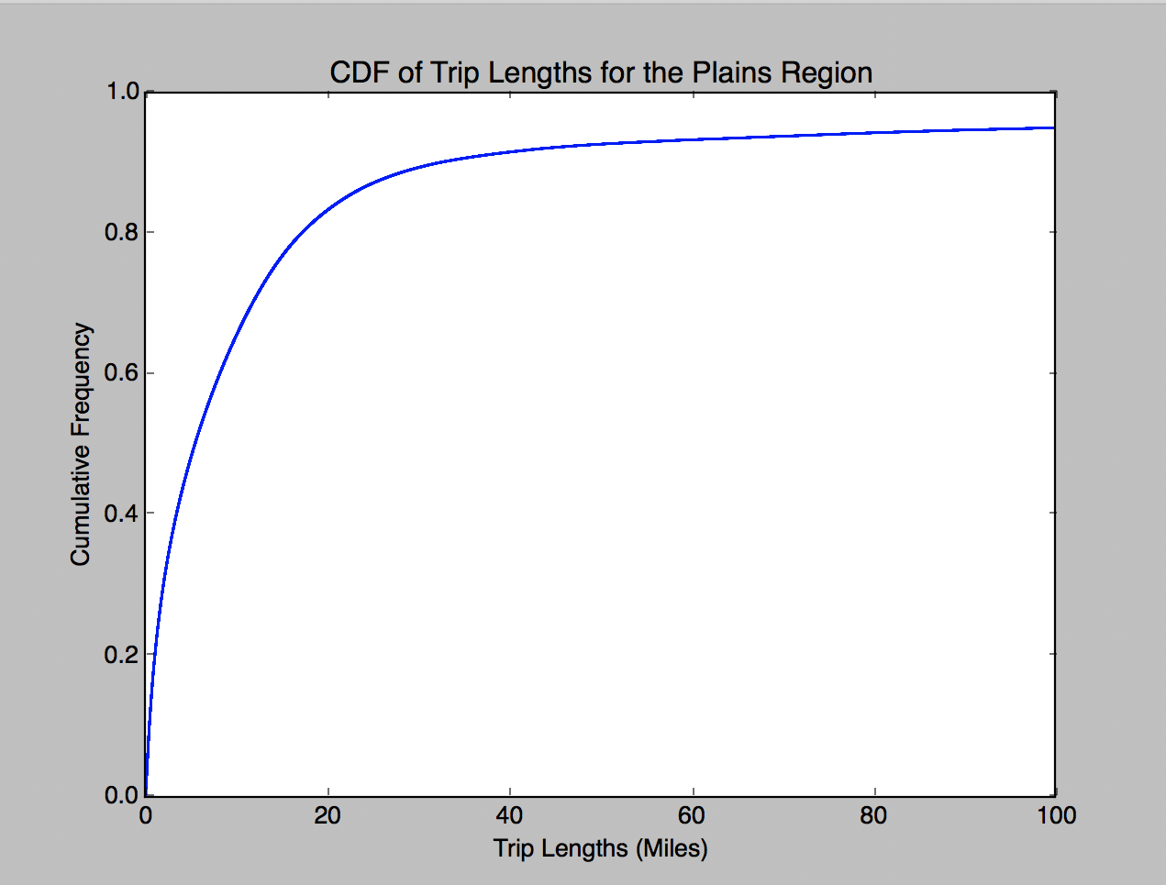

Figure:

Cumulative distribution of PersonTrip lengths for the Plains region

Note that the vast majority of trips (~80%) are shorter than the average trip length (21.7)

Data Outputs
NN_FINAL.csv contains for each county: FIPS Code, County average Lat, County average Long, County population, County PersonTrip count, County average PersonTrip length, County median PersonTrip length.

aTaxi Analysis

Person-Segment Analysis
To consider the usability of aTaxis in the Plains region, we analyzed all trips originating from the region. This covered a total of 136,933,569 person-segments travelling 2,808,064,417 road miles. (We consider the road miles travelled to be 1.2x the Great Circle Distance (GCD).) Some charts showing the input data can be found below.

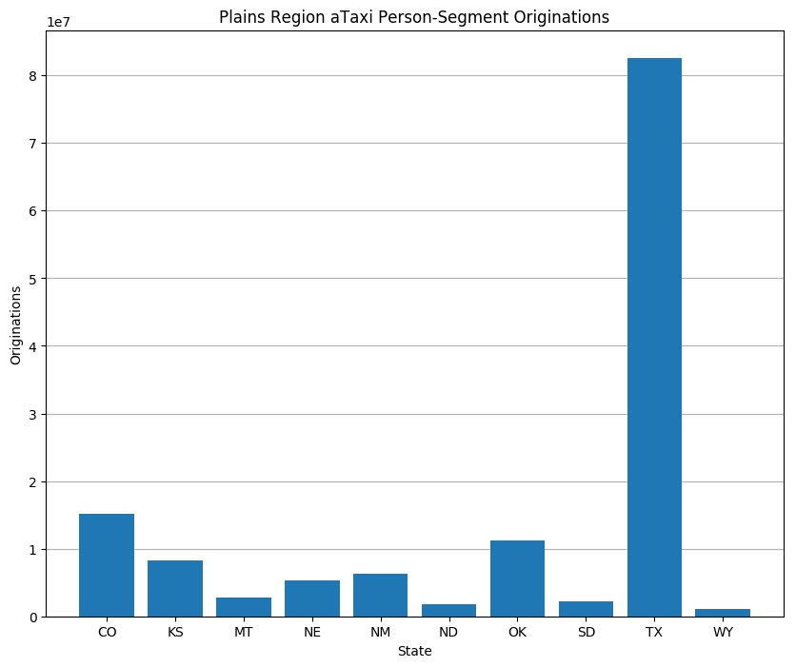 | Figure:  The number of person-segments utilizing aTaxis originating in each state in the region.  As expected, there are more originations from states with larger populations (TX, CO) and fewer originations from the more rural, less populated states (ND, WY). This closely matches with population.

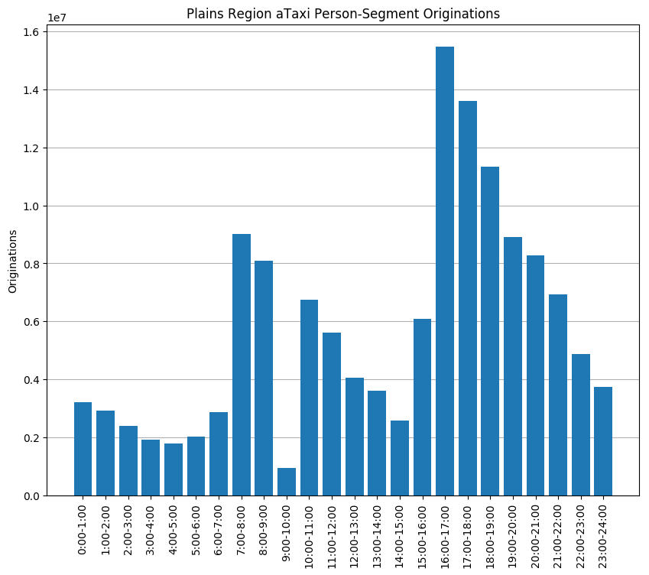 | Figure:  The number of person-segments utilizing aTaxis originating during each hour of the day  This distribution appears to mimic the origination distribution for the entire country, which suggests that our data is representative.

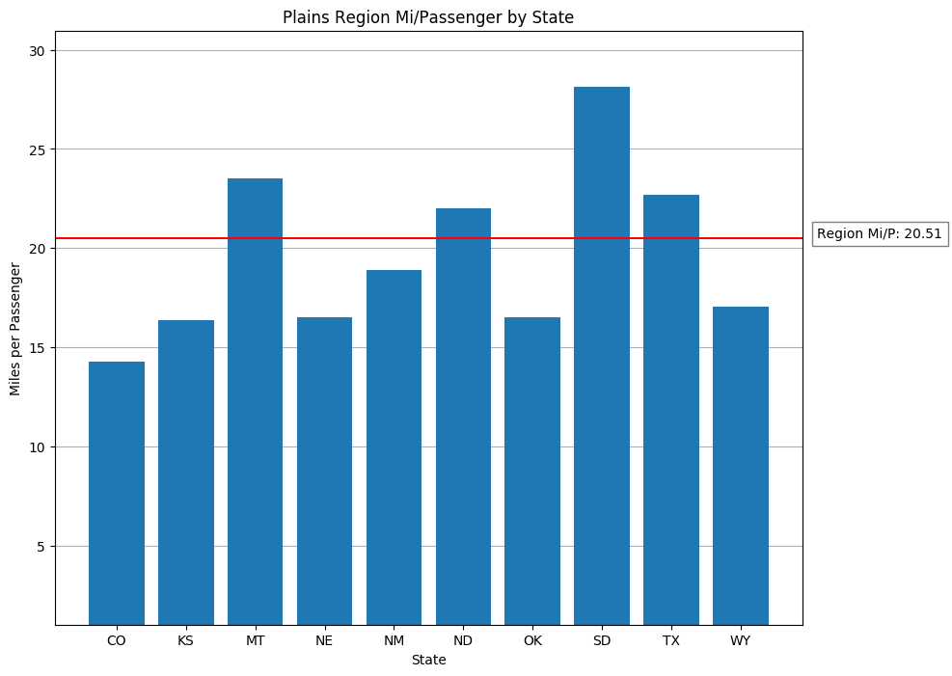 | Figure:  The average trip length of person-segments using aTaxis for each state in the region  There is some decent variation among the various states, with no particular pattern over large/small states or rural/urban states.

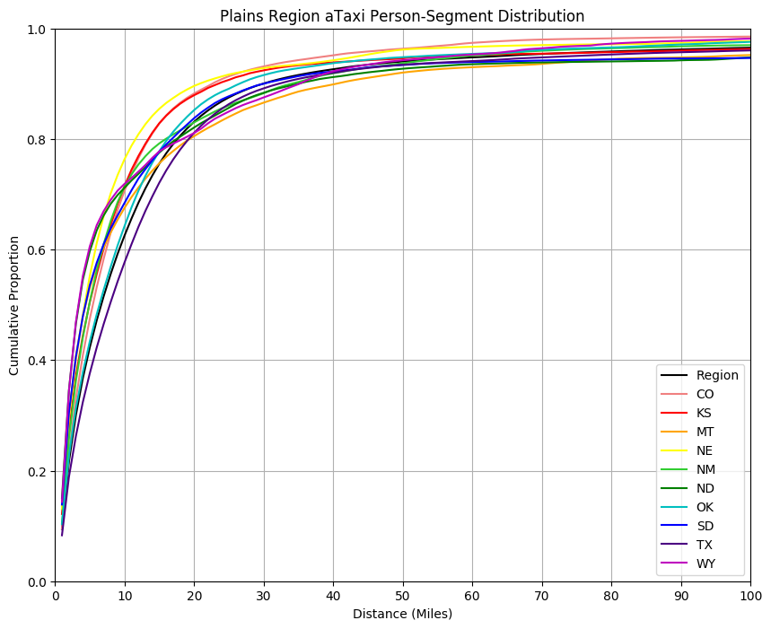 | Figure:  The cumulative distance distribution of person-segments utilizing aTaxis for each state in the region  We note that all states have roughly similar distributions, but as expected, the states with longer trips on average are lower on the distribution.

Ridesharing Analysis
Our rules for assigning person segments utilizing aTaxis to individual aTaxis were as follows:
- Only person-segments originating from the same pixel were grouped into the same aTaxi
- Each aTaxi was limited to a maximum of 5 passengers
- Wait times for each person-segment were as follows:
  - 300 seconds (5 min) wait for segments less than 2 miles in GCD
  - 420 seconds (7 min) for segments between 2 and 10 miles GCD
  - 600 seconds (10 min) for segments between 10 and 100 miles GCD
  - 1200 seconds (20 min) for segments greater than 100 miles GCD
- Proximity for ridesharing was as follows:
  - Within a 2x2 block of pixels for segments less than 2 miles GCD
  - Within a 3x3 block of pixels for segments between 2 and 10 miles GCD
  - Within a 5x5 block of pixels for segments between 10 and 100 miles GCD
  - Within a 10x10 block of pixels for segments greater than 100 miles GCD

This procedure resulted in 90,713,883 aTaxi-segments. Coupled with the approximately 137 million person-segments, this means aTaxis departed with an average occupancy of 1.510.

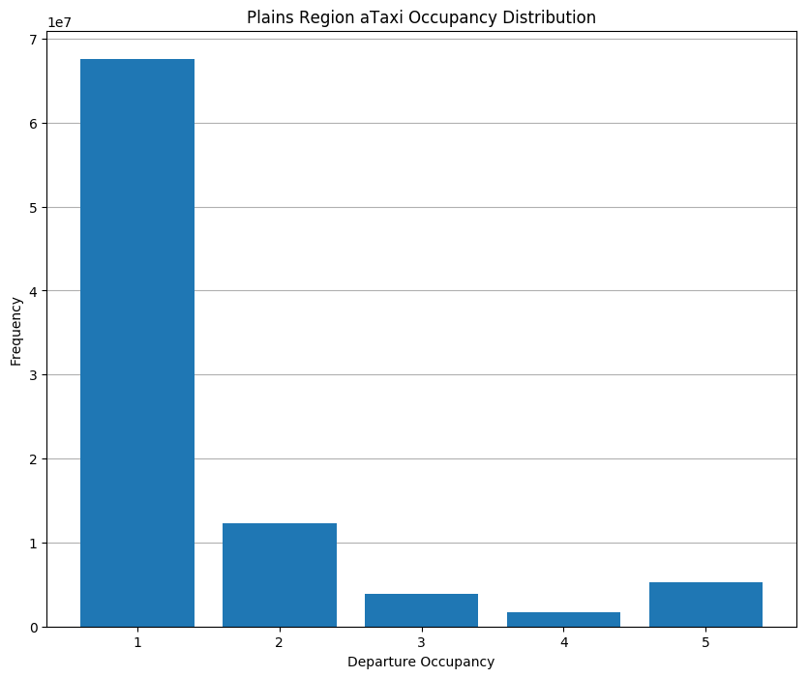 | Figure:  The number of aTaxis with each occupancy at departure  Sadly yet predictably, the vast majority of departing aTaxis have only 1 passenger at departure. However, the increase between 4 and 5 passenger aTaxis suggests there are some routes with high demand requiring multiple aTaxis.

In calculating the Average Vehicle Occupancy (AVO) of each vehicle, we utilized the following procedure for determining the number of vehicle miles travelled:
- The aTaxi first drops off the passenger whose destination is closest to the aTaxi’s start location and adds this distance to its miles travelled
- The aTaxi then drops off the passenger whose destination is closest to the first passenger’s dropoff location (that is, the current location of the aTaxi) and adds this distance to its miles travelled
- The aTaxi repeats this process until the aTaxi is empty

The above vehicle miles calculation resulted in 1,878,404,508 road miles travelled by the aTaxis resulting in an AVO of 1.495 for the region.

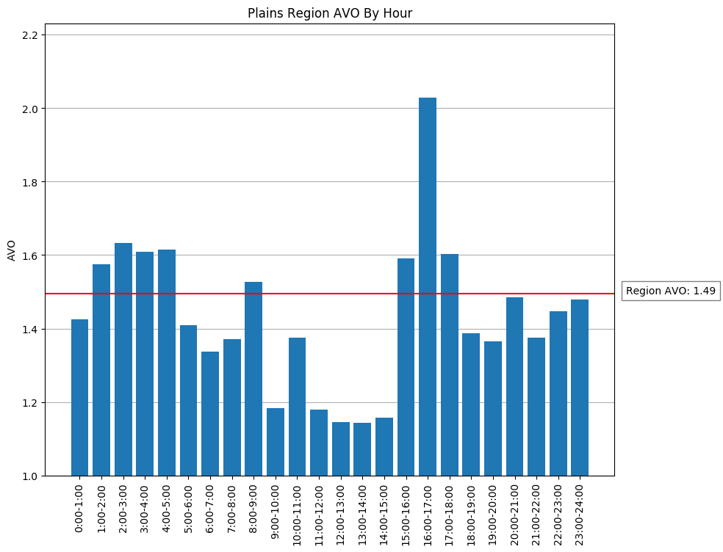 | Figure:  The AVO of aTaxis departing in each hour

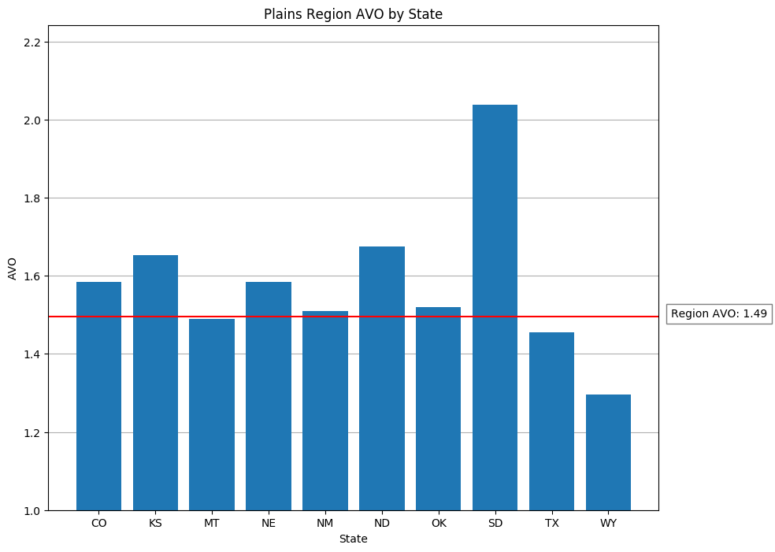 | Figure:  The AVO of aTaxis departing from each state in the region
It is worth analyzing the AVO breakdowns, as there are some surprising trends. With the time distribution, it is not surprising to see the highest AVO is in the afternoon commute times, and that there is a spike in AVO during the morning commute. However, there is actually above-average AVO during the overning (early morning) hours between 1AM and 5AM which is not expected due to the low ridership during these hours. This suggests these relatively few trips must be going to similar destinations.

It is suspected this sharing may be caused by workers going to airports (or much more rarely in this region, transit centers) to “commute” to work, with the early departure due to a long-distance trip and needing to arrive “on time”. There may be a similar phenomenon with university-age students “commuting” to state universities which may be far from the student’s residence.

The abnormally high AVO of South Dakota may be explained by a similar phenomenon, with trips going to similar locations. We noted earlier that South Dakota also had the longest aTaxi trips on average, and the rural nature of the state may mean there are generally fewer destinations for passengers meaning there are more opportunities for ridesharing, which contributed to the higher AVO.

aTaxi Repositioning and Usage
In a real-world scenario, we would not use an aTaxi for each individual trip, but rather have aTaxis reused for multiple trips each day. We can obtain upper and lower bounds on the number of aTaxis necessary. The lower bound is given by the maximal number of aTaxis moving at any given point of the day, which is found to be 4,891,992.

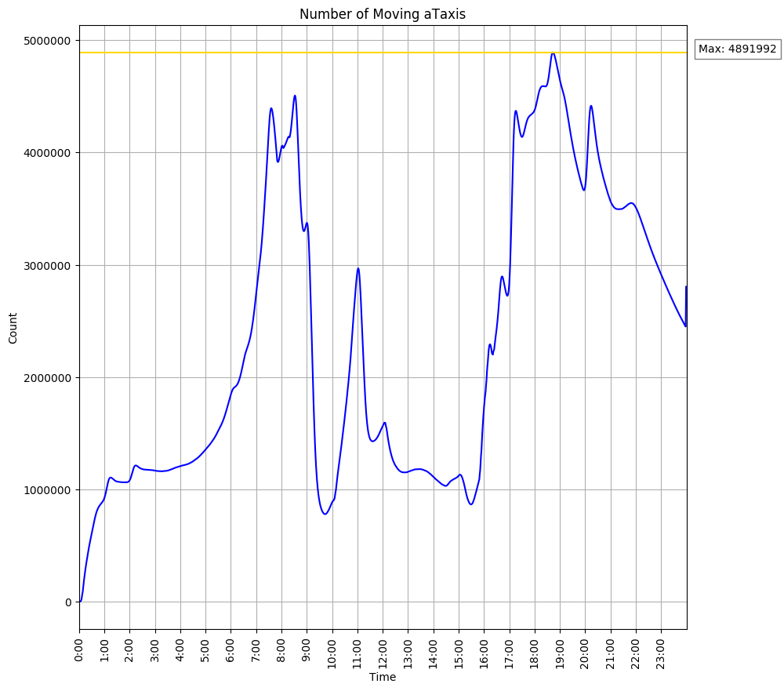 | Figure:  The number of aTaxis moving at any given minute of the day
There are some quirks of the above graph worth explaining. First, we do not take into account “wrapping” of aTaxis whose trips will end in the next day. We opted not to include the arrivals of these aTaxis in this graph as (a) the moving aTaxis would dip into the negatives with more aTaxis having “arrived” in the morning (from the previous day) than have departed during the day, an unrealistic situation, and (b) on the first day of any service, we would not have any aTaxis wrapping.

Second, while the graph does a pretty good job of mirroring the originations by hour, there is a small spike at the end of the day caused by many aTaxis departing at 11:59:59pm (rather than waiting to depart the next day) which is coded into our simulation.

The lower bound can be thought of as the number of aTaxis needed if they could instantaneously reposition to where they needed to be.The upper bound to the number of aTaxis needed is if aTaxis did no repositioning during the day, resulting in a set of pixels needing a supply of aTaxis at the beginning of the day to take passengers on trips, while a different (likely intersecting) set of pixels would end up with an excess of aTaxis at the end of the day. The upper bound is simply the sum of all aTaxis demanded at each pixel at the beginning of the day, which is 16,760,059 aTaxis.

A table displaying the sensitivity of the upper bound to the size of the superpixel the aTaxis can instantaneously reposition within can be seen below:

Instantaneous Reposition Area | Number of aTaxis | Percentage of Upper Bound | Multiples of Lower Bound
1 pixel (no reposition) | 16,760,059 | 100% | 3.43x
3x3 superpixel | 12,354,597 | 73.7% | 2.53x
5x5 superpixel | 10,856,886 | 64.8% | 2.22x
10x10 superpixel | 9,222,012 | 55.0% | 1.89x
20x20 superpixel | 7,741,652 | 46.2% | 1.58x
Infinite size superpixel (instantaneous reposition) | 4,891,992 | 29.2% | 1x

A visual representation of the start of day aTaxi demand and end of day aTaxi supply can be found at http://nyang.mycpanel.princeton.edu/ORF467_F2017/FinalProject/sod_data.html and
http://nyang.mycpanel.princeton.edu/ORF467_F2017/FinalProject/eod_data.html respectively. This data is displayed summed across 20x20 superpixels as any increase in resolution would result in much slower rendering of the data. The radius of each superpixel is proportional to the logarithm of the demand/supply in the superpixel.

Some things immediately jump out. In both representations, we see dots in Mexico and the Gulf of Mexico. These dots are a result of erroneous location data for some businesses and other locations supposedly in Texas. Putting these locations aside, we are pleased to see that high demand and supply are present in the major population centers in our region (best seen after zooming in two levels).

We see from the end of day supply that most significant out-of-region travel by aTaxi is generally to larger metropolitan areas, with more trips to closer cities (Kansas City, Milwaukee, St. Louis). In terms of cooperation with other regions, there is good reason to cooperate with all three neighboring regions (West, Midwest, South) but there is more need to cooperate with the Midwest (particularly due to the Kansas City metropolitan area straddling the two regions) and the South (with lots of travel to Louisiana and to a lesser degree Arkansas and Mississippi). On the other hand, there is less significant travel to the West region, likely because the major metropolitan areas (Salt Lake City, Phoenix) are slightly further away from our region than on the east side of the Plains.

Data
Some source code for this segment of the project can be found online. Descriptions of the code are as follows:
- generate_taxi.py processes the raw person-segment data generated by Kyle and outputs files of only trips travelled by aTaxis
- reposition_taxi.py uses the aTaxi data generated from generate_taxi.py and determines how to reuse them
- plots.py traverses all the data and outputs some visualizations

Summary data for all trips can also be found in plains_summary.csv.

Business Case
To produce the viability of this project as a business, we must consider the costs to start operations (that we will assume to be a 30-year loan to annualize the cost). We also assume that these costs would be an overnight implementation rather than an initial trial with rapid growth model meaning our costs will significantly higher. This business model also assumes that every individual in our region will be a customer from the start. For startup we assume we need enough capital to operate for three months.
In order to establish an estimate for the amount of capital we need, we considered five factors that would represent the bulk of our initial costs:

- The cost of cars and replacement parts
- Land to build parking lots and maintenance centers
- Insurance to cover potential accidents
- Server space to communicate with our aTaxis
- Electricity stations to charge our aTaxis

For each of these five, we need to look at how to distribute our resources across the plain states in order to determine final costs as different materials and factors cost different things in different states.

Cars and Replacements
Utilizing our calculated minimum of just under 5 million aTaxis and adding on 15% plus rounding up, we will establish a fleet size of 6 million vehicles. As each vehicle costs $60k (including self-driving hardware), we have an upfront vehicle cost of $360 billion.

The next component of purchasing cars is dealing with malfunctioning vehicles. The cost of repairs includes wages for engineers (will be considered later) and the cost for replacement parts. For our vehicles, we will assume the most likely places to fail within the 150k mile lifespan will be:
- The battery pack
- The tires
- The self-driving hardware
To simplify our cost calculations, we will assume on average about 5% of battery packs need to be replaced, 5% of cars’ tires, and 10% of cars’ self-driving hardware. From this, we look at average cost of each of these components and determine the number of units we need to purchase based on our fleet-size. Our calculations are in the following table.

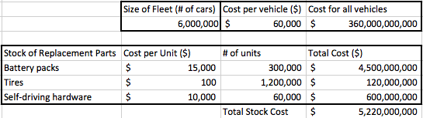

Cost of Infrastructure
Our next highest fixed cost will be purchasing and developing the land for our fleet of vehicles. Because land-purchasing and construction costs vary so widely from region to region and even from town to town, we will try to reach a rough-estimate that we acknowledge is an overestimate by always taking higher values in the range.

First, price of land (measured in dollars per acre) varies between states and varies by type of land to be purchased. To simplify, we will just use the price of land overall in each state (which we know undeveloped-industrial land will always be cheaper than because the average includes more expensive residential and commercial properties). These prices are listed in the table below.

The next thing we need to consider is how much land to purchase per state. We managed this by simply distributing our fleet based on population proportions such that the percentage of our aTaxi fleet in the state is the same as the percentage of customers in the state.

We also took some national averages for construction costs to arrive at a rough estimate for our construction costs. We assumed that our parking spaces would be 8ft by 16ft meaning an acre would be able to contain ~300 parking spaces (without elevation). From a rough estimate of raw materials and price of labor, we would have an average price of $1,792 per parking space. From these, we arrive at our rough estimate for the price overall of our fleet’s infrastructure needs.

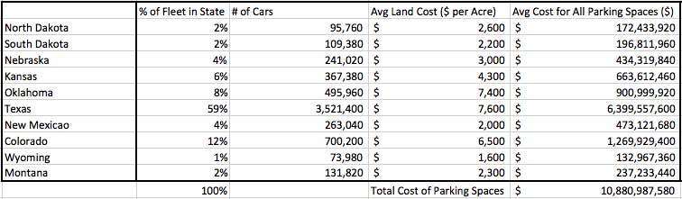

Electricity Demands
Our next greatest cost will come in the form of a one-time payment of building electric charging ports. We will assume we are building level 3 multiport charging stations to minimize time charging for our fleet. Each multiport charging station costs around $20k with some state-specific subsidies for the construction of these charging stations.

Furthermore, after the initial construction, we also have to find the cost of charging our cars. We will plan on using the existing grid rather than constructing solar panels for our own electricity production because electricity currently is fairly cheap in these states (average about $0.10 per kWh). What will also affect our cost is the amount of miles travelled on average, by one of our vehicles and the range of our vehicles. Taking a simple overall average, we see each vehicle would travel approximately 300 miles in a given day, and assuming a standard 50 kWh battery pack in our cars, this would mean only one charge per day. Our calculations are summarized in the table below.

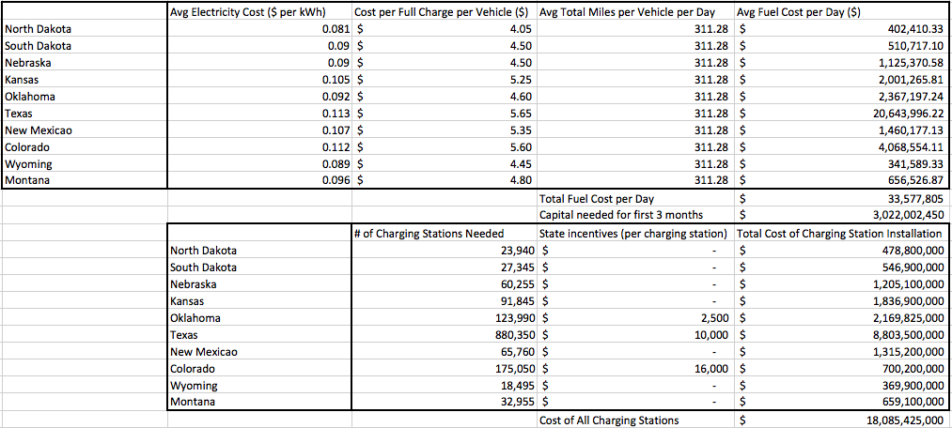

The important points: upfront cost of about $1.5 billion for electricity and $23.7 billion for charging stations.

Miscellaneous Costs
Our final costs come in the form of insurance, employee wages, and renting server space. For insurance, we assume a monthly $150 premium per vehicle because current family plans are about $200 a month and self-driving cars are (in theory) safer and have a lower risk of being in an accident.

Our labor costs come from two components: engineers and charging station workers. Our engineers are in charge of maintaining our fleet while our charging station workers are just there to plug in the vehicles when a vehicle needs to charge. We assume that there will be 5 engineers per maintenance facility and 2 extra personnel per charging facility. For convenience, we can assume these are the same number and are the same facility. For each facility, we would have a maximum capacity to service 9,000 aTaxis per month if we allow for rotation of the fleet. This would lead to around 670 facilities across our region for the purpose of maintaining and upkeep of our aTaxis.

Renting server space is a trivial cost because it comes out to approximately $1k a month meaning a start-up capital of $3k.

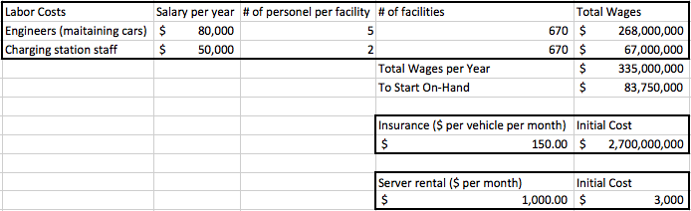

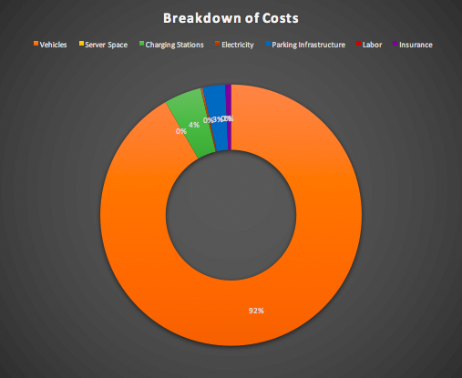
Cost Breakdown
Our initial costs account for most of the capital we need to raise as well as limited operating cost for the first few months of operation. This represents an overestimate of our actual operating cost because we have been using overestimates for individual prices. We see from the breakdown that the most significant portion is in purchasing the vehicles and parts themselves (~92%) while most of the rest comes from the one-time construction cost for supporting infrastructure (~7%)

Revenue Model
With an annual operating cost of approximately $50 billion, a subscription model seemed appropriate as it means guaranteed revenue while minimizing costs assuming people will pay for more than they use. We will try to reach an average annual revenue of $60 billion to achieve a marginal profit of $10 billion (20%). This means on average, each user must pay about $123 a month. This subscription based plan also means that if people go over the allotted miles for their subscription, we can charge a higher price per mile from that point on ($0.25 more than operating cost per mile) which would come out to be about $0.27 per mile because the cars cost about $0.01 per mile to operate after initial start up costs.

We can achieve this using tiered subscriptions based on number of miles travelled in an aTaxi with the first being offered being significantly lower than needed for the average person, the next two being relatively the same, and a “premier” tier for possible extra revenue.

Tier 1: $75 a month for 500 miles travelled
Tier 2: $130 a month for 1000 miles travelled
Tier 3: $140 a month for unlimited miles
Tier 4: $175 a month for unlimited miles with no ride-sharing

This last tier is important because our AVO is only 1.5 which means on average, most people will be alone anyway. This would extract revenue for those who are very opposed to sharing a ride even though the chances of having to do so is small.

To note, this should be a preferred alternative to the customers who, with our services, will not have to make car payments, pay for car insurance, or gas, all of which accounts for over $7,000 in annual savings for the average american even with a Tier 4 subscription.

This would hopefully mean most people will be split between our Tier 2 and Tier 3 subscription types with many choosing Tier 3 for the extra level of service, but not using it as much. Going off a rough estimate of 3 trips per day for the average person and an average of 21 miles per trip the average person (middle 90%, approx 32 million people) will need almost 1900 miles a month. For us this means almost everyone will need at least Tier 3 level to travel the number of miles they need to without going over their subscription and paying extra.

If we assume the bottom 5% opt for Tier 1, 45% opt for Tiers 2 and 3, and 5% opt for Tier 4, we would have a projected annual revenue of $58 billion (16% of operating cost) before any additional revenue from over-use charges.

Further income in the form of renting parking spaces (since we never have our entire taxi parked at the same time) and letting other drivers use the charging ports as well as the over-use charges would be hard to predict and would represent bonus that we could use to pay back our 30-year loan ahead of time, or pay as dividends to investors.

Future Projections
This plan is formulated assuming all prices stay at current levels; however, we know that specific portions of our cost will inevitably go down such as insurance, cost of charging stations, cost of electricity, and price of the cars themselves.

Insurance costs could go down due to self-insuring or from insurance companies lowering premiums for the safety features in our vehicles.

Charging station costs are more likely to be subsidized more as electric cars gain popularity and can be mitigated through federal grants for our construction projects.

Cost of electricity can be lowered as we reinvest in the company infrastructure and set up solar-power generation plants meaning either our electricity from the grid is subsidized or we would be able to be energy-independent from the grid.

Cost of car replacements should decrease as battery pack costs decrease and self-driving hardware becomes more reliable, we would need to purchase less components per year meaning lowered operating costs and higher operating margins.

Recommendations for Further Analysis

aTaxi Recommendations
First and foremost, we would want to run our simulations again using correct location data for the businesses and other attractions in Texas that had improper location data leading to their locations being in Mexico or the Gulf of Mexico. There are a not insignificant number of these locations, and due to their being further away from the bulk of Texas, perhaps this inflates distances for trips in Texas, thereby deflating AVO.

It would be highly useful to determine the sensitivity of the number of aTaxi trips/aTaxis needed to the level of service provided. One might reasonably suspect that if we allow passengers to wait longer for an aTaxi, then there would be more ability to rideshare and thus fewer aTaxi trips performed daily. A similar effect might well be seen if we increase the size of destination superpixels that a passenger will rideshare with. While the directionality of the move may not be in question, the magnitude is unknown and could have significant impacts on our business.

It would also be interesting to see the effect on the number of aTaxis (as opposed to aTaxi trips); while there might be fewer trips overall, the fact that aTaxis spend more time waiting may mean more aTaxis will be necessary to serve all trips.

More analysis can also be done with regard to repositioning aTaxis. We may wish to simulate the possibility of aTaxis being able to reposition at reasonable speeds throughout the day - for example, a waiting aTaxi at pixel A may be able to perform a pickup for a trip at pixel B several miles away, provided the aTaxi arrives at pixel A early enough in the day. This will give us a significantly more accurate number for the amount of aTaxis physically needed; it is unrealistic to have aTaxis reposition across the region instantaneously, but also highly inefficient to have aTaxis not reposition at all during the day.

Repositioning also has consequences for the mileage accumulated by our aTaxi fleet. There is a tradeoff to be had between lifespan and the number of aTaxis acquired: active repositioning causes more miles to be accumulated on an individual aTaxi thereby decreasing its lifespan, and vice versa. We can analyze the quantity of vehicles and vehicle lifespans for different heuristics of active repositioning to see which heuristics minimize our operating costs.

Analysis can also be done to determine the sensitivity of the number of aTaxis needed to the capacity of an aTaxi. As many trips are with fewer people, if for example we capped aTaxi capacity at 4 individuals, we would likely see more aTaxis needed but this increase may be offset by a lower cost for a 4-seat vehicle. A more complicated analysis may look into the possibility of multiple sizes of vehicles operating under the same system.

Finally, we may want to break down trips served based upon the origin and destination type (Home, School, Work, etc). We may see significantly higher AVOs for certain types of trips (eg. Home-Work, School-Transit) with more common origin/destination spots, which an aTaxi rideshare system may want to target.

Business Recommendations
If we assume that our entire business does not spring up in its entirety overnight, we can begin by optimizing the location where we grow our business from. We can do further analysis (mostly in Texas) on the most high-traffic areas that would represent the most number of trips with the highest ride-sharing capability (and thus most cost-effective).

Beyond that, we would also only start with states that provide federal incentives to having electric cars and building charging stations as that would significantly mitigate upfront costs. We can also look to the avenue of federal grants towards the purchase of electric cars or setting up electric infrastructure and see how this affects our startup finances.

As an established business with regular and established sources of income, investing in solar power generation would be a good idea to minimize our electricity needs. However, electricity is already cheap and will continue to get cheaper as natural gas fracking increases so we can do more analysis to find the optimal level of grid-power usage vs own-power usage. Again, we can look to federal grants for the money to build some of these solar power generation facilities.

Another point to look at is if there is location, finding land that is cheap but also centrally located to mitigate the empty-aTaxi repositioning costs. Finding an optimal balance between initial cost of land and development subsequent cost of repositioning taxis would be a good next step to increase revenue.

Finally, we can extend our analysis down to specific county or state levels to optimize pricing in order to incentivize higher subscription prices by home county.

Team Member Responsibilities
Each team member was completely responsible for a section of the assignment, including coding (as necessary), research (as necessary), and writeup. The sections were as follows:
- Jason Fu: Assessment of Population Served
- Nicholas Yang: Assessment of Trips Served, ridesharing potential, and aTaxi generation
- Wesley Yuan: Analysis of Business Case

For the other sections of this report, responsibilities were divided thusly:
- Jason Fu: Executive Summary
- Nicholas Yang: Future Recommendations, aTaxi subheading
- Wesley Yuan: Future Recommendations, Business subheading

This report represents our own work in accordance with University guidelines.
/s/ Jason Fu
/s/ Nicholas Yang
/s/ Wesley Yuan

Available at http://nyang.mycpanel.princeton.edu/ORF467_F2017/FinalProject/NN_FINAL.csv
Available at http://nyang.mycpanel.princeton.edu/ORF467_F2017/FinalProject/code/
From http://orf467.princeton.edu/NationWideModalPersonTrips18Kyle/aTaxi/
Available at http://nyang.mycpanel.princeton.edu/ORF467_F2017/FinalProject/plains_summary.csv

