Core discussion networks of Princeton students
Assignment 6 (Due: April 1, 2015)
Sociology 204: Social Networks
Matthew J. Salganik

Remember to write your name and precept on your assignment and staple it!

Short answer questions:

1) Imagine that next year humans discover that there is life on Mars. Further, by overhearing the Martian phone calls, humans learn that the Martians actually have complex patterns of social relations. For example, it was discovered that Martians have a special relationship called occra, which is similar to friendship in human, but the precise characteristics of this relationship are still be studied. However, one thing that has been discovered is that occra is an undirected relationship; that is, you would say that Peter and Paul are occras not that Peter is Paul's occra. If not all Martians have the same number of occras, which of the following must be true about the network of occras between Martians? Please do not assume that Martian social relations look anything like human social relations. [10 points]

a) There is short average path length
b) There is high clustering coefficient
c) both (a) and (b)
d) The mean number of occras of occras will be greater than or equal to the mean number of occras of Martians
e) The number of occras of every Martian is less than the average of occras of his or her occras
f) We don't know for sure any properties of the occras network because we don't know enough about this type of relationship

2) The figure below is from the paper by Liljeros et al. and describes the sexual network of Swedish adults. Does this network contain more cycles of length 4 than would be found in an Erdos-Reyni random graph with the same number of nodes and edges? (Note that this is exactly question 5 from the midterm, a question that many people did not answer correctly). [10 points]

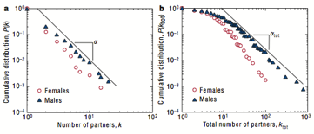

A. yes
B. no
C. impossible to tell

3) Below are the screenshots from the first and second experiments in Salganik, Dodds, and Watts (2006) (i.e., the Musiclab experiments). Now, imagine that Salganik et al. had conducted an additional experiment that was exactly the same as second experiment except that the font size for the download counts was increased from 10 point font to 24 point font; in other words, in this hypothetical experiment, the song download count was featured more prominent than in the second experiment. (Note that this is exactly question 1 from the midterm, a question that many people did not answer correctly).

Experiment 1:
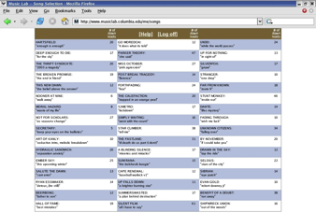

Experiment 2
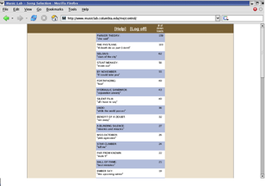

Based on the relationship between the results of experiment 1 and 2, what do you think would be the relationship between results for experiment 2 and this hypothetical additional experiment? [3 points]

A. inequality of success will increase and unpredictability of success will decrease
B. inequality of success will increase and unpredictability of success will stay the same
C. inequality of success will increase and unpredictability of success will increase
D. inequality of success will stay the same and unpredictability of success will decrease
E. inequality of success will stay the same and unpredictability of success will stay the same
F. inequality of success will stay the same and unpredictability of success will increase
G. inequality of success will decrease and unpredictability of success will decrease
H. inequality of success will decrease and unpredictability of success will stay the same
I. inequality of success will decrease and unpredictability of success will increase

4) Why? [2 points]

5) What is one question or issue that you would like to discuss in precept? [18 points]

Core discussion networks of Princeton students

This week we read about the core discussion networks of Americans, and now we are going to learn about the core discussion networks of Princeton students. First, please make some predictions.

1) Do you think Princeton students will have larger or small core discussion networks than Americans? Here core discussion networks are defined in the way that McPherson et al. did: people with whom the respondent discusses important matters. [2 points]

2) What percentage of core discussion partners of Princeton students do you think will be other Princeton students? [2 points]

3) What percentage of core discussions pairs of Princeton students (i.e. ego and alter both Princeton students) do you think will be people who are the same gender? [2 points]

4) What percentage of core discussions pairs of Princeton students (i.e. ego and alter both Princeton students) do you think will be people who are in the same eating club? [2 points]

5) What percentage of core discussions pairs of Princeton students (i.e. ego and alter both Princeton students) do you think will be people who lived in the same residential college freshman year? [2 points]

6) What percentage of core discussions pairs of Princeton students (i.e. ego and alter both Princeton students) do you think will be people who are the same race/ethnicity? [2 points]

Now that your predictions are made, please select 3 of your friends to be interviewed. Ask them if they would like to help you complete your assignment and tell them that each interview will take approximately 10 minutes. For each friend, please complete a survey form that you can download from the class website. After collecting the data, please answer the following questions

7) Based on your data, do Princeton students have larger or small core discussion networks than Americans? Here core discussion networks are defined in the way that McPherson et al. did: people with whom the respondent discusses important matters. For this question, you can assume that the McPherson et al. (2004) article is correct. Be specific and cite data. [5 points]

8) Based on your data, do kin (e.g., family members) make up a higher or lower proportion of Princeton students' core discussion networks than Americans' core discussion networks? For this question, you can assume that the McPherson et al. (2004) article is correct. Be specific and cite data. [5 points]

9) Based on your data, what percentage of core discussion partners of Princeton students are other Princeton students? [5 points]

10) Based on your data, what percentage of core discussions pairs of Princeton students (i.e. ego and alter both Princeton students) are people who are the same gender? [5 points]

11) Based on your data, what percentage of core discussions pairs of Princeton students (i.e. ego and alter both Princeton students) are people who are in the same eating club? [5 points]

12) Based on your data, what percentage of core discussions pairs of Princeton students (i.e. ego and alter both Princeton students) are people who lived in the same residential college freshman year? [5 points]

13) Based on your data, what percentage of core discussions pairs of Princeton students (i.e. ego and alter both Princeton students) are people who are the same race/ethnicity? [5 points]

14) How did you predictions compare to your results? For which kinds of things were your predictions most accurate? Least accurate? Be specific and cite data. [10 points]

15) Finally input all of your survey data (not your predictions or analysis results) into the class data collection website; the link will be posted on Piazza. This aggregated data will give us a fuller picture of the core discussion networks of Princeton students and will be discussed in precept.

