Executive Summary

The South Region of the United States consists of the nine States: North Carolina, South Carolina, Georgia, Florida, Alabama, Mississippi, Tennessee, Arkansas, Louisiana.

While fast-growing, dating back to its historical roots, the Southern region of the United States remains much more rural and agrarian compared to other regions. The population of our region is about 124 million people, with Florida and Georgia accounting for the largest populations (20.1 Million and 10.31 Million, respectively). The region is largely characterized by suburban lifestyle, with the few largest cities in region being Atlanta, Miami, Tampa, Orlando, and Charlotte.

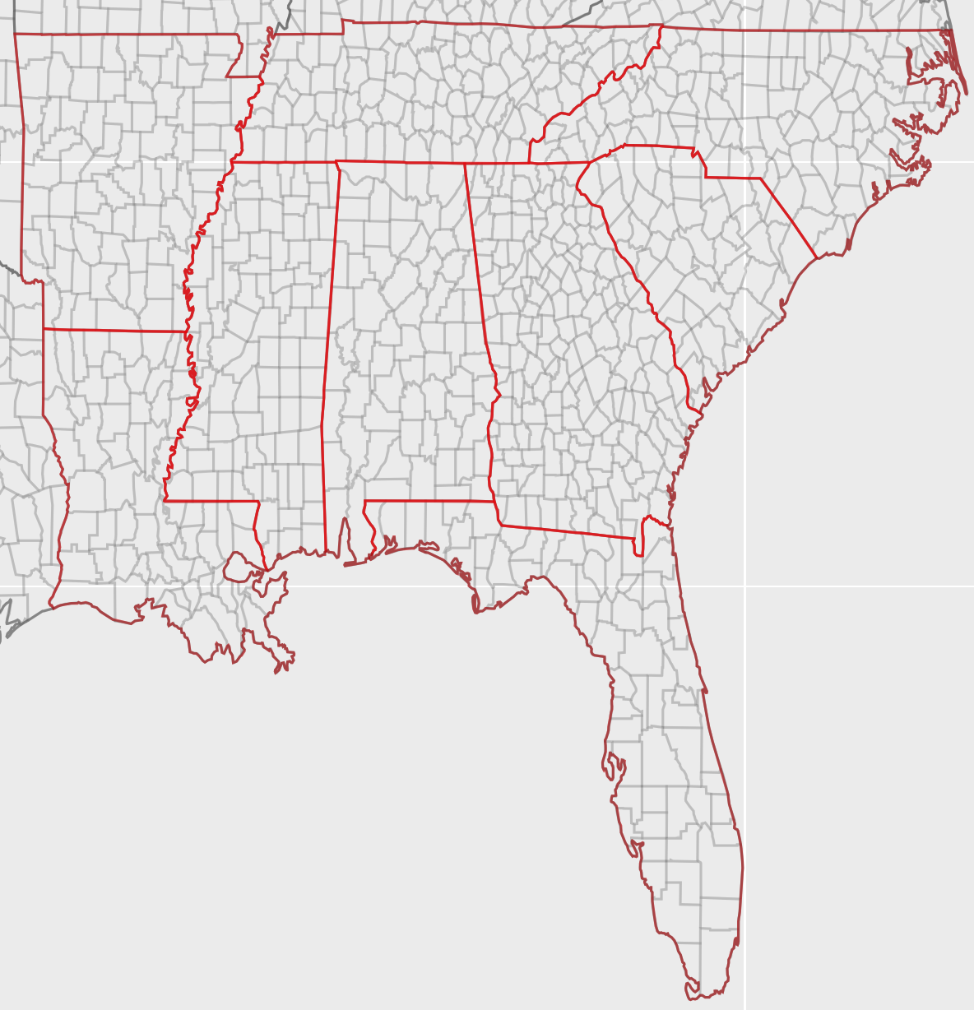
Figure 1: The Southern Region

In total, we found that there are approximately 143 million trips taken each day, totaling around 3.4 billion passenger miles and 2.4 billion vehicle miles. These number give us an Average Vehicle Occupancy(AVO) of 1.38, while the average passenger occupancy comes down to about 1.37. This figure can be explained by the slightly lower population density of this region compared to the rest of the country.

Population Totals (NN files)
The Southern region has, on average a low population density, with a few highly populated regions, such as Atlanta, or Miami. This fact is illustrated in the circle plot of population below:
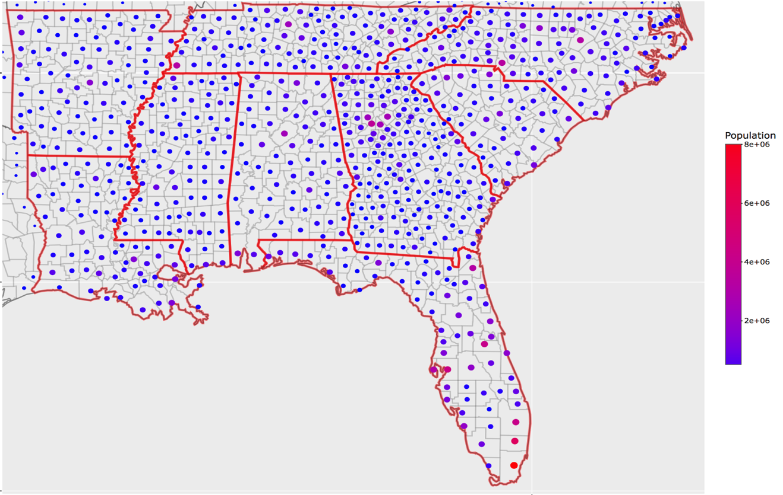
Figure 2: Population Distribution in the southern region

As a matter of fact, only 40% of all counties have a population greater than 100,000 people in this region. Counties with more than 100,000 inhabitants are marked in red below.
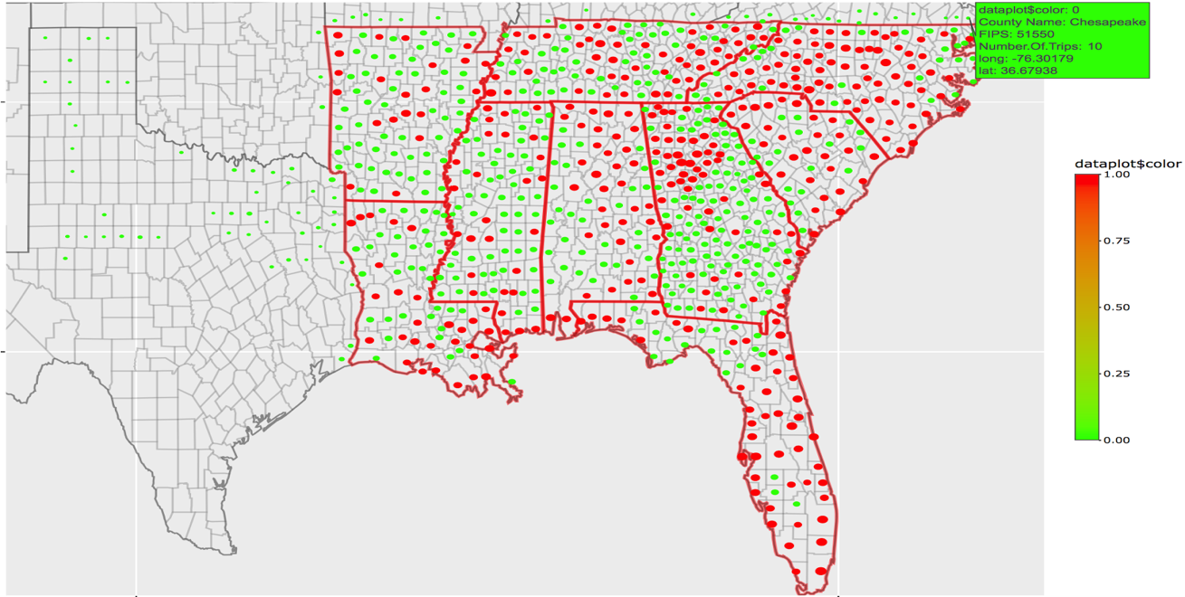
Figure 3: Counties with more than 100,000 inhabitants in red
Person Trips Miles Totals (Nationwide Files)

Based on our calculation, the total person trips miles for aTaxis is 3,608,115,305 (3.6 Billion) Miles per day. This number represents the total number of miles traveled on any given day by the whole Southern region.
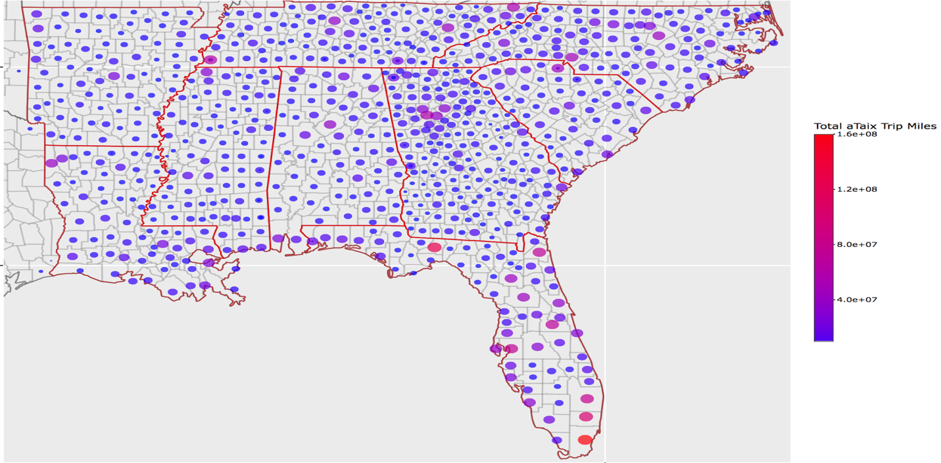
Figure 4: Total Person Trip Miles Distribution - Color Coded
From the plot above, we can see that most counties have similar person trip miles total, with a few outliers such Miami-Dade County in Florida which has a total PersonTripMiles of 16.1 million! To get more insight into this data, we have isolated the counties with at least one million person trip miles. The plot below illustrates this data:
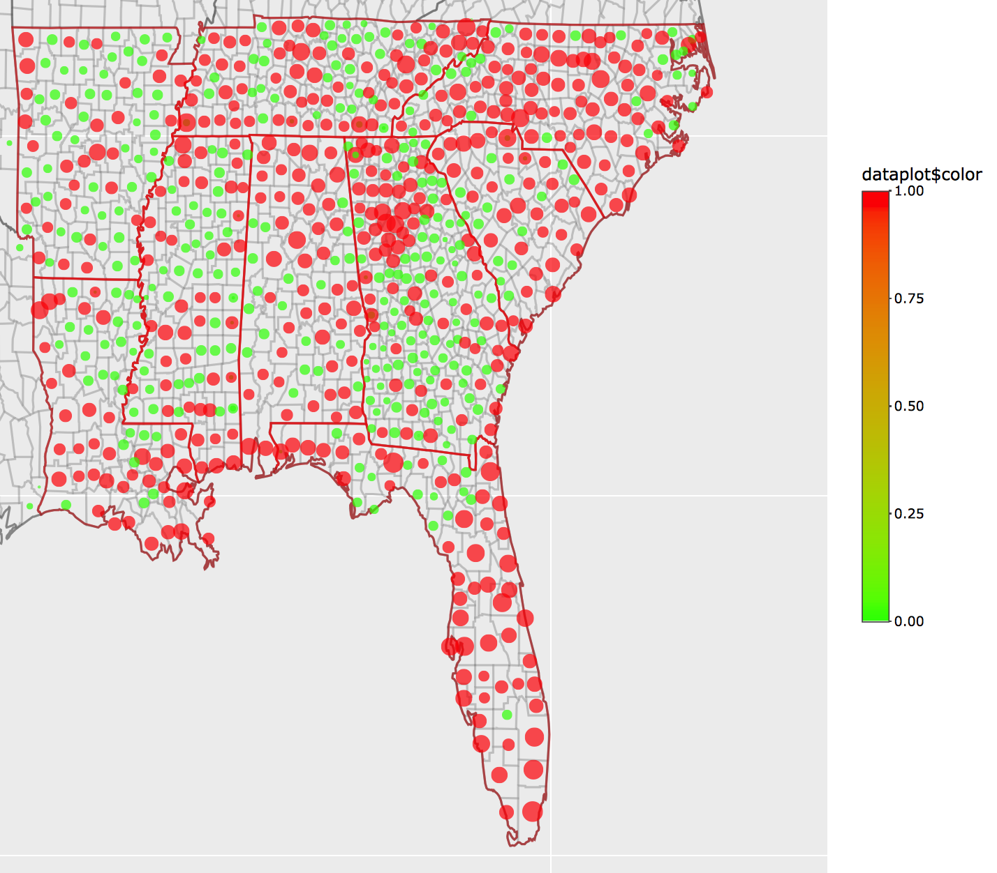
Figure 5: Counties with more than 1 million person trip miles are in red.
Average PersonTrip Length Distribution (Nationwide Files)

The daily Average Person Trip length for the southern region is 17 miles. The circle plot below illustrates the average person trip length for each county in the southern region.
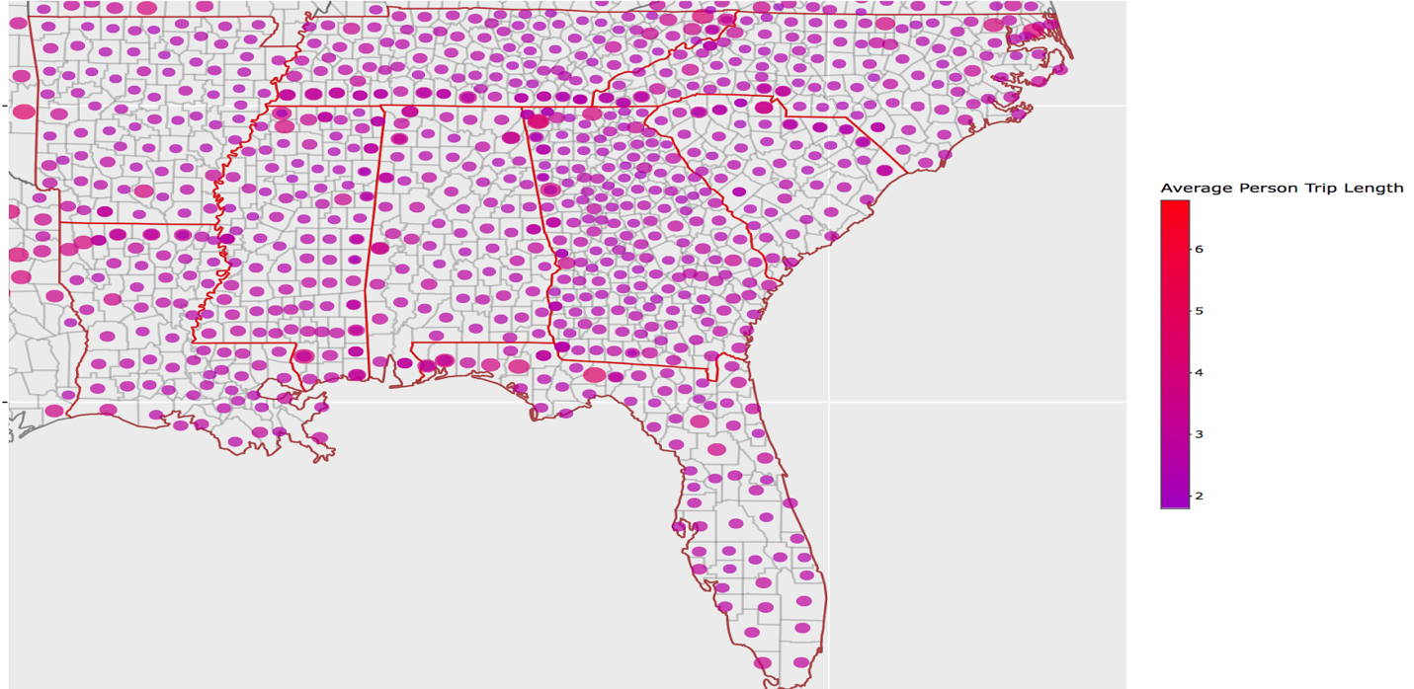
Figure 6: Average Person Trip Miles Distribution - Color Coded

Based on the homogeneity of the plot above and on our analysis, we found that the average person trip length is consistent across counties, although some of the smaller, more isolated counties did have slightly higher average PersonTrip length as expected.

Assessment of Trips Originating in the Southern region based on Nationwide Trip Data
Cumulative distributions of Trip based on Trip types

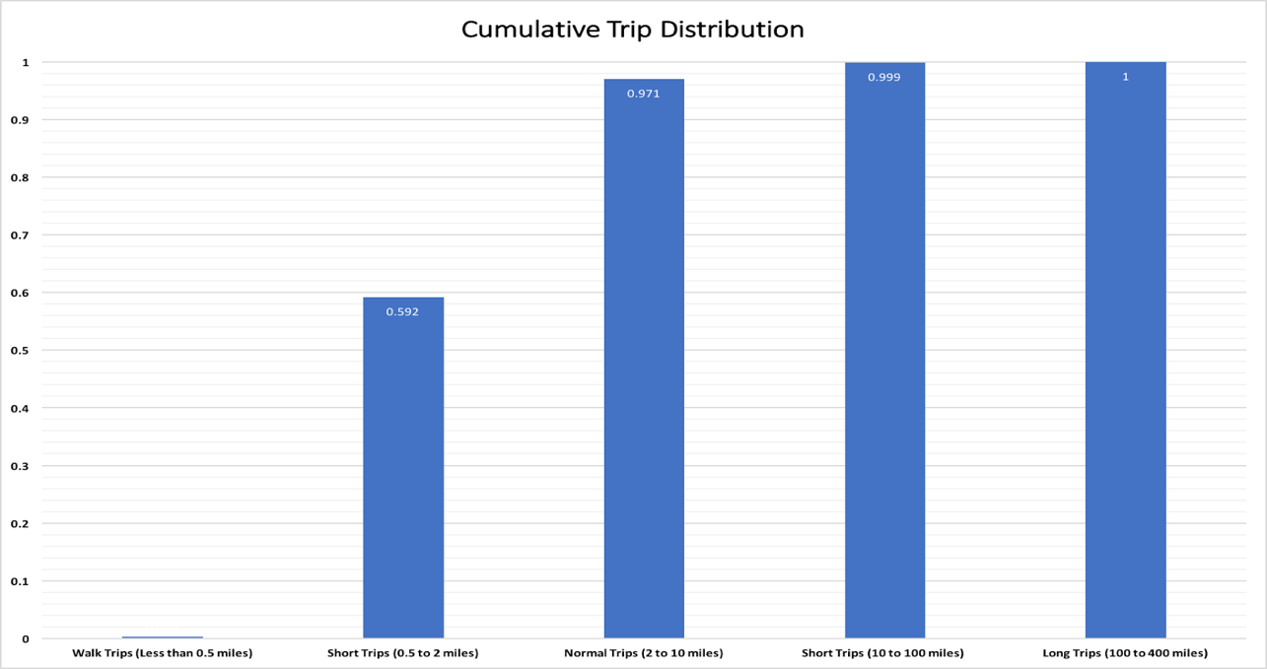
Figure 7: Cumulative Distribution of Trip Types
The plot above shows that most of our aTaxi trips are either Short Trips (59%) or Normal Trips (39%). These trips are great as they do not take too long, and will allow our aTaxis to be available for further use within a reasonable delay. For example, if we assume that we will be travelling at 30 mph, most of our taxis should be available for use within 20 minutes of their last use.

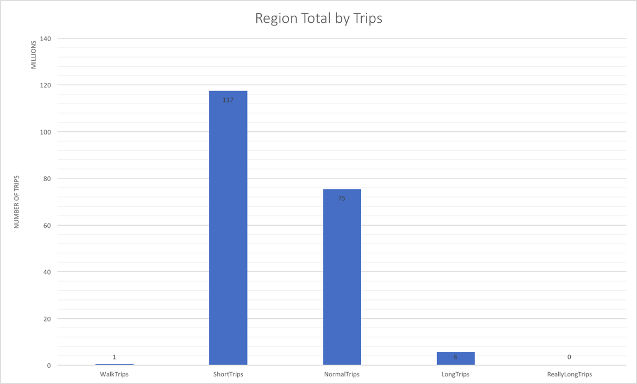
Figure 8: Region Total for each Trip Types
The graph above shows that close to Short Trips account for about 117 Million trips daily!
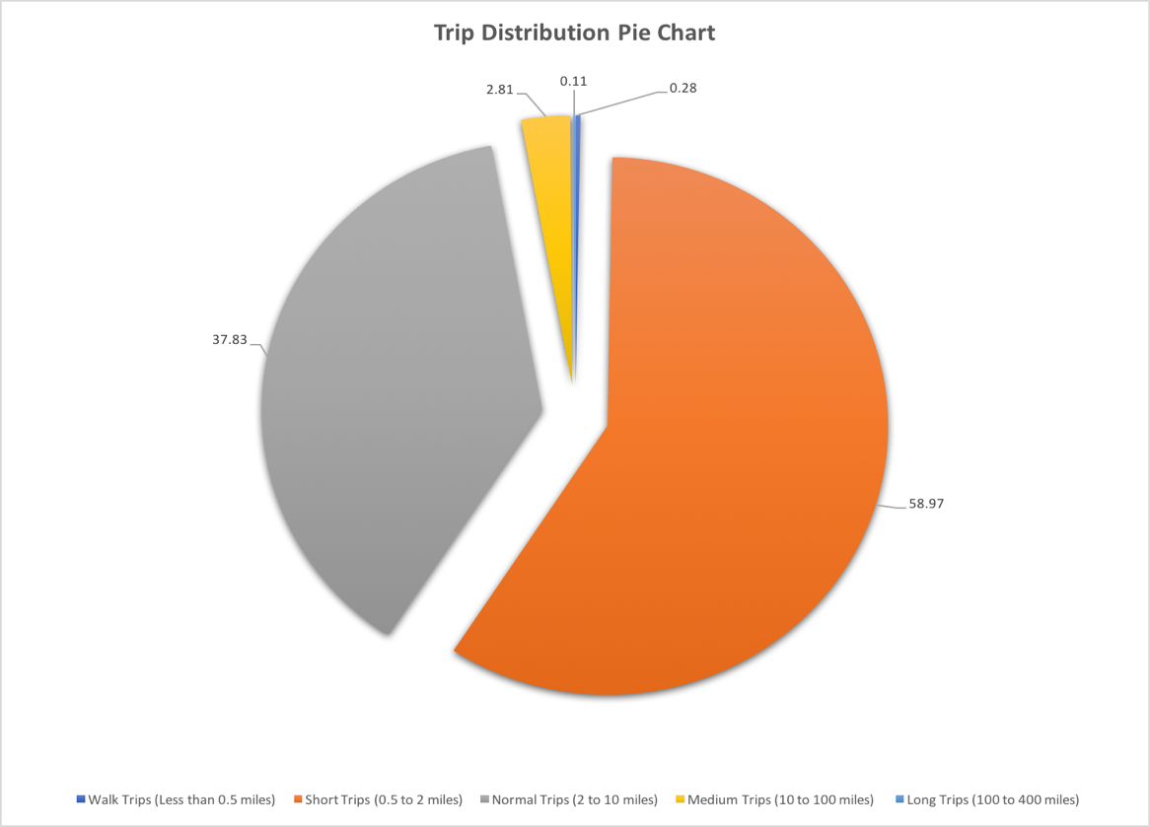
Figure 9: Pie chart for Trip Types distribution

The pie chart above serves to visually reinforce the idea that most of the trips in the Southern region are either Short Trips (in orange) or Normal Trips (in Grey)

Distribution of Number of Trips with respect to time

We thought it would be interesting to have a look at the number of trips in the southern region with respect to time. The plots below illustrate this:
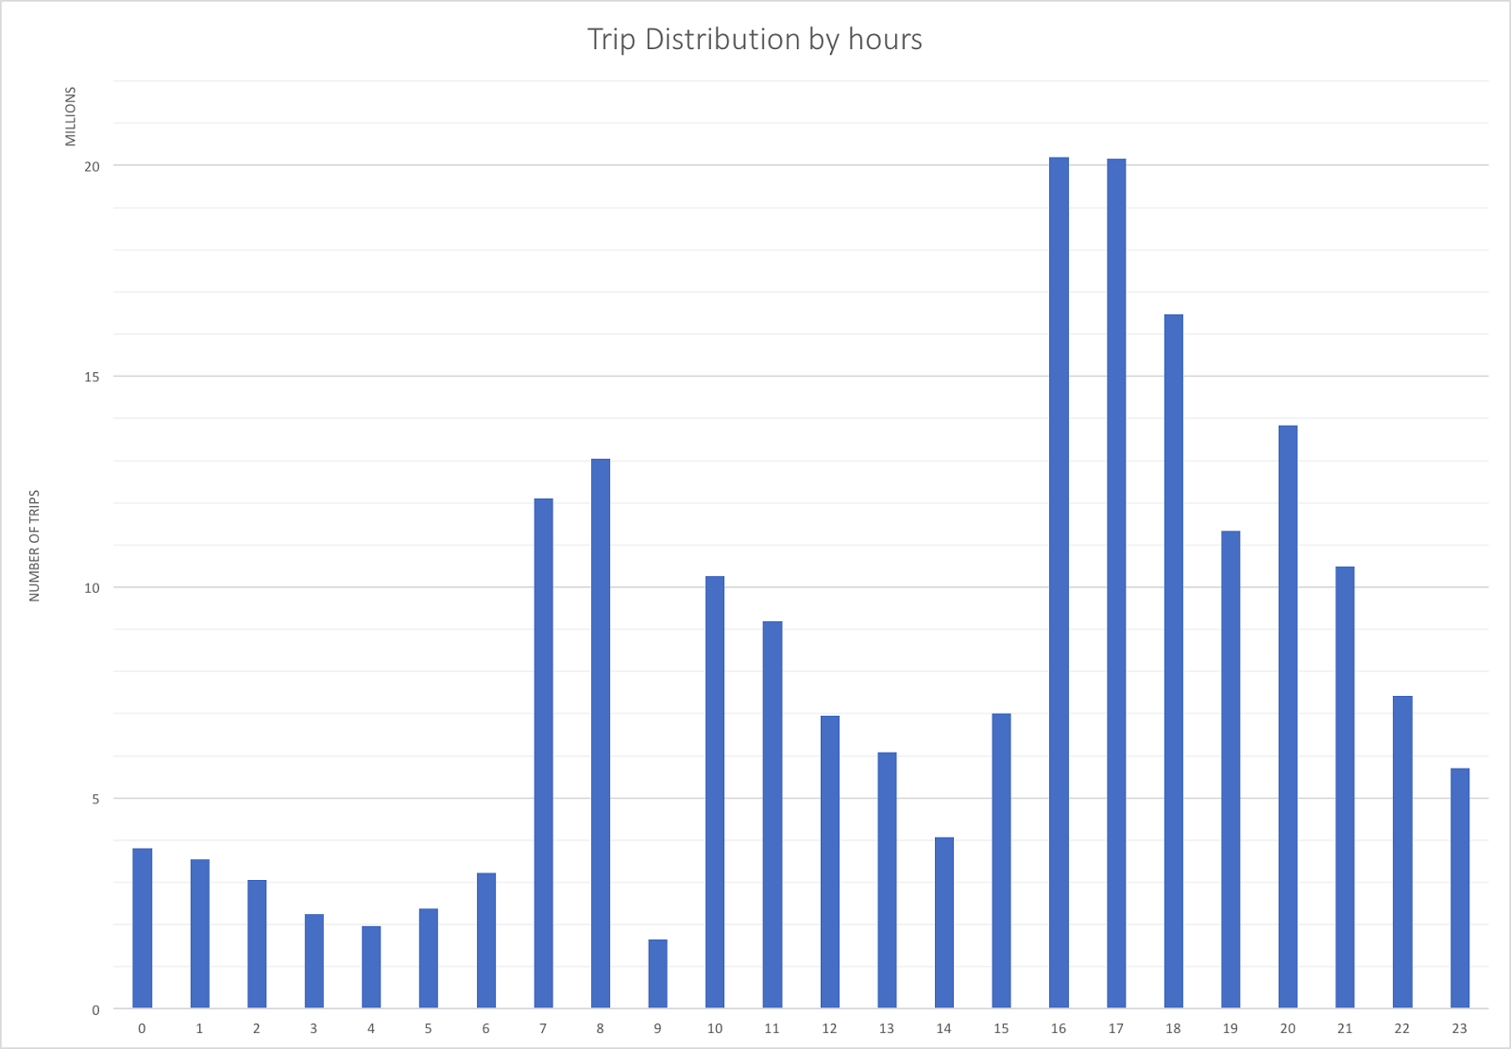
Figure 10: Distribution of Trips (in millions) by hour
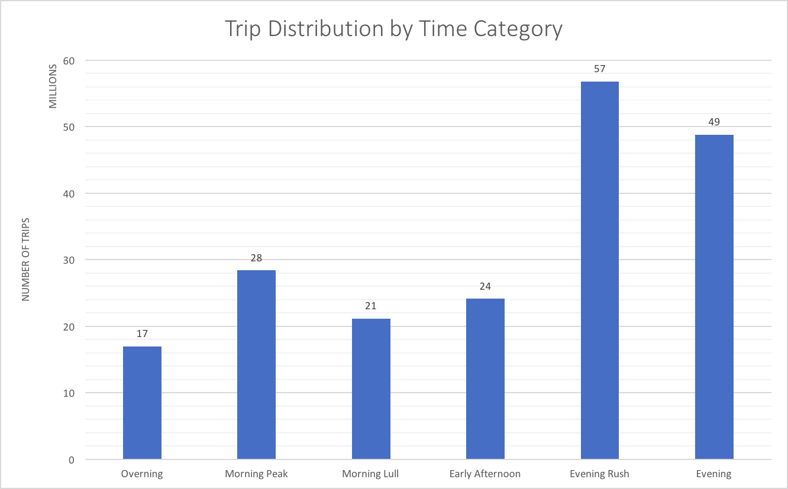
Figure 11: Distribution of Trips (in millions) by time category

The above plots show that most trips occur in the morning (people heading to school or work) and in the evening (people returning home from office and work). These hours could potentially be great for ride-sharing. Additional analysis of this aspect is provided further down this report.

Cumulative distributions of Trip Lengths (Nationwide files)

Let us now have a look at the cumulative distribution of our trips lengths over our whole region. For this part of our report, we are focusing solely on aTaxi trips.
The cumulative graph for all aTaxis across the southern region looks as follows:

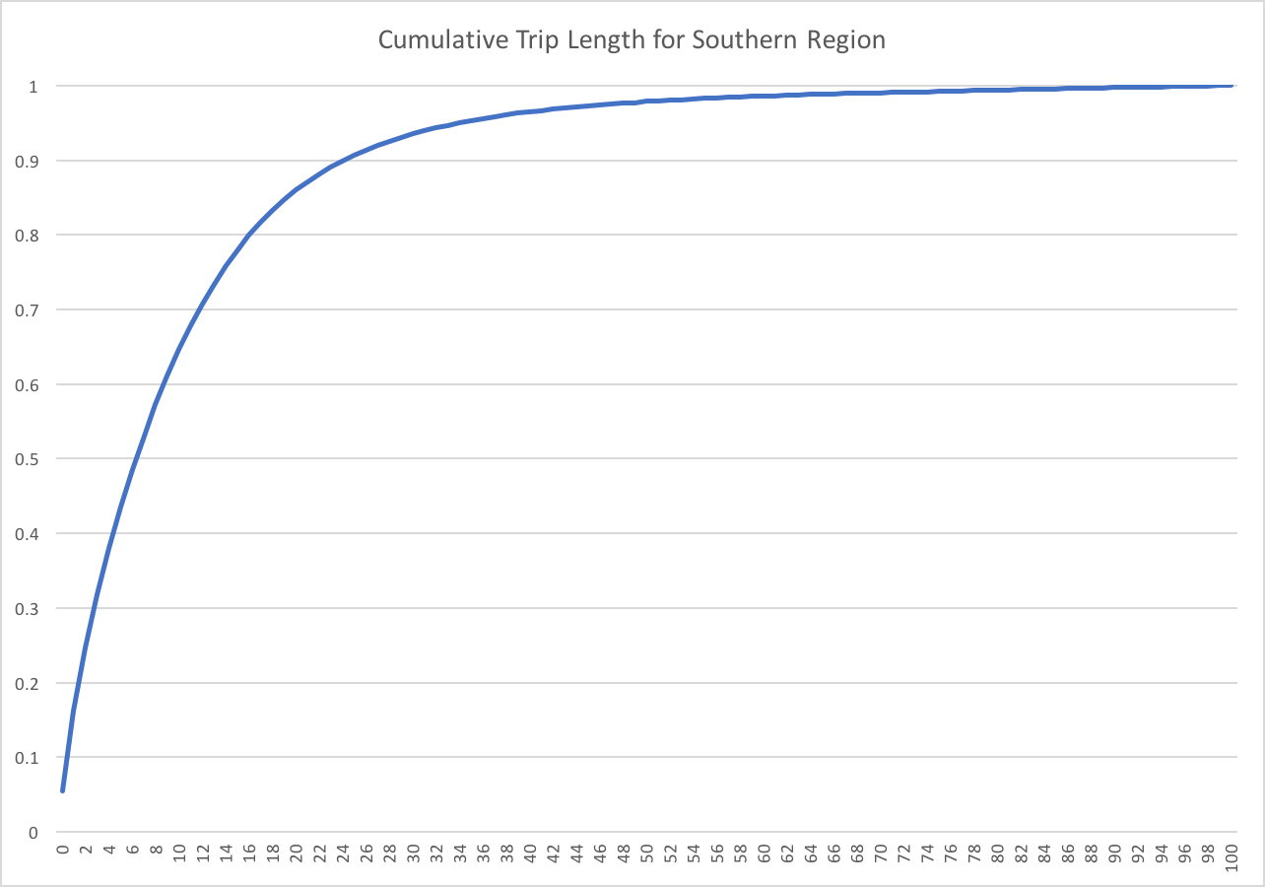
Figure 12: Cumulative Distribution of Trips for Southern Region

More than 50% of the trips in our region is less than 8 miles long, which is in line with our analysis from the previous sections.

Assessment of Ride-Sharing Potential

So far, we have only analyzed the trip length and trip type for our region. In this section, we will delve deeper into our ride-sharing analysis, and will now consider Average Vehicle Occupancy (AVO). We define AVO for a trip to be the ratio of Person Miles Trips (PMT) to Vehicle Miles Trips (VMT). This measure gives us meaningful insight into how much we can potential exists for ride-sharing. An AVO-plot for the southern region looks as follows:
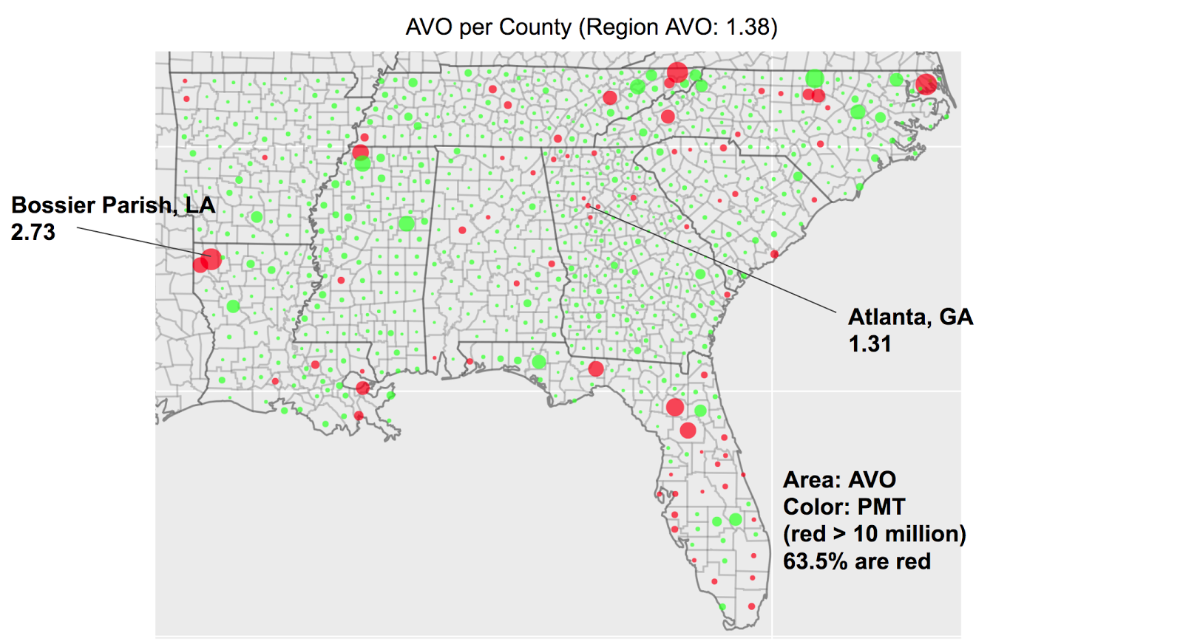
Figure 13: Circle plot of AVO in Southern region

In this circle plot above, the radius of the circle is proportional to the AVO of the county, while any circle in red represents a county with Person Miles Trips of at least 10 Million.

This plot also illustrates the surprising fact that rural areas such as Bossier Parish, LA actually have high AVOs which make them great for ride-sharing. This phenomenon is probably explained by the fact that most people from these rural areas go to the same places around the same time.
This is an incredible insight which goes against the generally agreed consensus that ride-sharing potential in rural areas is low because of the smaller population size. This point is further reinforced by the following plot of AVO for each state in the southern region.

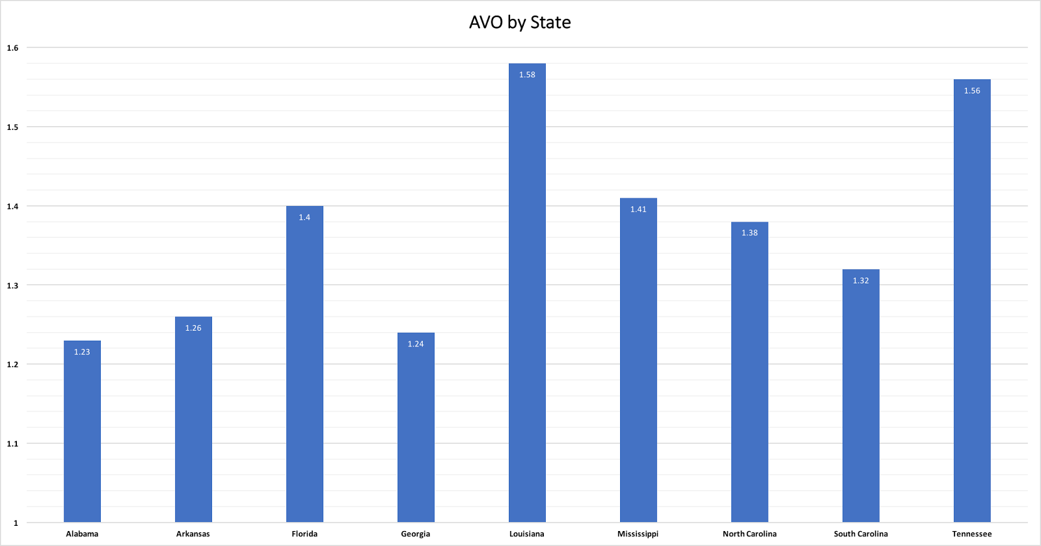
Figure 43: Bar chart AVO by state for the Southern region

Louisiana and Tennessee are the leading state in terms of AVO with 1.58 and 1.56 respectively – thus again illustrating the ride-sharing potential of rural states.

We will now consider a time-based analysis of AVO. The graphs below illustrate AVO with respect to time:
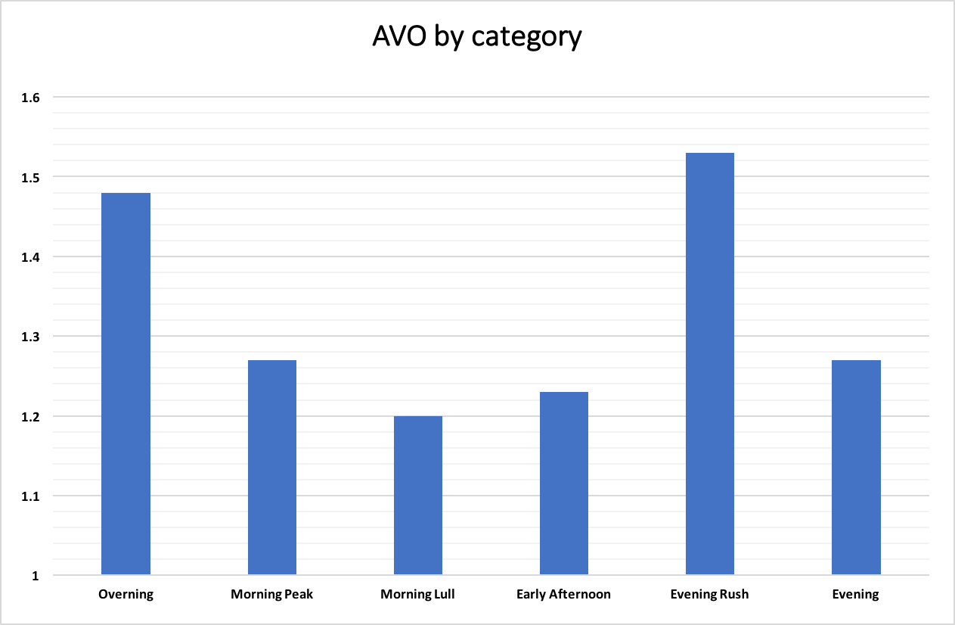
Figure 15: Bar chart AVO by time category for the Southern region

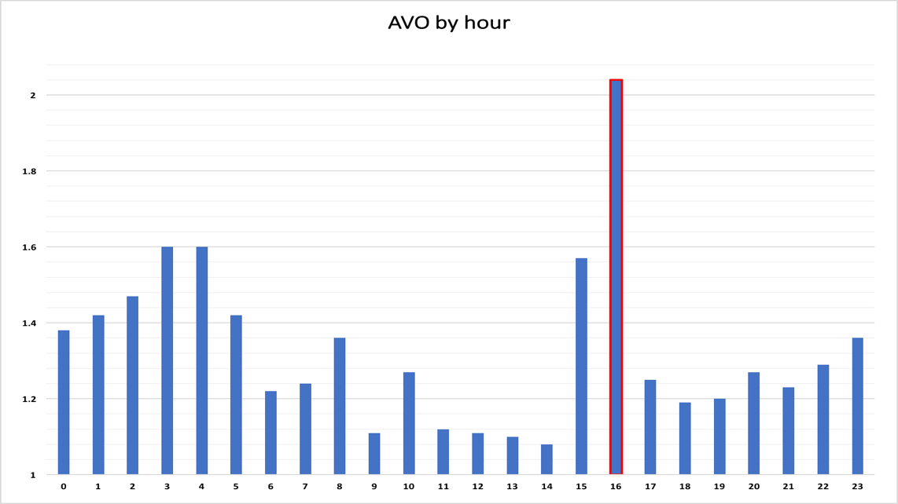
Figure 16: Average Vehicle Occupancy by Hour

The two graphs above provide interesting insight into our population. For instance, the fact that AVO is substantially high at around 4pm highlights the fact that a lot of people work in close vicinity, and often go to similar areas after work. Moreover, we can also see that there is a surprisingly high AVO between 2 and 4 in the morning. One possible explanation for this would be that people who are out at these out are usually at the same locations (e.g. nightclubs or bars) and usually head back to the same residential areas after a long night.

Based on the AVO by time category distribution, we can see that the evening rush has the most potential for ride-sharing. Strategically position aTaxis near offices and school might be an avenue worth considering.

Generation of aTaxi Trips files for the region

The aTaxi trip files were generated as a csv file during the AVO analysis, containing the fields: oXpixel, oYpixel, aTaxiDepartureTime, dXpixel, dYpixel, aTaxiMadeEmptyTime, aTaxiDistance, aTaxiDepartureOccupancy, SumOccupantTripMiles, dXSuper5x5, dYSuper5x5, dXSuper10x10 and dYSuper10x10. The pixel coordinates were used to calculate the SoD demand and EoD supply, and the departure time and made-empty time were used to determine the number of active taxis in each minute of the day.

Start of Day Demand and End of Day Supply for the region
After completing the AVO analysis for the southern region, we will now take a look at the Start of Day (SoD) Demand and End of Day (EoD) Supply for our region, focusing on Altanta, GA.
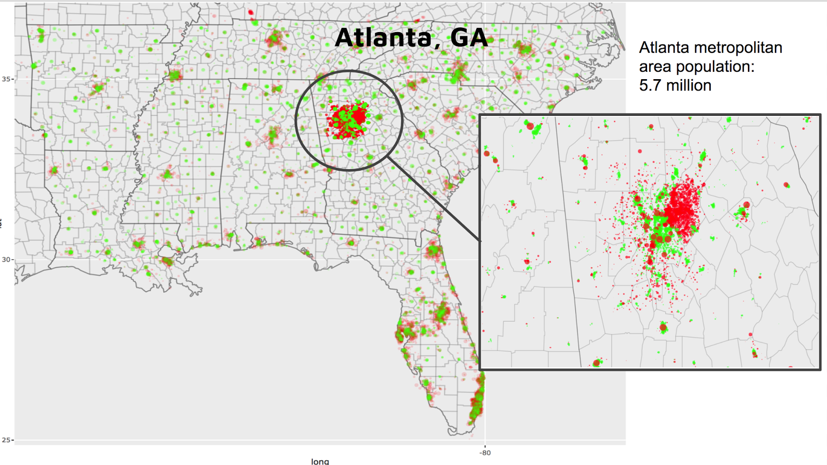
Figure 17: Circle plot detailing Average Vehicle Occupancy for the Southern Region

These measures provide an interesting insight into aTaxi relocation. Indeed, we can think of our 1x1 model as a representation of ride-sharing where vehicles are never explicitly rerouted after completing a trip. Instead, they start at a given pixel (which is a demand spot) and end at another pixel (which turns into a supply spot). Let us now look at the analysis of a 1x1, 5x5, and 10x10 pixel model for supply and demand across the southern region.

It is interesting to see how the same region looks under our different models, as illustrated below.
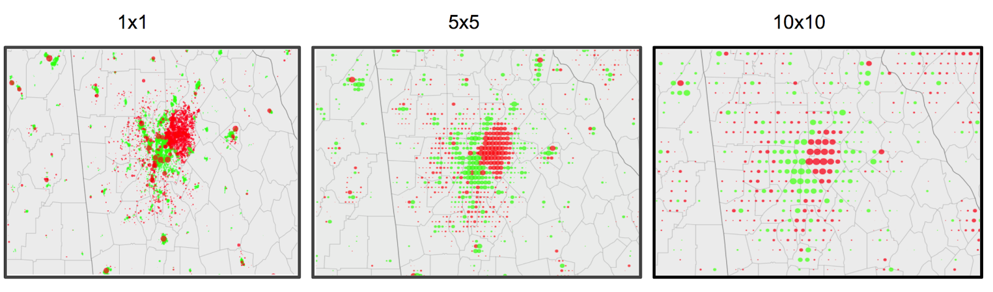
Figure 17: Supply/demand of 1x1, 5x5, and 10x10
Using bigger pixel means that relocation occurs readily within a bigger area, hence leading to decreased overall demand for physical vehicles at SoD.
1x1 Pixel
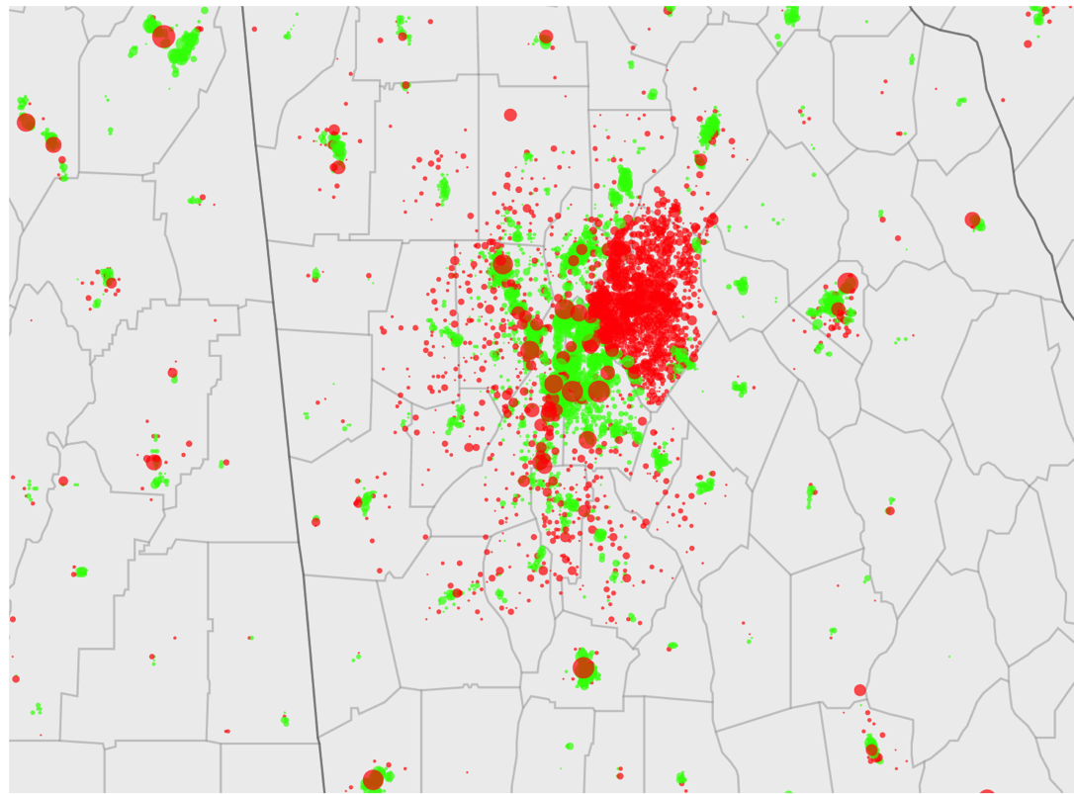
Figure 18: supply/demand of Atlanta, GA

Start of Day Demand(Red): 6,370,692, End of Day Supply(Green): 6,370,692 (or 6364257 if we consider aTaxi staying within the southern region)

5x5 Pixel
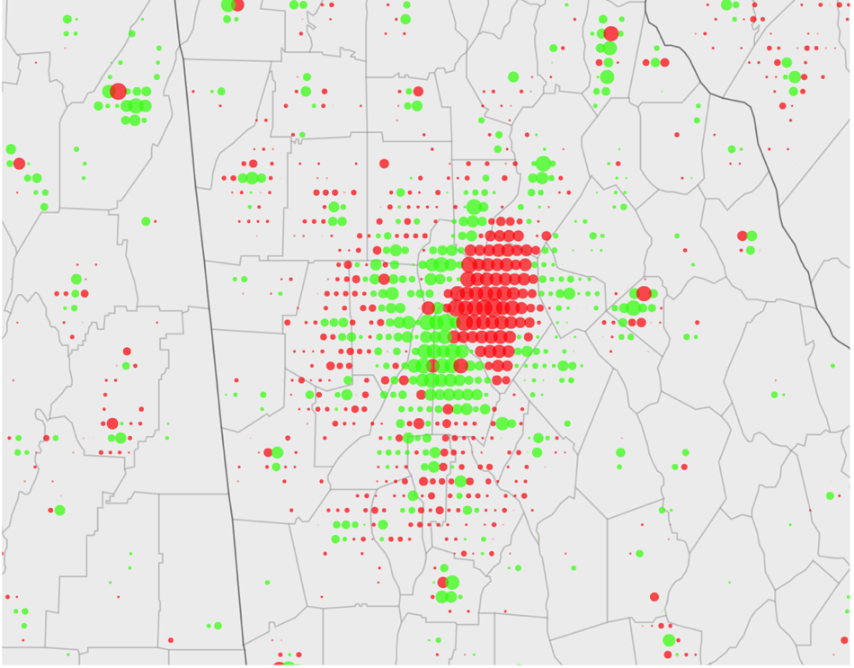
Figure 19: supply/demand of Atlanta, GA 5x5 pixel
Start of Day Demand(Red): 3,474,926, End of Day Supply(Green): 3,474,926

10x10 Pixel
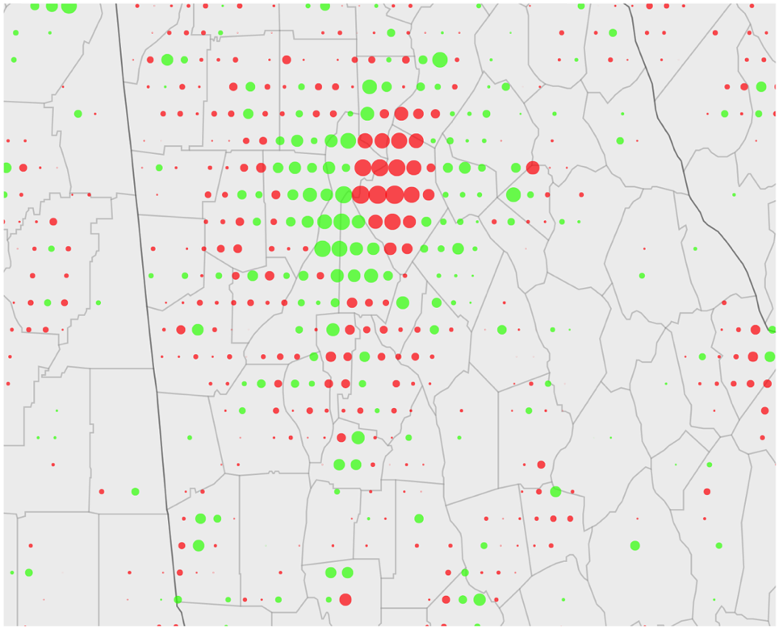
Figure 20: supply/demand of Atlanta, GA 10x10 pixel
Start of Day Demand(Red): 2,769,045, End of Day Supply(Green): 2,769,045

Surprisingly, the demand at the start of the day for the 1x1 pixel model is only 6.37 Million. This number is lower than expect, but can be explained by the fact that about a quarter of the pixels have a balanced supply and demand, with a zero-net number of taxis.
A possible explanation may be that as there are a limited number of pixels receiving taxi traffic and at the end of the day, many of the trips return to their origin. Natural repositioning of taxis may be a characteristic of more rural states, in which there are not many destinations attracting the population and most trips return home.

Cooperation with neighboring regions
While, instinctively speaking, it would make sense that partnering with neighboring regions will benefit both our region and our neighbors. However, as surprising as this may seem, the Southern region is almost a self-contained region, in terms of aTaxis. Only 6,435 aTaxis find their way outside the periphery of the region, thus implying that partnering with neighboring regions to make aTaxi relocation more efficient might not be necessary in this case.
We acknowledge, however, that it is unlikely that one single ride-sharing company will have a monopoly over the whole Southern region. In the case of smaller ride-sharing companies covering subsets of the Southern region, cooperation with neighboring regions will be key in making sure that the distance covered by aTaxis are minimized (and consequently, relocation costs kept to a minimum)
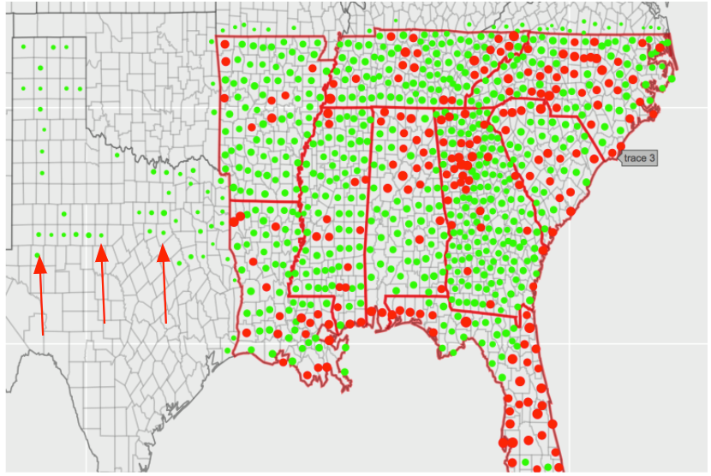

Number of Active aTaxis

With a fluctuating demand of aTaxis throughout the day, it is essential to know the minimum amount of aTaxis we might need at any point in time to be able to serve all our customers throughout the day. In order to do this analysis, we initialized a 1440x1 array and increment index for an aTaxis active time (from the time it leaves its pixel to the time it drops its last passenger off). We’ve also made sure to use the wrap around technique to cater for trips which end after midnight. Our analysis for the southern region yields the following graph:

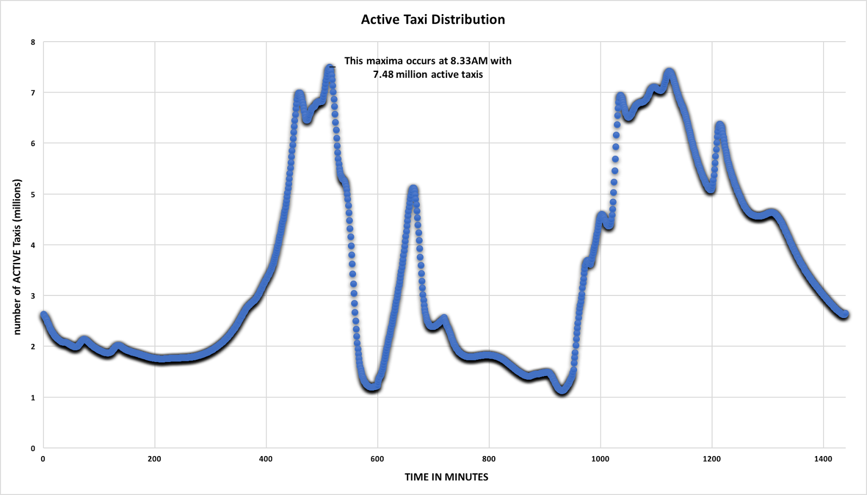

This plot, illustrating the number of active taxis throughout the day, has a peak at 8.33 AM. That peak reaches 7.48 Million taxis, which implies that, on any given day, our company needs at least 7.48 Million taxis to be able to serve all its customers throughout the day.

Assessment of Business Case for Southern Region
Operating Cost
Vehicle Expenditures
Our minimum fleet size requirement in our ride-sharing service is 7,497,428. Rounding this figure to 7.5 million and purchasing 1.15x the minimum fleet size requirement, we would need to purchase roughly 8.625 million taxis to serve the southern region.
There are ~3.4 billion passenger miles traveled per day, and ~2.4 billion vehicle miles traveled each day. On average, about 283 miles per vehicle per day (~103,000 miles per vehicle per year). We assume that if we can reposition taxis on a 10x10 pixel system, we would need to reposition about 2.5 million taxis per day. We also assume that repositioning distance is 30% of the total daily distance incurred by the repositioned taxi, the total average miles traveled per vehicle per year becomes about 134,000 miles. Each car has a life expectancy of ~150,000 miles and requirement maintenance costs of ~$1400 for every 27,000 miles (with maintenance approximately five times annually) [2, 4]. As given, we will approximate the retail cost per vehicle is around $60,000.
Since we need 8.625 million vehicles and each vehicle is $60,000, the total vehicle acquisition expense comes out to about $517 billion, which deteriorates .89 of its lifetime a year (134,000/150,000 miles), so every 1.12 years we will need to replace the fleet of cars or $460 billion each year.
Other annual expenses from maintenance comes out to be ~$60 billion per year. Therefore, the total vehicle expenses per year is ~$521 billion per year.

Operational Expenditures
Additional expenses are necessary for energy to power the vehicles and land space for parking.
Energy: Each vehicle has a mileage efficiency of approximately 3 miles per kWh energy [1]. We will assume that each vehicle needs to be recharged exactly once per day; therefore, 779,125,000kWh energy are necessary each day. Assuming that solar energy and the land for the installation can be installed for a one-time fee of $5 per Wh and then produced for 12.2 cents per kWh, a one-time fixed cost of $190 billion that we consider as a 20-year loan (which we divide over 20 years) plus an additional ~$95 million per year [7].
Parking: We will assume the cost of leasing an acre of land to be $1500/year (source gives an estimate of $300/year - $2000/year) and that each acre can offer ~242 parking spots, thus a total of ~53 million must be spent on renting land [6].

Pricing Model
Revenue
The average American’s hourly wage in the Southeast region of the United States is ~$22.30 [5]. Through our Taxi service, they would be able to regain much of their productivity previously lost to driving, and because we estimate each vehicle is modeled to travel on average, 30 miles per hour, we will charge customers $.65 per mile traveled, customers receive a net $5.80 per hour of value through our service. Since there are ~1.2 trillion miles traveled per year, our annual revenue is projected to be $798 billion.
Other potential sources of revenue include streaming advertisement during rides and combining services with package and consumer delivery industries such as Amazon prime and GrubHub.
Balance Sheet
From the above data, we estimate that our balance sheet will look as follow:
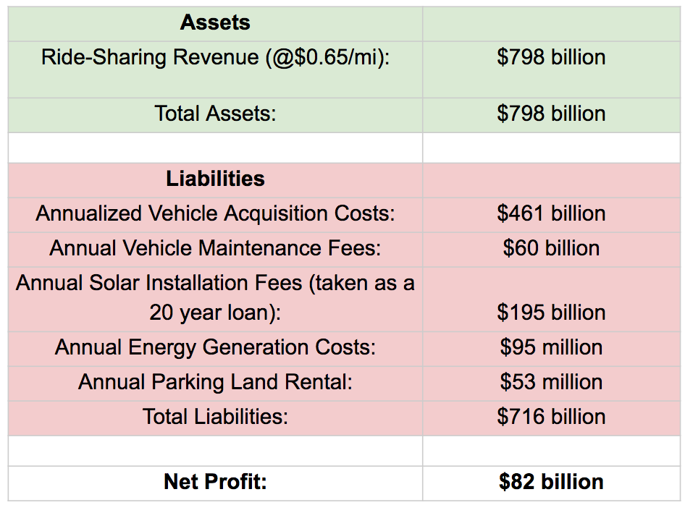
Figure 22: Balance Sheet of Business Model

Annual Total profit is expected to be $82 billion.

Recommendations for Further Analysis
Further analysis should include looking more closely at the walk trips and try to determine if there’s potential for more ride-sharing opportunities. We also noticed that some small counties have incredibly high AVOS. It would be interesting to see how these trips in those town occurs (where they go, at what frequency). It is possible that some ride-sharing opportunities have already been used there. Additionally, we used a naïve approach for calculating vehicle trip miles, using the order of arrival of passengers. We also implemented a TSP heuristic that can be used in future experiments, which would yield a better AVO. However, we believe that even the naïve implementation already gives valuable insights.
Another potential follow-up project is to complete a server integrated with Google Maps API. We wrote preliminary code to implement this, but due to time constraints, we were not able to develop it further.

Team Member Roles
Name | Role
Yowan Ramchoreeter | Front End visualization and processing in R (Part 1)
Yun Teng | Efficient Ride Sharing Potential Analysis in Golang (Part 2)
Albert Wang | Business Case (part 3)

References
[1] “Comparing Energy Costs per Mile for Electric and Gasoline-Fueled Vehicles.” Advanced Vehicle Testing Activity, Idaho National Labratory, avt.inl.gov/sites/default/files/pdf/fsev/costs.pdf.
[2] Leanse, Alex. “These Are the Most (and Least) Expensive Car Brands to Maintain.” Popular Mechanics, Popular Mechanics, 14 Nov. 2017, www.popularmechanics.com/cars/a23877/car-maintenance-costs-mileage/.
[3] Quinn, Brian. “Average Cost of Insurance: Car, Home, Renters, Health, and Pet (2017).” ValuePenguin, ValuePenguin, 29 Mar. 2017, www.valuepenguin.com/average-cost-of-insurance.
[4] Reports, Consumer. “Make Your Car Last 200,000 Miles.” Consumer Reports, 9 May 2017, www.consumerreports.org/car-repair-maintenance/make-your-car-last-200-000-miles/.
[5] “U.S. Average Hourly Earnings- Total Private Industries.” U.S. Average Hourly Earnings, St.Louis Federal Reserve Bank, 12 Jan. 2018, www.data360.org/dsg.aspx?Data_Set_Group_Id=773
[6] Holland, Rob. “Estimating the Number of Parking Spaces Per Acre.” Center for Profitable Agriculture, University of Tennessee, Institute of Agriculture, May 2014.
[7] Conversation, The. “When Will Rooftop Solar Be Cheaper Than the Grid?” U.S. News & World Report, U.S. News & World Report, www.usnews.com/news/articles/2016-03-31/when-will-rooftop-solar-be-cheaper-than-the-grid.

