The Opinion Pages

http://kristof.blogs.nytimes.com/tag/anne-marie-slaughter/

January 25, 2008, 12:41 pm

Guest Bloggers
By NICHOLAS D. KRISTOF
I’m delighted to introduce a new line-up of guest bloggers for On the Ground. Originally, I brought in guest bloggers only for the period when I was on book leave in the fall, but it worked so well that I thought I’d continue it even when I’m contributing to the blog as well. So here’s the line-up for the next six months or so:
December 24, 2007, 11:42 am

Christmas, Asian Style
By ANNE-MARIE SLAUGHTER
Anne-Marie Slaughter, an international lawyer and the dean of the Woodrow Wilson School at Princeton University. She is the author “The Idea that is America,” and she is spending this academic year in Shanghai.
To travel anywhere in Asia from mid-November on is to understand that Christmas has reverted to its Roman origins before Christianity – a festival of lights to brighten the darkest days of the year. Christmas trees, angels, Santa Clauses, reindeer, sleighs, garlands, bells and assorted other Christmas paraphernalia festoon streets, shops and hotels from Kyoto to Phnom Penh, creating a blaze of colored lights.
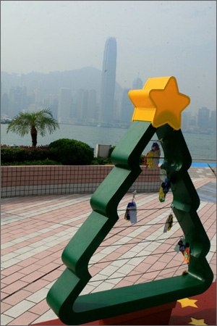Photos by Andrew Moravcsik
Across the big cities of northeast Asia, hotels and fancy stories are staffed with elfin young women garbed in red velvet with white trim selling luxury goods. As one moves closer to the equator, the “darkest days” part falls away as day and night even out, and the temperature and humidity rise upwards of 30 degrees centigrade (90 degrees F). Still, the southeast Asian countries are not to be outdone –and trees, lights, and deer pop up in strange places.
The results are often incongruous, but fun. In the end, though, like so many globalized dimensions of Asia, the apparent similarities ultimately serve to highlight difference.
The Kowloon waterfront across from the famous but now pollution-shrouded Hong Kong skyline makes the point. My husband and I look down a promenade lined with green plastic cut-out Christmas trees, each with a plastic yellow star on top and little luggage label-sized cards hanging from the wires stretched across the cut-out space.
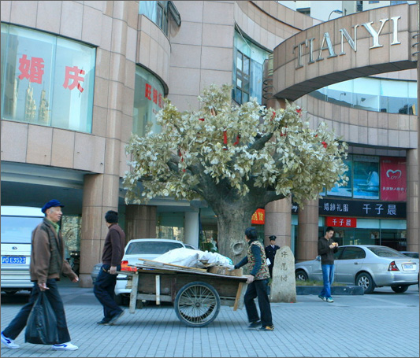
Street vendors puzzled by Christmas decorations on a concrete tree in Shanghai.
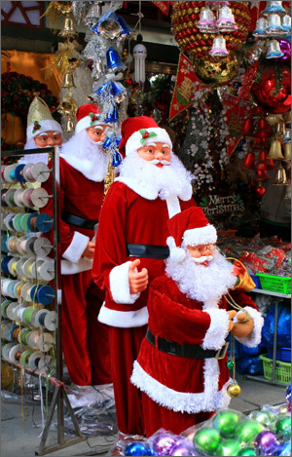 Santas in Shanghai.
“Wishing cards,” they’re called, sold by the Hong Kong tourism board – printed with Santa Claus, snowmen and gingerbread men, as well as more conventional flower motifs. On the back of the gingerbread card, it says, “gingerbread men herald the holiday season,” and has place to write your wish before tying it to the rod. A doleful version of a jazzed up “Oh come, oh come Emmanuel” is piped through loudspeakers fixed to lampposts, with small vertical banners advertising the Beijing Olympics and Hong Kong equestrian events hanging below them. Neon stars are strung on wires between the lampposts.
All this is all part of Hong Kong’s “Winterfest,” the ultimate secular version of Christmas. It makes me wonder what it is about Christmas that is so special for so many of us back home in the United States, even for families who do not attend any services or acknowledge the religious significance of the holiday in any way. It is certainly not the relative commercialization of the holiday in Asia; on the contrary, Christmas decorations go up in the malls across the United States earlier and earlier each year, now well before Thanksgiving, and the hype of the “must have toys” each holiday season, driving parents to distraction (or, in my case, to e-Bay) is unrelenting.
Yet there is a difference. I suggest that it is the strong communal power of the holiday and precisely the individualization of each family’s traditions — from special foods to decorations to when presents are to be opened (Christmas Eve vs. Christmas morning) and with what attendant rituals – that gives Christmas its particular meaning. For some the holiday does not mean Christmas at all, but Hanukkah or Kwanzaa, with greater or lesser melding of Christmas-like elements.
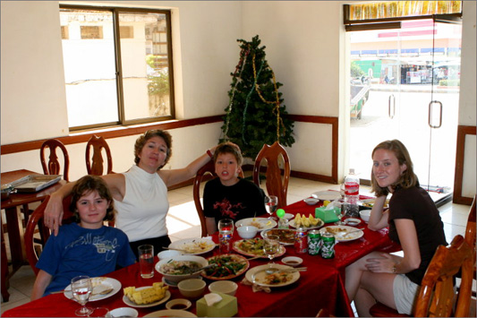
Restaurant Xmas Tree, Kompong Thom Province, Cambodia

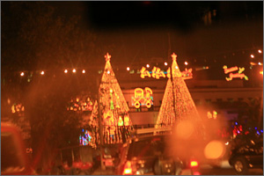
The American embassy in Phnom Penh, Cambodia.
Thanksgiving is the most prescribed holiday, with creativity reserved for some special side dishes or desserts, but Christmas (and its non-Christian equivalents) is there to be shaped by each family, or more precisely, by each generation of parents and children within each family, and by each community – with carol sings, tree lightings and charity drives. It is this individualization that ultimately resists and triumphs over the mass generic commercial forces bombarding us from all sides.
Here in Asia, as the flood of comments that followed my post on mooncakes back in October attests, families have many similar opportunities to make national holidays their own. But Christmas does not have any of those roots; it is purely imported as a globalized product. It works well here as a festival of lights and often offers great entertainment through the wide variety of decorations. But in the end, at least for this Westerner, it serves mostly to underline what we are missing back home.

November 29, 2007, 10:58 am

Shanghai’s Skate Showdown
By ANNE-MARIE SLAUGHTER
Anne-Marie Slaughter, an international lawyer and the dean of the Woodrow Wilson School at Princeton University. She is the author “The Idea that is America,” and she is spending this academic year in Shanghai.
Correction Appended
The world’s largest skatepark (as in skateboarding and in-line skating) is in Shanghai, or more precisely in New Jiangwan City, a planned community that includes an enormous park (think Central Park-size) as part of the city’s emerging “greenbelt.” To celebrate my son Edward’s 11th birthday, we spent Saturday October 27th at the 3rd annual Shanghai Showdown, a competition for the best “professional skaters, inline and BMXers from around the world.” For those of you who may not be regulars on this circuit, as none of us are, “BMXers” refers to trick bicycles, on which riders do amazing stunts in the half-pipe.
We had to drive almost an hour in a taxi even to get to the park – all still well within Shanghai city limits. As we headed into the skatepark itself, I briefly thought I was back on the corner of 4th Street and 6th Avenue in Manhattan: First the scalpers, then a row of hoops with pick-up basketball games, fast and furious, among kids wearing American-style basketball clothes and shoes – one with cornrows, a diamond stud in one ear, and a headband.
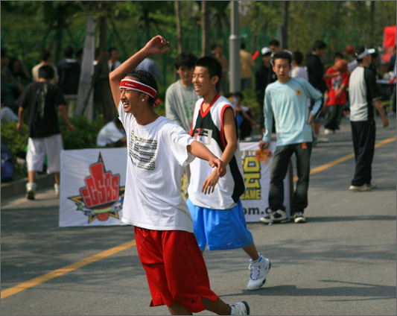
Photos by Andrew Moravcsik
The size, talent level, and intimidation was nowhere close to 4th Street (let alone Yao Ming), but the enthusiasm was infectious and there were plenty of additional wannabe’s watching.
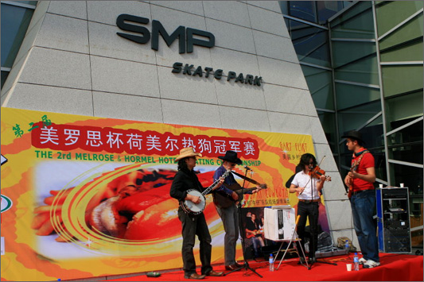
We turned the corner and walked past a country-western band, a hot-dog eating contest and a rock climbing wall where kids could climb for 20 kwai (about $3)–the reward being a Snickers bar.
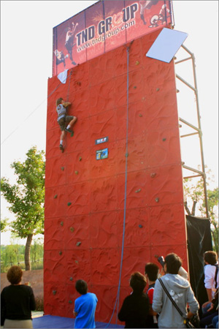
Immediately to our left was the half-pipe, which featured a mix of Western and Asian boarders and in-line skaters warming up. They were pretty much indistinguishable in their baggy shorts, t-shirts, helmets and pads. From our vantage point, at the top of the half-pipe, the idea of going straight down what appears to be an essentially vertical surface from the top on a skateboard was completely terrifying, but the kids were essentially imitating Sean White on various kinds of wheels.
We made our way over to the “street competition,” one of the three big events, which took place in a shallow bowl with various ramps, slopes and platforms in it. The announcer, speaking in American-accented English, explained how skateboarding became a real sport, not just a street sport, and talked about the various riders we were going to see competing (rider being the term for what I would have called a skateboarder). As soon as he finished, another announcer repeated what he said in American-accented Mandarin; the second announcer then took over switching effortlessly between Mandarin and English, much as Club Med employees switch between English and French. The soundtrack blared a mixture of rock and rap; the audience jamming the edges of the bowl was overwhelmingly Chinese teenagers, some with resigned parents in tow, munching a mixture of Chinese and Western food and taking pictures of individual riders on their cell phones. The logos around the bowl were a mixture of Chinese and Western, including several for SMP, the clothing company that built the Skatepark, with the tagline “Sex, Money, Power.”
The competition began, with each rider introduced in turn. The some 15 contestants came from Brazil, Southern California, Chile by way of Miami, Canada and elsewhere in the United States. There was, I think, one European. The champion from the 2006 Shanghai Showdown was an American, Dayne Brummet. Three “jam sessions” began the competition, with the announcer urging the riders to “dig deep in their bag of tricks.” All the riders tried multiple tricks in multiple places all at the same time, with the crowd cheering for specific riders to the accompaniment of AC/DC and the announcer urging us to “give it up” in both English and Mandarin. The event also moved seamlessly between real and reel; video-camera operators were posted at various places amid the riders and closed in to focus on specific tricks for the video of the event. I had an image of a set of YouTube videos up within the hour.
The skaters did as well – deliberately mugging for the camera.
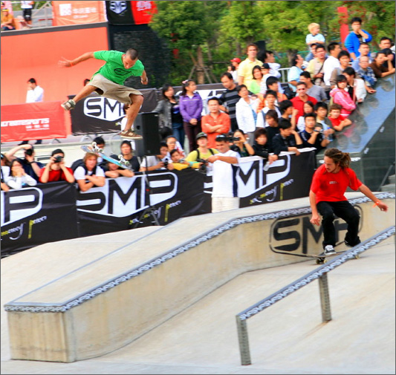
(In the photo above don’t miss the fellow in green way up in the air. You’ll see his skateboard inverted about 2-3 feet below him. He landed on the board, right-side up, and eventually won the competition.) And when a rider named Tyler Henley reached his arm out in a back-handed salute to the crowd, they all returned the gesture and cheered.
The next event was in-line skating on the half pipe, with skaters soaring impossibly high above the pipe and doing various complicated twists and flips before landing on their skates and zooming down the pipe and up the other side. They wore knee and elbow pads and helmets. When a trick failed they landed on the side of the pipe on their knees and slid down to the bottom. The top three performers were all Japanese – two brothers, who at the end performed a mesmerizing synchronized act in which they shadowed each other’s every jump and twist, and the only woman competitor, with a long pony tail and absolute determination to get one particularly complicated triple twist done, which she finally stuck after multiple tries.
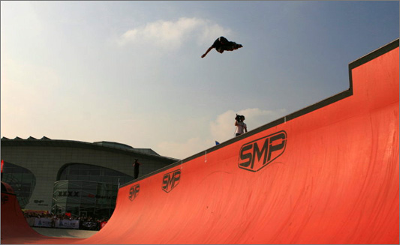
In this photo, the Japanese winner doing a twisting areal somersault. Other competitors were American, Chinese and Israeli. After watching the event, my son turned to me and said “Mom, I do this stuff in computer games.” Reality and virtual reality meet again.
For most people, the day was scheduled to end with an outdoor concert–but we took the kids home to bed instead. The take-away from the day, aside from some great entertainment, is that American “soft power” is alive and well among at least a large segment of Chinese youth. (One point for Joseph Nye!) The hybrid, creative, spontaneous nature of both the competitors and the many amateur Chinese riders; the music, food, clothing, and language – all combined in a “mondo culture” (for what SMP calls the Mondo Bowl) that was American at its core but radiating outward and changing and growing in the process.
Our observations that afternoon have been corroborated in various conversations with students around Shanghai, several of whom have explained to me that their generation watches American movies and television and then goes on the Internet to discuss them. One student told me that she and her friends thought that Americans had better relationships with their children – that they focused less on achievement and more on doing the right thing. And often when Andy and I are walking through the park young Chinese come up and engage us in English, asking where we are from. When we say New York (it’s just simpler than New Jersey), we invariably get a positive response. This culture also seemed to render irrelevant the traditional coolness of the Chinese vis-a-vis Japan.
These are only snippets, of course. But I keep hearing that American skateboard announcer blend Mandarin and English effortlessly for a Chinese audience watching extreme sports competitors from many different countries and thinking about those kids playing basketball. It’s a very different view of Chinese-American (and inter-Asian) relations.
Correction
Due to an editing error, Dayne Brummet, an American skater, was incorrectly called Dave Grommet.

November 3, 2007, 2:56 am

Chinese Recycling
By ANNE-MARIE SLAUGHTER

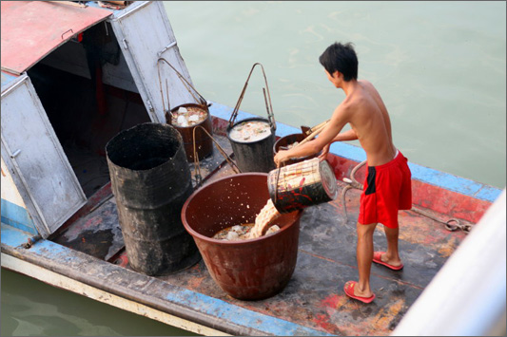
Photos by Andrew Moravcsik

Anne-Marie Slaughter, an international lawyer and the dean of the Woodrow Wilson School at Princeton University. She is the author “The Idea that is America,” and she is spending this academic year in Shanghai.
On the blog we have been keeping for friends and family about life in China, many stories are about food: live frogs and fish on the boat, pig snout and pig tail on the menu, butchered carcasses on the street. Why do we find it all so remarkable? The answer comes readily: Americans rarely see their food except in antiseptic packages. Among the books I brought to China is Michael Pollan’s “The Omnivore’s Dilemma,” which tells the story of our antiseptic American food in precise and distressing detail. It comes processed and packaged – packaging that also accounts for so much of our mountains of waste.
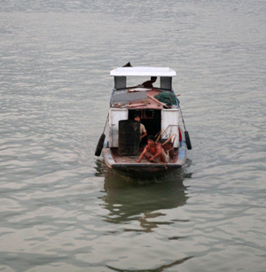
On our Yangtze river boat, by contrast, every scrap was dumped into garbage cans at the back of the boat — one for bread and noodles, one for vegetables, one for meat. In the morning a small sampan came across the river with a nicely dressed woman and two shirtless guys in shorts: one the carrier, the other the boat handler.
After some negotiation the woman, lime green purse slung across her neat white shirt and capri pants, scooped the slops into smaller buckets, which are then carried on a bamboo pole down to waiting buckets on the boat to be taken back and fed to pigs, chickens, and other animals. A far better system of recycling than even the most diligent American environmentalists can devise, and made possible because the food is fresh in the first place — grown locally, sold in the markets live (in the case of animals) or freshly stacked (the vegetables), chopped and quick-fried, and then eaten by humans or animals, with waste going back into the soil.
Even the small tour boats that took us for 2-3 hour trips into the side canyons off the river loaded an entire counter full of vegetables to prepare and serve. This system also made me feel far less guilty about leaving so much food on the table at every meal. The four of us typically ordered 4 dishes for variety, but that meant a lot left over.
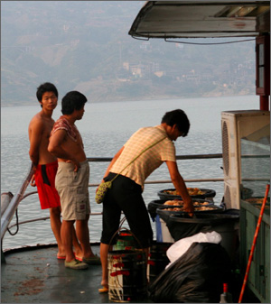
None of this is news to the Slow Food movement, or to environmentalist Bill McKibben, who has tried living for a year only on food grown within his New England watershed. In the United States organic farms, farmers’ markets and vegetable co-ops are springing up all over the place. Yet the limiting factor for most of us is time. When we go to Italy in the summer we tell our friends that our day basically revolves around food. At 11:00 every morning we decide what we are going to have for lunch, then shop for it, going to the butcher in our village, the cheese maker at the local market, the wonderful vegetable seller Sergio in the little town 15 minutes away. We come home around 1:00, cook, eat around 2:00 and then sit around the table talking and drinking until siesta.
This schedule is wonderful for vacation, but when fellow academics went to Italy during the year planning to get serious research and writing done, they found that daily food shopping and preparation robbed them of much of the day. Here in China, where the tradition is to make a meal of soup, one meat dish, one fish dish and several fresh vegetables every night, our ayi spends hours washing, chopping and slicing the mounds of food she shops for in the morning.
As many yuppie cooks know, and as our celebrity chef culture documents in countless books and articles, cooking that way can be relaxing as a avocation or rewarding as a profession, but it is hard, hot work, demanding long hours, meticulous attention to detail and the right tools.
In America we have tried to solve the time problem by providing fresh salad bars and steam tables, where we purchase pre-chopped fresh vegetables and prepared food. But this is of questionable culinary and sanitary quality, and creates a mountain of plastic tubs and utensils, as well as leftover food to be thrown away.
Some say now the answer must be once again to create micro-economies, like micro-climates, within our massive regional, national and global economies, taking people back a step from the industrial revolution as well as forward a step. So while some in a community can telecommute and work wirelessly with friends around the globe, others can return to the fields, markets and kitchens of an earlier time, taking pride in their work and their product. Calculating and charging the carbon cost of our food will bolster this movement, making locally grown food much cheaper.
The problem, of course, is that the food available to most Americans under a local supplier system would be a far cry from the astonishing array of fresh vegetables, fish and meat that was on offer daily on our river boat. Are many of us prepared to survive on turnips and kale during the winter?
Given the lousy quality of so much of our supermarket produce (even in New Jersey, the Garden State, it’s impossible to find a decent tomato even in August outside a farmers’ market), the answer for some might be yes. But in America, the land of seemingly infinite choice, it’s hard to imagine going back to diets circumscribed by local climates. And even in China, with galloping urbanization, river boat eating and recycling is giving way for many to supermarket living.

