The Wall Street Journal

[PAGE ONE](http://online.wsj.com/public/search?article-doc-type=%7BA-hed%7D&HEADER_TEXT=a-hed)

AUGUST 24, 2010

**Political Party for Mild-Mannered Is Off to a Slow Start**

**Whigs Try to Tap the Angry Middle; Just 59 Points Back in the Polls**

**By** [**MICHAEL M. PHILLIPS**](http://online.wsj.com/search/term.html?KEYWORDS=MICHAEL+M.+PHILLIPS&bylinesearch=true)

This year, an anti-Washington mood is opening doors to novice candidates from right and left who speak to the ire coursing through the electorate. The Modern Whigs, a start-up party with a venerable name, are trying to tap an even more elusive force: the angry moderate.

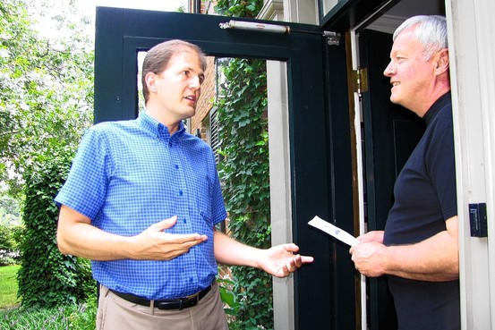

Modern Whig Party

Jeff Vanke, left, in Virginia, is the party's only congressional candidate.

Sparking a grass-roots uprising in the center has been a frustrating task. "A moderate person tends not to be the kind of person who gets out there and marches at a rally," says party Vice Chairman Andrew Evans, a 30-year-old college student from Greenville, N.C. "They see people further to the right and further to the left making a huge ruckus. They think they don't want to be like that."

The Modern Whig Party was the brainchild of soldiers tired of the bickering that filled chow-hall TV screens on bases in Iraq and Afghanistan. One of them, Capt. Mike Lebowitz, a Washington lawyer then serving with the 101st Airborne Division, emailed his buddies and began talking up the idea of a party that would be fiscally conservative, socially liberal and generally mild-mannered. They picked the Whig name because of its ties to the Founding Fathers, William Henry Harrison and the early career of Abraham Lincoln.

"Our whole goal when we started this was not to come across as weird or fringe," says the 32-year-old Mr. Lebowitz.

In 2008, the party predicted that 2009 would see a handful of candidates for local and state offices and that 2010 would bring its first congressional bids. Reality has been harsher. "We…are not delusional in believing that people will flock to our party," the California Modern Whigs admit on their website.

Nationwide, Whigs point to just two members in political office, both in unpaid, local positions. Alan Reynolds, a 25-year-old engineering consultant who stumbled onto the Whigs by Googling "Political Parties," holds an appointed post on the Parks and Recreation Commission in South Pasadena, Calif.

Ken Belcher, a retired waste-water-treatment-plant manager, won election as constable of Beat 14 in Lee County, Ala. He appeared on the ballot as a Democrat because the Whigs weren't eligible. Mr. Belcher thought the office would give him a platform, but he has found the constabulary a very low podium. "I'll be honest: Constable is an obsolete, pointless office in all but the poorest areas of Alabama," says Mr. Belcher, 56 years old.

Last fall, the Modern Whigs had an unpleasant split with the Florida Whig Party over centrist purity. The Florida Whigs, who predate the Modern Whigs by a couple years, think the "Moderns" are closet Democrats. "Simultaneously confusing and hypocritical, isn't it?" the Florida Whig site says of Modern Whiggery. The Modern Whigs suspect the Florida Whigs are Republicans in Whig clothing.

The party says 30,000 people have clicked to express their interest online. In California, Mr. Reynolds says the party would need 90,000 registered voters, or 900,000 signatures, to appear on ballots as a qualified political party. The state party currently has about 100 registered voters and 15 or 20 active members.

"We realize the cards are greatly stacked against us," says Mr. Evans.

The party's electoral aspirations have been delayed by a philosophical coup led by Andrew Scholtens, a 25-year-old credit-bureau marketing executive from Marietta, Ga. As a college Republican at the Georgia Institute of Technology, Mr. Scholtens held Affirmative Action Bake Sales, which mocked racial-redress policies by charging customers different amounts for baked goods depending on what they were wearing.

By his junior year, Mr. Scholtens had become disenchanted with the partisan vitriol. He stumbled across the Modern Whig Party on the Internet and decided it would be a great platform to try out his own political philosophy, which he called Value-Added Methodology Politics. Boiled down, the idea is that ideology of any stripe makes good government impossible. Instead, he says the country needs statesmen who use approved, rational methods to find the correct responses to the problems of the day.

Mr. Scholtens made his pitch at the Modern Whigs' national convention in suburban Washington in December, arguing that even centrism is too ideological. "Socially liberal, fiscally conservative—that was a gimmick," Mr. Scholtens says disdainfully of the party's original platform.

Whig elders went for it and decided to forgo immediate electoral gains in favor of a slow evolution into a methodology-based party. They started creating an online Whig Academy designed to forge a generation of statesmen problem-solvers.

Party founder Mr. Lebowitz endorsed the idea but fears the Whig party might slip back into obscurity if it doesn't take stands on issues. After all, the original Whig Party disappeared from the political scene partly because of its failure to take a firm stance on the expansion of slavery into new U.S. territories in the 19th century. Adopting methodology politics "must be done gradually or else risk becoming just another theoretical idea that holds little practical basis in reality," warns Mr. Lebowitz, who has stepped down from the party leadership.

The Modern Whigs got a boost in June when they absorbed the American Centrist Party, founded in 2004 as a reaction to the government's alleged swing toward "an ultra right-wing Christian fundamentalist autocracy," according to its website. The American Centrists come with a 16,000-address email list, although they have never elected a candidate to federal office, either.

Another bit of good news for the Whigs: A few weeks ago, Jeff Vanke, a former college history teacher running for Congress in Roanoke, Va., joined the party. Mr. Vanke had previously shunned the Modern Whigs because of their links to the Florida Whigs, instead starting his own one-man Center Party. The recent Modern-Florida schism persuaded Mr. Vanke to join the Modern Whigs—their only congressional candidate this year.

The bad news: Mr. Vanke has raised just $3,000 and is 59 points behind incumbent Rep. Bob Goodlatte, a nine-term Republican, in a WDBJ-TV poll conducted last month.

Copyright 2009 Dow Jones & Company, Inc. All Rights Reserved