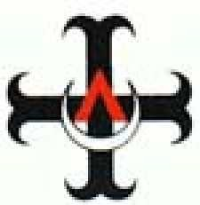

The Aquinas Institute
at Princeton University

Roman Catholic
Campus Ministry

65 Stockton Street, Princeton, NJ 08540
(609) 924-1820 Aquinas@Princeton.edu

http://www.princeton.edu/~aquinas

Welcome to Aquinas

Inside you’ll find a brief synopsis of some of the activities that the Aquinas Institute sponsors. For a schedule of this year’s regular activities, please see the enclosed yellow bookmark.

If you are interested in more details related to the day/time of specific small group Catholic Principles and Bible Studies offered or other activities mentioned in this brochure, please feel free to contact Aquinas@Princeton.edu.

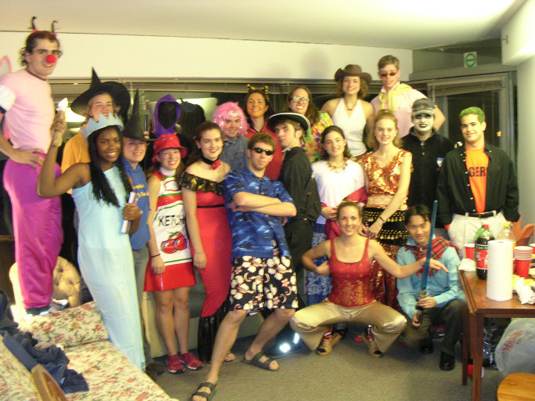
Aquinas provides many opportunities and resources to help students grow closer to Christ individually and as a community. Don’t feel obliged to do too much (no one does or can do all the activities listed in this brochure), but do feel welcomed and encouraged to be a part of some of the activities at any time throughout the year, regardless of your previous background and knowledge of Catholicism. We invite you to join us in our faith journey and look forward to getting to know you this year!

Halloween Party
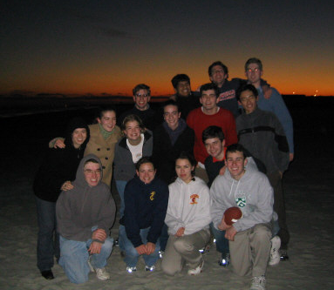
Football and Sunset on the Fall Beach Retreat

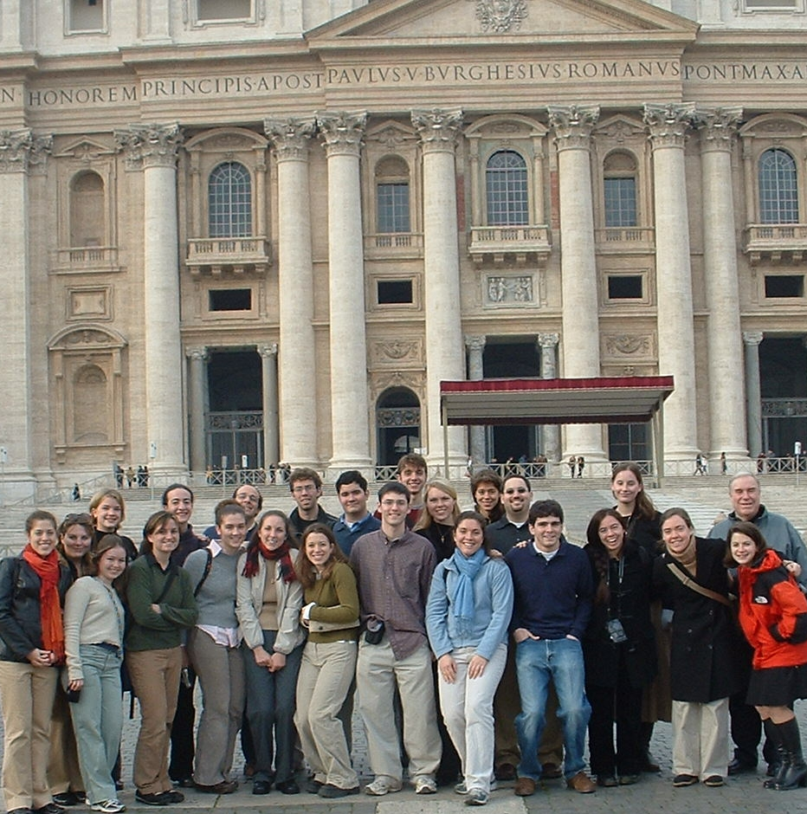

In Front of Saint Peter’s Basilica in Rome

Liturgy, Sacraments, and Prayer
Aquinas offers a variety of opportunities for prayer and worship, including several Sunday Masses and daily Mass at noon in the University Chapel. Throughout the year we pray Vespers (evening prayer) with the Lutherans and Episcopalians on Tuesdays; a communal Rosary is prayed once a week. During Lent, Morning Prayer is prayed daily in the University chapel. Within the University Chapel, there is a small Blessed Sacrament Chapel which is reserved for Aquinas. Jesus is present in a special way in the Eucharist and this is a great place to go for personal prayer. In addition to Advent and Lent communal Penance services, the priests of Aquinas are available to hear confessions before or after any Mass or whenever is most convenient for you. Just ask.

Catholic Principles / Bible Studies
Each year there are two small group Catholic Principles Studies offered for freshmen. These groups are led by upper-class undergraduates and are intended to build a solid foundation of the Catholic faith. In addition, there are two groups of sophomores that read through an entire Gospel and Epistle during the course of the year. There are also two groups for upper-class students: one group builds on that which was started in the freshman and sophomore studies, while the other is designed to introduce students to Catholic principles. This year there will also be small groups specifically for graduate students. Every Tuesday, after our Tuesday Night Dinner, there is an opportunity to study the Scriptures that will be read at the upcoming Sunday Mass. This is a great way to become more familiar with Scripture and to prepare for Sunday’s Mass.
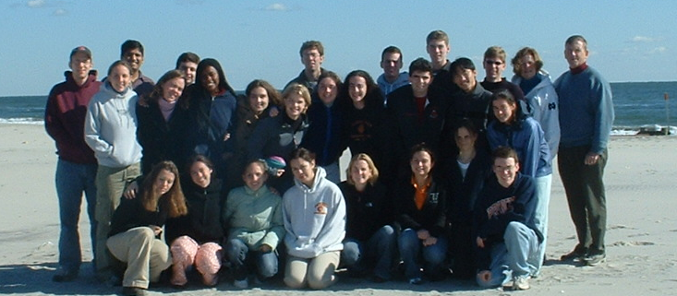
RCIA (Rite of Christian Initiation of Adults)
Intended for non-Catholics, but useful for Catholics who desire a brush-up on their understanding of the faith, the RCIA program is a low-key weekly informational session in which people learn about the Faith. At the end of the year, those who desire to become Catholic are brought into the Church during the Easter Vigil. This is also intended for baptized Catholics who seek to receive their first communion or be confirmed.

Community Service
Aquinas provides several opportunities to engage in loving service to our brothers and sisters. With weekly service trips to Philadelphia and Trenton, we attempt to put our faith into action as we serve our neighbors. As Christ identifies himself particularly with the poor and down-trodden, this is a great way to encounter Christ in other people.

Retreats
In addition to a half-day freshmen retreat at the Aquinas House, we organize two Beach Retreats each year (either to the Jersey Shore or the Chesapeake Bay). For many students, these weekend trips are the highlights of their semesters. They provide the perfect release from campus life and refresh us for when we return.

Pilgrimages
During the winter recess, Aquinas sponsors a 10-day trip to a place of Catholic interest. Last year we traveled to Spain, and the year before to Rome and Assisi. This year there are plans to travel to Catholic sites in Europe – either Jerusalem, Poland, or London.

Speakers and Seminars
Throughout the course of the year, guest speakers are invited to talk on issues relevant to Catholicism and the world. In addition, small seminars focused on relevant Catholic topics are offered periodically.

Fellowship
On Thursday nights, graduate students gather at the Aquinas House following the communal meal for the graduate student fellowship meeting. On Friday Night, undergraduates gather together in a casual setting to enjoy good conversation, good food, and good fun.

Music Ministry
A Gregorian Chant choir provides musical accompaniment for sung prayer during the Sunday 4:30 Mass and the Tuesday night Vespers.

Dinners
Concerned about both the spiritual and physical needs of its students, the Aquinas Institute sponsors two free dinners each week. On Tuesday night, we gather before the Bible study/RCIA program for a meal in Murray Dodge. On Thursday night a meal at Aquinas House is prepared for the Aquinas community.
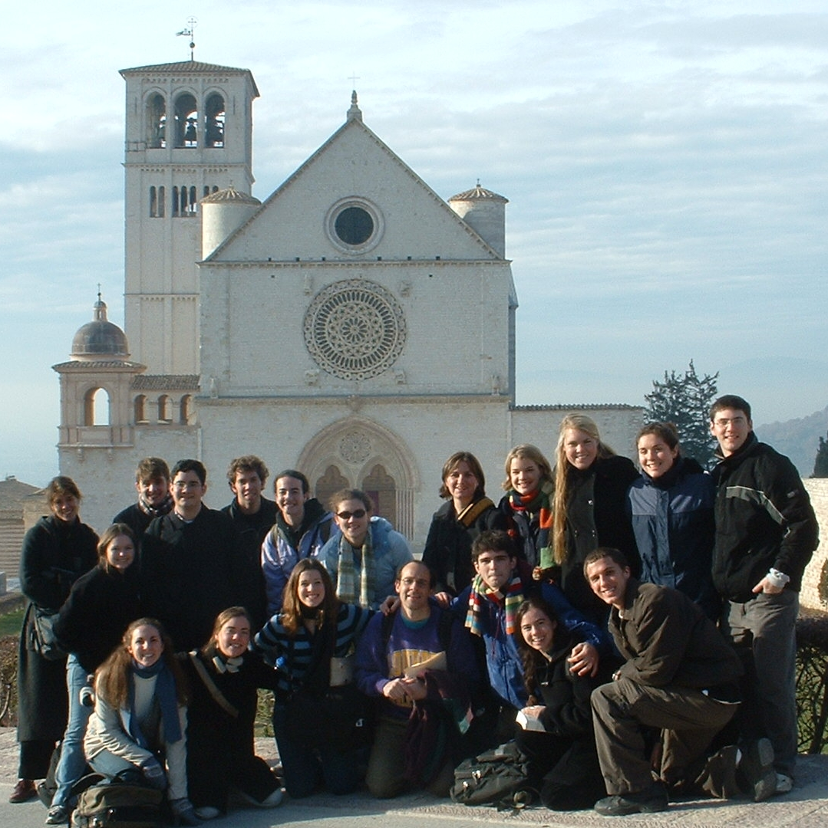

In Front of the Basilica of St. Francis in Assisi
Fall Beach Retreat at the Jersey Shore

