Chapter Six
AIRPLANE: WILBUR AND ORVILLE WRIGHT

The age of powered air travel began when the Wright brothers flew an experimental airplane for twelve seconds on the sand dunes of Kitty Hawk, North Carolina, in 1903. Today millions of Americans fly every day. In 1939 passenger air travel was still a luxury. But the airplane of the Wright Brothers, the first powered heavier-than-air craft to fly a pilot in sustained level flight, was the crucial breakthrough that made later aircraft possible. Unlike earlier would-be aviators who thought the problem of flight was how to get off the ground, the Wrights studied how to stay in the air, using gliders. Their focus on how to stay aloft led them to see that an airplane needed manueverability as well as power. The Wrights made accurate measurements of how various parts of an airplane would perform. After testing several aircraft designs as gliders, they assembled an airplane and successfully flew it on December 17, 1903.

Early Attempts to Fly

Before the modern era, people imagined flying like birds. Leonardo DaVinci envisioned human flight by means of artificial wings flapped by arms and legs, but attempts to fly in this way failed. In 1783, the Montgolfier brothers in France flew a hot-air balloon, and in the same year Professor J.A.C. Charles of France flew a hydrogen-filled balloon. But lighter-than-air craft provided little experience of use to heavier-than-air flight, and interest in the latter came only with the new spirit of engineering inquiry that marked the industrial revolution in the nineteenth century.¹

Modern aviation began in 1799, when an English landowner, Sir George Cayley (1773-1857), sketched the basic design that airplanes have followed ever since: a fixed lateral wing across a longitudinal body, with a cross-wing tail and a vertical rudder. Cayley understood that an airplane needs to develop enough forward force, or thrust, to overcome the resistance of the air, or drag. He also realized that to fly required achieving lift, an upward force that overcomes the downward weight of the plane. Lift results when the air pressure above the wings is lower than below them.

Lift can be achieved when an airplane moves forward at a positive angle of attack (Fig. 6-1). Propelled forward, the angled wing cuts through the air and creates more pressure under the wing than above it. This pressure difference can be increased by the use of cambered wings, in which the upper wing surface has greater curvature than the lower surface. The air flowing over the wings moves faster than the air flowing below them, reducing the pressure above the wings. Cayley studied model wing surfaces with a rotating arm and counterbalancing weight, and he made lift measurements at positive angles of attack. He also made the discovery that a cambered wing increased lift. A glider he designed flew a short distance in the 1840s.²

After Cayley, experimenters treated the problem of flight as one of simply placing an engine on wings and trying to power themselves into the air. But airplanes with steam
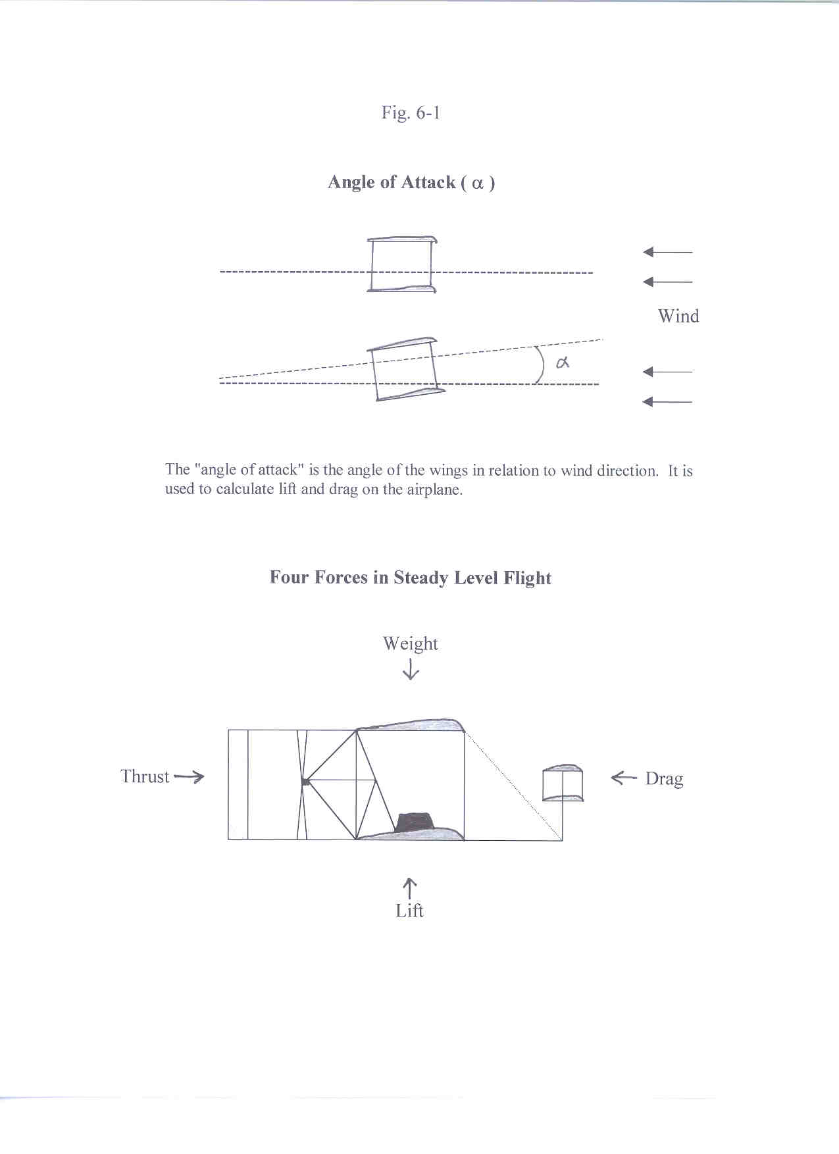
engines and propellers could not produce enough power to overcome their weight at sizes large enough to carry a pilot. Theoretical work useful to later aerodynamics advanced as researchers acquired a more exact understanding of flows over surfaces, and practical research advanced when Francis Wenham (1824-1908) invented the wind tunnel in 1870. But neither theory nor laboratory studies led to the development of practical powered airplanes.³

A German engineer, Otto Lilienthal (1848-1896), approached the problem of flight in a new way. Instead of trying to get an airplane off the ground, Lilienthal looked first at what actual flying was like. He designed and flew hang gliders to imitate the way birds used their wings to glide. Successful flight in his view depended on learning how to stay in the air, not just get off the ground. Lilienthal learned from hang gliding that to stay in flight required adjusting the wings to changing air currents. Lilienthal did this by shifting his weight. Unfortunately, this method of control limited the size of the aircraft and was difficult to perform in turbulent winds. In 1896 Lilienthal died when one of his hang gliders stalled in the air and fell.⁴

The leading aviation researcher after Lilienthal was Samuel P. Langley (1834-1906), an American astrophysicist who became secretary of the Smithsonian Institution in Washington in 1887. Langley studied carefully the lifting abilities of various wing shapes, and he tested small models that he called "aerodromes" to experiment with different body and wing configurations. On May 6, 1896, he launched a model airplane powered by a steam engine, using a catapault on a houseboat in the Potomac River. The unpiloted plane, with a wingspan of fourteen feet, continued to fly on its own power for ninety seconds a distance of half a mile, unprecedented for a model aircraft. Another model aerodrome flew almost a mile on November 28, 1896.

Langley believed that the next step was to build a larger version of his model airplane and fly it with a pilot. He declined to pursue the project, believing that it was enough to have proved the concept with a model. In 1898, however, the Spanish-American War broke out and the U.S. War Department gave Langley $50,000 to develop a piloted airplane that the Army could employ. He continued his research after the war ended later that year. In place of steam power, he substituted a lighter and more powerful gasoline engine built by his assistant, Charles Manly. Langley launched a larger model plane in 1901. A full-scale piloted airplane would be next. Any Americans determined to be the first to fly would have to beat Langley.⁵

Enter The Wright Brothers

Wilbur (1867-1912) and Orville (1871-1948) Wright of Dayton, Ohio, completed high school but did not formally graduate. They educated themselves to a higher level on their own with the help of a home library collected by their father, a bishop in the United Brethren Church, and their mother, who had attended college. The Wrights also learned how to work with their hands from their mother. After failing to start a printing business, the Wrights opened a bicycle shop in Dayton in 1892 that was a success. They began making their own line of bicycles a few years later. The Wrights' combination of manual skill and intellectual curiosity eventually drew them to the challenge of powered flight.⁶

On May 30, 1899, Wilbur Wright wrote to the Smithsonian Institution for information on aviation. An assistant to Langley replied with several pamphlets and a list of suggested readings. These included Progress in Flying Machines, an 1894 book by Octave Chanute (1832-1910), a civil engineer who had become a clearinghouse of information on aviation in the United States. Chanute would later give the Wrights advice and encouragement.⁷ With the help of Chanute's book and the other material, Wilbur and Orville quickly brought themselves up to date on the work of earlier researchers. They decided that, despite his accident, Otto Lilienthal had been correct to try to learn how to stay in the air before attempting powered flight to get off the ground. But the Wrights realized that the key to staying in the air was to have better control over the aircraft so that it could adjust to changes in the wind.

To stay in level flight, a pilot needs to control the rotational motion of an airplane around three axes (Fig. 6-2). The first, defined by a line parallel to the wingspan, is called the pitch axis. If the airplane rotates around it, it will nose up or down. The second runs lengthwise through the fuselage and is known as the roll axis. If a side wind pushes one wing up, causing the other to go down, the airplane will roll or rotate around this line. If a plane in level flight turns to the right or left, like a car turning on a road, it is said to yaw or turn on its vertical axis.⁸

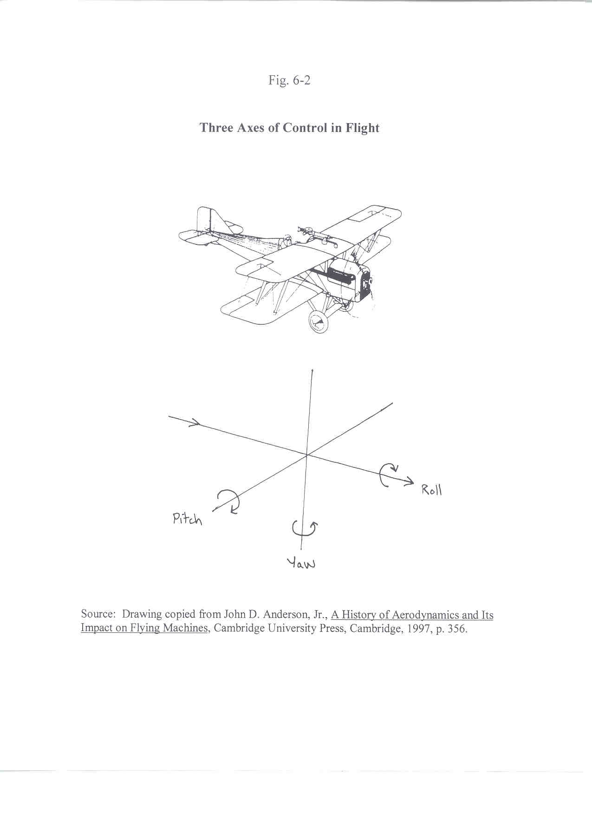
Aviation researchers before the Wright brothers had recognized the need for stability in flight. Using a model airplane with a rubber-band propeller, Alphonse Pénaud (1850-1880) of France found that a tail wing with a slight negative angle would help stabilize the plane in the direction of its flight.⁹ He also made the wing tips slightly higher than the places where they attached to the main body, giving some stability in roll. But the wings were fixed in position and could not therefore be controlled flexibly.

The Wright brothers saw the problem of stability with their cycling experience in mind. A bicycle is stabilized by the rider, who learns how to balance while steering and pedaling forward. The Wrights did not see weight shifting as a practical way to steer an airplane, but they saw a need for the pilot to control the plane in all directions, especially in roll. They invented a way in which a pilot could pull or "warp" the back edge of each wing up or down with wire controls. With these controls, they believed, a pilot could recover from sudden gusts and steer the plane.¹⁰

During the fall of 1899, the Wrights flew a five-foot long biplane kite with hand-held wire controls (Fig. 6-3). They made the kite fly up or down in the direction of its pitch by raising or lowering the back edges of the wings together. By raising the back of the right wing and lowering the left, or vice versa, they could also bank the kite to the right or left.¹¹ The kite tests encouraged the Wright brothers to build a glider and gain experience flying with wing controls.

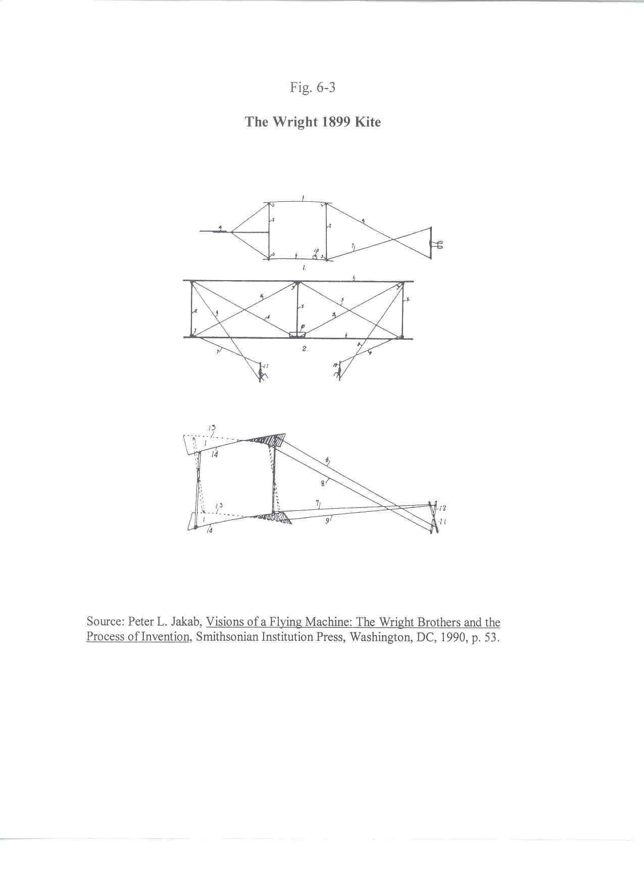

The Wright Gliders

The Wright brothers had to support their research out of their income as makers and sellers of bicycles, and their business kept them busy for all but the late summer and early fall months. But the brothers found the time to complete a design and make parts for their first glider by August 1900. The Wrights traveled in September to the village of Kitty Hawk, North Carolina, where steady onshore breezes from the ocean and enormous empty beaches and sand dunes created a safe place to conduct glider flights.

The first Wright glider consisted of biplane wings sixteen and one-half feet long and five feet wide (5.64 x 1.52 meters) made of curved wooden slats and sateen fabric. Vertical struts held the two wings together and diagonal wire trusses provided reinforcement in the front and back but not on the sides, so that the back edges of the wings could be pulled up or down. The pilot lay prone on the lower wing and controlled the wings by wires. The Wright brothers also gave the wings a slight camber, with a ratio of height to width of 1 to 22. A small wing in front of the main wings, called the forward elevator, lessened the danger of stalling.¹²

With the help of local villagers, the Wrights began to test their glider, at first tethered to the ground and then in free flight. In the first free flights, Orville and Bill Tate, a village youth, held each end of the plane atop a dune with Wilbur lying on the lower wing at the controls. The breeze lifted the plane and carried it several hundred feet. The Wrights tested the drag of the airframe by tethering it to a weighing scale and measuring the pounds of force exerted by the wind. Drag turned out to be low. But lift measurements also turned out to be low. The Wrights had calculated that their plane would lift itself and a pilot in a twenty-three mile per hour wind, at a positive angle to the wind of three degrees. Measurements of lift indicated that the glider would lift this weight only at an angle of twenty degrees in a twenty-five mile per hour wind. An angle of attack this high would have unacceptable drag and risk pitching up and stalling.

Over the following winter and spring, the Wright brothers built a new glider with the main wings measuring twenty-two feet by seven feet (6.7 x 2.13 meters). They also raised the camber of the upper wing surfaces to a ratio of 1 and 12, the same one Lilienthal had used for his gliders. Returning to Kitty Hawk in July 1901, the Wrights began making free flights again. But this time, their glider became unstable in pitch and stalled frequently. The airframe landed safely but the glider was less stable than the previous year's plane. By adjusting the wings on the spot with a lower camber of 1 to 19, the Wrights were able to restore pitch stability to the plane.¹³

Then a more serious problem emerged. In the previous year, the brothers had not tested their wing controls by trying to bank the plane to the left and right. In several tests now, Wilbur banked the plane in one direction only to have the wings suddenly move in the opposite direction. The Wrights' great insight of flexible wing controls appeared to backfire. To make matters worse, when the brothers tethered the glider and flew it as a kite to measure lift, they found that the larger airframe generated less lift than their previous glider. The Wright brothers returned home deeply discouraged.¹⁴

Rethinking the Fundamentals of Flight

The Wright brothers were not down for long. In the spring of 1900, they had begun to correspond with Octave Chanute, who encouraged them in their efforts. After the Wright brothers returned home in late August 1901, Chanute invited Wilbur to report their research to the Western Society of Engineers in Chicago on September 18.¹⁵ Wilbur's slide lecture was concise and well received, and the interest of professional engineers restored the confidence of the brothers in their quest to fly. But the Wrights now realized that something was fundamentally wrong.

In designing their plane, Wilbur and Orville had relied on earlier research to calculate lift at various speeds. The basis of this research was the work of the English engineer John Smeaton, who had published a 1759 paper on the flow of water and wind against flat plate surfaces. This paper led to a formula for calculating the pressure of an airflow perpendicular to a plate: F = k V ² S, in which F is the force hitting the plate (in pounds), k V ² represents air pressure in pounds per square foot, and S is the surface area of the plate, measured in square feet. In the number for air pressure, V is the velocity of the air in miles per hour, and k is a number, known as Smeaton's coefficient, that in part represents air density. Smeaton assigned this coefficient a value of 0.005.¹⁶

If the plate changed its angle to the wind, the amount of force varied. Air pressure caused two kinds of force on such an angled wing: lift and drag. These forces could vary with the angle of attack. To calculate lift and drag on a wing at a given angle, aviation researchers added a coefficient for lift or drag to Smeaton's formula. Adding a coefficient for lift (C_{L} ) defined lift: L = k V ² S C_{L} , with L representing the lifting force and S representing the surface area of the wingspan. Substituting a drag coefficient (C_{D} ) for the lift coefficient defined drag: D = k V² S C_{D} , with D representing the drag force. The value of each coefficient for any given wing had to be determined for each angle of attack by testing. Lilienthal had studied lift and drag on different wings and had produced tables of coefficients at various angles of attack. These were the best tables in existence and the Wright brothers had relied on them and on Smeaton's coefficient to design their gliders.

The Wrights now suspected that Lilienthal's numbers for lift and drag were mistaken. Questioning these numbers was not easy, because the formulas for lift and drag each contained two coefficients: one for lift or drag and the other Smeaton's coefficient. The Wrights built a small wind tunnel in October 1901, out of a wooden crate, in which they placed model surfaces. The brothers skillfully found ways to test lift and drag numbers independently of Smeaton's coefficient. They initially concluded that Lilienthal's numbers were inaccurate until they realized that they may have been correct for the wing shape Lilienthal used, which was different from the one the Wrights had used in their own gliders. The Wrights then tested their own wing shape and many others, and also tested wings with different cambers. The brothers compiled a new set of lift and drag coefficients for a range of wing shapes over a range of angles to the wind.¹⁷

The Wright brothers soon realized the source of their difficulty: Smeaton's coefficient was wrong. Langley had discovered in 1891 that the coefficient was inaccurate but the Wrights didn't take notice until their wind tunnel research suggested that the factor k should be 0.0033, the number Langley proposed, and not Smeaton's number 0.005. Modern aeronautical research has shown that the value of k at sea level is 0.00257, and the wrong value for k explained why the earlier Wright gliders had insufficient lift. The factor that the Wrights now proceeded to use, 0.0033, was accurate enough to enable them to design a successful airplane.¹⁸

Wind tunnel results also showed that a plane with a longer and narrower wing would generate the same lift at lower angles of attack than a shorter and wider wing having the same square feet. Instead of wings that were twenty-two feet long and seven feet wide, as in 1901, the new glider had wings thirty-two feet long and five feet wide (9.75 x 1.52 meters). The wings had a lower camber of about 1 to 25. The Wrights also came up with an answer to the problem of banking the plane in flight. They realized that in banking one wing to turn, the other wing acquired more drag. By placing a vertical rudder behind the airplane, they believed this effect could be counteracted.

The needs of their bicycle business delayed testing the improved glider until September 1902, when the Wright brothers returned to Kitty Hawk. In free flights, the new plane proved itself dramatically. The glider flew at a low angle of attack (three to four degrees) at the desired minimum windspeed of twenty-three miles per hour. The Wrights needed to make the vertical tail rudder adjustable, but with that modification the brothers believed they were now ready to add an engine to their airplane.

The Wright Flyer

To design a powered airplane, the Wrights first had to decide the dimensions and weight of the plane. For the shape of the biplane wings, they chose one of the airfoils (wing shapes) that they had tested in their wind tunnel (Airfoil Number 12). They planned each wing to measure 40 feet by 6.25 feet, or 500 square feet in total surface area. The weight of airplane, engine, and pilot was expected to be 625 lbs. The brothers planned to fly in the range of attack angles that they considered safe, between 2.5 and 7.5 degrees (at higher angles of attack, the plane risked pitching upward in a wind gust and stalling, while at a lower angle lift would be difficult to obtain). The Wrights calculated that the plane would need a maximum speed of 35 miles per hour to fly within these angles. Their wind tunnel tests showed them the lift and drag, expressed in coefficients, that they could expect at these angles of attack (Fig. 6-4).¹⁹

With these numbers and a revised air density coefficient (k) of 0.0033, the Wrights could estimate the power needed by their engine to reach a speed of 35 miles per hour. In level flight at a fixed speed, lift and weight would equal each other. With lift therefore equal to 625 pounds, and a velocity of 35 miles per hour, the drag came to 90
Fig. 6-4

The Wright Flyer Design:
Lift, Drag, and Power at 2.5 Degree Angle of Attack

Wind Tunnel Tests: Table of Lift and Drag Coefficients¹

Angle of attack  (in degrees) | C_{L} (lift) | C_{D}/ C_{L} | C_{D} (drag) | Velocity² (mph)
0 | 0.145 | 0.263 | 0.038 | 51.3
2.5 | 0.311 | 0.138 | 0.043 | 35.0
5.0 | 0.515 | 0.105 | 0.054 | 27.2
7.5 | 0.706 | 0.108 | 0.077 | 23.2
10.0 | 0.839 | 0.118 | 0.099 | 21.3

1. Source: Marvin W. McFarland, ed., The Papers of Wilbur and Orville Wright, McGraw-Hill, New York, 1953, Vol. 1, pp. 579, 583 (for Surface No. 12).

2. Velocity computed from L = k V ² S C_{L} for each angle of attack.

Lift, Drag, and Thrust at 2.5 degree angle of attack (k = 0.0033)

L = Lift Weight (W ) (=L) = 625 lbs. Wing Area (S ) = 500 sq. ft.
D = Drag Air Density (k) = 0.0033 Frontal Area (S_{F}) = 20 sq. ft.

L = k V ² S C_{L}

625 = (0.0033) (35) ² (500) (0.311)

D = k V ² ( S + S_{F} ) C_{D} = Thrust (T)

T = (0.0033) (35)² (500 + 20) (0.043) = 90 lbs.

Power required to fly at 2.5 degree angle of attack

P = T V / 375

P = (90) (35) / 375 = 8.4 Hp

pounds. In an airplane in steady level flight, drag and thrust (T) are equal. Power can be calculated with the same formula used to find the traction horsepower of an automobile, substituting thrust for traction. Thrust (T) multiplied by velocity (V) and divided by 375 gives the thrust horsepower needed to fly at that speed. As shown in Fig. 6-4, at a thrust of 90 pounds and speed of 35 miles per hour, the plane needed an engine capable of producing 8.4 Hp.

The Wrights could not find a shop able to make an internal combustion engine with the power and low weight they needed. With the help of Charles Taylor, the Wright bicycle shop assistant, the brothers built a 140 lb. four-cylinder gasoline engine themselves. The brake horsepower of the engine came to 11.81 Hp. The Wrights knew that the actual power propelling the plane would be less owing to efficiency losses in the chain transmission and in the propellers. The engine was not in fact strong enough to power the airplane at 35 miles per hour when these losses were found by testing. But the Wrights hoped to fly the plane at an angle in the middle of their preferred range of attack angles. At a five degree angle, shown in Fig. 6-5, their engine could fly the plane.

The final component of the airplane was the propeller. This turned out to be the most difficult part of the airplane to design. The Wright brothers soon realized that a propeller on a moving airplane would not produce the same thrust as a propeller fixed to a stationary engine. As Orville wrote:

Fig. 6-5

The Wright Flyer Design:
Engine and Power at 5.0 Degree Angle of Attack

Wright Flyer Engine Specifications

Pressure (P) = 50 lbs. per sq. in.

Length (L) = 4 in.

Area (A) = D² π / 4 = 4 in.² π / 4 = 12.53 sq. in.

Number (N) = 2180 strokes per minute (four cylinders)

Engine Power

Indicated Hp P_{i} = PLAN / 33,000

P_{i} = (50) (4 in.) (12.53 sq. in.) (2180) / 33,000 = 13.85 Hp

Brake Hp P_{b} = Indicated Hp x Mechanical efficiency (0.85)

Brake Hp P_{b} = (13.85) (0.85) = 11.81 Hp

Propeller Hp P_{p} = Brake Hp x Transmission (0.95) x Propeller (0.66) efficiencies

Propeller Hp P_{p} = (11.81) (0.95) (0.66) = 7.4 Hp

Power required at 5.0 degree angle of attack (V and C_{D} from Fig. 6-4)

D = k V ² ( S + S_{F} ) C_{D} = Thrust (T)

T = (0.0033)(27.2)² (520 + 20) (0.054) = 68.55 lbs.

P_{t} = T V / 375

P_{t} = (68.55) (27.2) / 375 = 4.97 Hp
What at first seemed a simple problem became more complex the more we studied it. With the machine moving forward, the air flying backward, the propellers turning sidewise, and nothing standing still, it seemed impossible to find a starting-point from which to trace the various simultaneous reactions. Contemplation of it was confusing. After long arguments, we often found ourselves in the ludicrous position of each having been converted to the other's side, with no more agreement than when the discussion began.²⁰

Eventually, they decided to treat the propeller as a wing surface and to design it as if it was producing lift. The brothers settled on the dimensions and positioned two propeller blades in back to push the plane from behind. The blades would rotate in opposite directions to prevent them from turning the plane left or right on its yaw axis.

The Wright brothers brought their plane to North Carolina in September 1903. The higher horsepower of the engine enabled the brothers to add weight in the form of strengthening to the airframe, bringing the total weight (with pilot) up to 750 pounds. The main wingspan also grew from 500 to 510 square feet (Fig. 6-6). Octave Chanute visited them at Kitty Hawk and warned that transmission losses might be greater than the Wrights had planned. The airplane was now designed to include almost no margin for error. Anxiously, the brothers tested the plane with a rope and pulley to determine how many pounds of sand it could pull. It soon became clear that the propellers could deliver 132-136 pounds of thrust, far more than expected and more than enough to overcome transmission losses (and the error in their air density factor).²¹
Fig. 6-6

The Wright 1903 Flyer
Actual Performance

Aircraft Specifications and Engine Power

Weight (W = L) = 750 lbs. Frontal Area = 20 sq. ft.
Wing Surface Area = 510 sq. ft. Velocity = 45 ft. per second (30.7 mph)

Indicated Hp (P_{i} ) = 13.85 Hp
Brake Hp (P_{b}) = 11.81 Hp
Propeller Hp (P_{p}) = 7.40 Hp

Wright 1903 Flyer First Flight ( k = 0.00257)

Lift coefficient computed from weight, velocity, air density, and wing surface area:

Lift (= Weight) = k V ² S C_{L}

L (750 lbs.) = (0.00257) (30.7)² (510) (0.610)

From Appendix 6.1, for C_{L} = 0.610, angle of attack α = 6.1 degrees. From Appendix 6.2, for α = 6.1 degrees, C_{D} = 0.065.

Drag ( = Thrust) = k V ² ( S + S_{F} ) C_{D}

D = (0.00257) (30.7)² (510 + 20) (0.065)

Thrust = 84 lbs.

TV / 375 = (84) (30.7) = 6.9 Hp required to fly

While the Wrights prepared for their test flight, Samuel Langley in Washington began testing his own full-scale airplane. The gasoline engine of Langley's "Great Aerodrome" weighed 124 lbs. and delivered a huge 52 Hp. The airframe had never been tested as a full-scale glider, and Manly had no experience in the air. On October 7, 1903, the plane was ready. It took off by catapult over the Potomac River and immediately plunged into the water with Manly on board. But Manly and Langley blamed the launch mechanism for the failure and began preparing for a second flight.

On December 8, 1903, the Great Aerodrome was reset on its houseboat catapult. The plane had two sets of wide wings, one behind the other, several vertical rudders, and very weak structural bracing. The catapult propelled the aircraft along a sixty-foot track, accelerating the plane to thirty miles per hour. Upon leaving the platform, the airplane pitched up into the air at a ninety degree angle and collapsed into the river. Langley and his friends in the scientific establishment blamed the launch mechanism again. But the public ridiculed his attempt and Langley received no more funding to conduct research. He died in 1906.²²

The Wright brothers in North Carolina endured troubles of their own: in early November a propeller shaft broke, and no sooner had a replacement arrived by the end of the month than another shaft broke. Orville returned to Ohio to make new and stronger shafts and returned on December 11. The brothers were finally ready. Wilbur won a coin toss and piloted the first flight on December 14. Upon leaving the ground, the airplane pitched up too high, stalled, and came down after a flight of sixty feet. The Wrights decided that this was not a true flight, so after making some repairs Orville took the plane on December 17. He described what followed:

After running the motor a few minutes to heat it up, I released the wire that held the machine to the track, and the machine started forward into the wind. Wilbur ran at the side of the machine, holding the wing to balance it on the track. Unlike the start on the 14th, made in a calm, the machine, facing a 27-mile wind, started very slowly. Wilbur was able to stay with it till it lifted from the track after a forty-foot run.

One of the Life Saving men snapped the camera for us, taking a picture just as the machine had reached the end of the track and had risen to a height of about two feet. The slow forward speed of the machine over the ground is clearly shown in the picture by Wilbur's attitude. He stayed along beside the machine without any effort. The course of the flight up and down was exceedingly erratic, partly due to the irregularity of the air, and partly to lack of experience in handling this machine.

The control of the front rudder was difficult on account of its being balanced too near the center. This gave it a tendency to turn itself when started; so that it turned too far on one side and then too far on the other. As a result the machine would rise suddenly to about ten feet, and then as suddenly dart for the ground. A sudden dart when a little over a hundred feet from the end of the track, or a little over 120 feet from the point at which it rose into the air, ended the flight.

As the velocity of the wind was over 35 feet per second and the speed of the machine over the ground against this wind ten feet per second, the speed of the machine relative to the air was over 45 feet per second, and the length of the flight was equivalent to a flight of 540 feet made in calm air. This flight lasted only 12 seconds, but it was nevertheless the first in the history of the world in which a machine carrying a man had raised itself by its own power into the air in full flight, had sailed forward without reduction of speed, and had finally landed at a point as high as that from which it started.²³

Three more flights took place that day, ending with one by Wilbur that covered 852 feet in 59 seconds. Later that afternoon, a gust of wind overturned the parked airplane and broke the airframe. But the Wright brothers had achieved their goal.

The Wright Brothers: Aftermath

The Wrights attracted some publicity at the time of their first flight but a new plane they built the following year didn't fly. The brothers perfected their design in 1905, though, enabling Wilbur to stay up for 39 minutes and cover a distance of 24.5 miles around Dayton. The Wrights filed a patent on their airframe and control system in the United States that was granted in 1906.²⁴

The Wright brothers tried to sell their plane to the United States Army. To their surprise, they were turned down. The Army had backed Langley's airplane research and had come under criticism when the Great Aerodrome had failed. Military leaders demanded that the Wrights demonstrate their plane before giving them a contract. The Wrights declined to fly unless the Army first agreed to a contract. The Wrights did not believe that they could defend their patent in court against better-financed competitors and they feared that a public demonstration would lead to the pirating of their design. The British, French, and German governments also refused to sign contracts until they had seen the Wright plane fly. For several years, from 1905 to 1908, the Wright brothers kept their invention to themselves.²⁵

Aviators in France soon began to fly inferior planes based on reports of what the Wright Flyer looked like, although the French planes could not bank, or travel distances longer than a few hundred feet.²⁶ Alexander Graham Bell took an interest in aviation in his later life and conducted experiments with kites on his estate in Nova Scotia, Canada. For reasons of safety, Bell believed that the future of aviation lay in slower airplanes, not faster ones. He invented a multiplane wing that was stable in a ten mile per hour wind and he designed an airplane to travel at that speed.²⁷ Bell's plane never flew, but he attracted a staff of younger assistants, including a motorcycle racer and engine maker, Glenn Curtiss, who joined Bell in 1907. With Curtiss, Bell's staff developed a faster plane. On July 4, 1908, Curtiss flew the plane over 5,000 feet in a contest sponsored by the magazine Scientific American.²⁸

The Wright brothers had to act. In the summer of 1908, Wilbur Wright took the 1905 airplane to France and gave a public demonstration in August. His dramatic performance completely outclassed the clumsy machines flown by his European rivals, which could not turn in the air. Repeating his flights over several days to ever-increasing crowds, and flying again in late fall, he stunned the public and became the most sought-after celebrity in Europe. Wilbur quickly formed private airplane manufacturing companies with local investors in France, England, and Germany. The following spring, Wilbur flew over the Hudson river in New York City for the 300th anniversary of Henry Hudson's arrival and (two years late) the 100th anniversary of Robert Fulton's steamboat trial of 1807. Wilbur circled the Statue of Liberty to cheering crowds and saluting ships in the river.²⁹ In August and September 1908, Orville Wright went to Fort Myer, Virginia, to demonstrate another 1905 plane to officers of the U.S. Army. Despite a crash landing in which an officer was killed, the trials were successful and the Army signed a contract. The brothers formed an American company with investors in New York to manufacture airplanes and Orville personally trained the first military pilots.³⁰

Over the next few years, however, the Wright brothers failed to design and sell superior airplanes for a larger market. As bicycle makers, they had produced all of their bicycles by hand, and their demonstration airplanes were also hand-made. Like Bell, their talent had been to create a single breakthrough invention, not to run a large business. The airplanes made by their company were difficult to fly and began to lose their technological edge. Competing aircraft makers replaced wing warping with ailerons and used a single propeller in front instead of two in the back. In place of the lever-operated controls on the Wright planes, rival aircraft began to use a much simpler single control stick that could be moved forwards and sideways.³¹

As the Wright brothers had feared, public demonstrations of their plane enabled rivals to copy its most useful feature, its principle of flexible wing controls. But the Wrights patented their feature in such broad terms that any airplane with flexible controls infringed it. The Wright brothers, in effect, claimed a world monopoly over flyable airplanes. European aviators infringed the patent, claiming loopholes, and the German Wright patent was overturned altogether. The Wright company in France was poorly managed and made no money for the brothers.³²

Glenn Curtiss left Bell to form a company in 1909 with a partner who falsely claimed to possess airplane patents predating those of the Wrights. The Wright brothers sued Curtiss and a U.S. judge upheld the suit in January 1910, putting Curtiss out of business. But an appeals court in June ruled that Curtiss could produce airplanes until the matter was decided on appeal. Curtiss went back into business (without his original partner) and began selling seaplanes to the U.S. Navy.³³ Henry Ford saw the Wright patent as the kind of stranglehold that he had fought in the Selden case, even though Selden's invention hardly compared to the Wright Flyer. Ford gave his attorney to Curtiss.³⁴ In early 1914, the appeals court ruled in favor of the Wright patent. But Orville (Wilbur had died in 1912) had no interest in exploiting his monopoly. He sold the Wright company in 1915 to devote himself to laboratory research, just as Edison had after 1890. The company entered a patent-sharing agreement with its competitiors in 1917 and merged with the Curtiss firm in 1929.³⁵

Following the Wright legal victory in 1914, Curtiss found another way to strike back. Charles Walcott, Langley's successor as secretary of the Smithsonian Institution, believed that the Langley Aerodrome should have flown in December 1903 and that Langley deserved the credit that had gone to the Wright brothers. He authorized Alfred Zahm, director of the Smithsonian's Langley Aeronautical Laboratory, to rebuild the Langley plane, and Zahm engaged Curtiss to fly it. Zahm and Curtiss made a number of crucial and unreported changes that strengthened the original design. Curtiss flew the rebuilt plane over Lake Keuka, near his headquarters in Hammondsport, New York, in May 1914. The Smithsonian returned the plane to Washington, D.C., and declared it the first true airplane.³⁶

Orville Wright was understandably outraged. When photographs of the original and rebuilt Aerodrome proved that the rebuilt plane was clearly a different aircraft, Orville demanded a retraction and apology. Walcott and his successor refused. In 1928, Orville sent the 1903 Wright Flyer, which had been restored, to the Science Museum in Kensington, England, with orders that it remain out of the United States until the Smithsonian admitted its wrong. The exile of the Wright Flyer became an increasing embarassment to the Smithsonian and to the nation. Finally in 1948, after Orville's death, the Smithsonian retracted its claim and negotiated with the Wright estate for the Flyer's return. It now hangs in a place of honor above the entrance to the National Air and Space Museum, where a plaque recognizes it as the world's first successful powered airplane.³⁷

References

1. On early aviation, see John D. Anderson, Jr., A History of Aerodynamics and Its Impact on Flying Machines, Cambridge University Press, Cambridge, 1997, pp. 14-62. For the change brought by the industrial revolution, see Tom D. Crouch, "Aeronautics in the Pre-Wright Era: Engineers and the Airplane," in Richard P. Hallion, ed., The Wright Brothers: Heirs of Prometheus, Smithsonian Institution Press, Washington DC, 1985,
pp. 3-19.

2. For Cayley's work, see Charles H. Gibbs-Smith, Sir George Cayley's Aeronautics, 1796-1855, Her Majesty's Stationary Office, London, 1962; and John D. Anderson, Jr., A History of Aerodynamics, pp. 62-80.

3. Clement Ader of France and Sir Hiram Maxim of England tried and failed to achieve powered flight in the 1890s with steam engines. See Charles H. Gibbs-Smith, Aviation: An Historical Survey from its Origins to the End of World War II, Her Majesty's Stationary Office, London, 1985, pp. 59-63. On the failure of aerodynamic theory to inform practical efforts to fly in the second half of the nineteenth century, see John D. Anderson, Jr., A History of Aerodynamics, pp. 114-119. On Wenham, see ibid., pp. 122-125.

4. See Otto Lilienthal, Birdflight as ther Basis of Aviation, trans. A.W. Isenthal, Longmans Green, New York, 1911 [reprint edition, Markowski International,
Hummelstown PA, 2001]; and John D. Anderson, Jr., A History of Aerodynamics, pp. 138-164. For Lilienthal's influence on American aviation, see Tom D. Crouch, A Dream of Wings: Americans and the Airplane 1875-1905, Smithsonian Institution Press, Washington DC, 1989, pp. 157-174.

5. On Langley's research, see Samuel P. Langley and Charles M. Manly, Langley Memoir on Mechanical Flight, Smithsonian Contributions to Knowledge, Vol. 27, No. 3, Smithsonian Institution, Washington DC, 1911; and John D. Anderson, Jr., A History of Aerodynamics, pp. 164-192.

6. For a biography of the Wright brothers, see Tom Crouch, The Bishop's Boys: A Life of Wilbur and Orville Wright, W.W. Norton, New York, 1989.

7. Octave Chanute, Progress in Flying Machines, M.N. Forney, New York, 1894 [reprint edition, Dover Publications, Mineola NY, 1997]. On Chanute and his research, see Tom D. Crouch, A Dream of Wings, pp. 175-202.

8. For a summary of how airplanes fly, see John D. Anderson, Jr., A History of Aerodynamics, pp. 3-11.

9. On Alphonse Pénaud, see Charles H. Gibbs-Smith, Aviation, pp. 43-44.

10. For the influence of bicycles in the thinking of the Wright brothers, see Tom Crouch, "How the Bicycle Took Wings," American Heritage of Invention and Technology, Vol. 2, No. 1 (Summer 1986), pp. 11-16. The Wright brothers explained their basic ideas in Orville and Wilbur Wright, "The Wright Brothers' Aëroplane," The Century Magazine, Vol. 76, No. 5 (September 1908), pp. 641-650. See also Tom Crouch, The Bishop's Boys, pp. 157-180. For an examination of the Wrights' work, see also John D. Anderson, Jr., A History of Aerodynamics, pp. 201-243.

11. On the 1899 kite tests, see Tom Crouch, The Bishop's Boys, pp. 173-174.

12. In an airplane with main and tail wings, a stall caused the main wing to lose lift slightly before the tail wing. Placed in front, however, the smaller wing would stall first. The main wing would still have some lift, allowing the plane to fall in a slower and flatter descent, like a parachute. On the Wright gliders, see Wilbur Wright, "Experiments and Observation in Soaring Flight," Journal of the Western Society of Engineers, August 1903, pp. 400-417; and Peter L. Jakab, Visions of a Flying Machine: The Wright Brothers and the Process of Innovation, Smithsonian Institution Press, Washington DC, 1990, pp. 83-114.

13. The Wrights designed their wings so that the camber ratio could be adjusted at the test site. See John D. Anmderson, Jr., History of Aerodynamics, p. 236.

14. On the new difficulty with turning, see Peter Jakab, Visions of a Flying Machine, pp. 112-114.

15. For the published version of his presentation, see Wilbur Wright, "Some Aeronautical Experiments," Journal of the Western Society of Engineers, December 1901, pp. 489-510. Reprinted in Marvin W. McFarland, ed., The Papers of Wilbur and Orville Wright, 2 vols., McGraw-Hill, New York, 1953, Vol. 1, pp. 99-118.

16. For the formulas and numbers used by the Wright brothers to design their gliders, see Marvin W. McFarland, ed., The Papers of Wilbur and Orville Wright, 2 vols., McGraw-Hill, New York, 1953, Vol. 1, pp. 575-577. The term k is obtained from the formula
kV ² = 1/2 ρ V ², where ρ is the density of air at sea level in pounds-seconds squared per feet to the fourth power, and V is in feet per second. For k where V is in miles per hour, we multiply 1/2 ρ V ² by (5280/3600)² = (1.47)². Since the air density at sea level is 0.002377, the correct value for k there is 1/2 (0.002377)(1.47)² = 0.00257, not the 0.005 value of Smeaton's coefficient.

17. On the Wright wind tunnel tests, see Peter L. Jakab, Visions of a Flying Machine, pp. 115-155; and John D. Anderson, Jr., History of Aerodynamics, pp. 216-235.

18. For Langley's results, see Samuel P. Langley, Experiments in Aerodynamics, Smithsonian Institution, Washington DC, 1891. See also John D. Anderson, Jr., A History of Aerodynamics, pp. 168-169, 209-210.

19. For the lift and drag tables, see Marvin W. McFarland, ed., The Papers of Wilbur and Orville Wright, 2 vols., McGraw-Hill, New York, Vol. 1, pp. 579, 583. On the design of the 1903 Wright Flyer, see the articles in Howard S. Wolko, ed., The Wright Flyer: An Engineering Perspective, Smithsonian Institution Press, Washington DC, 1987, esp. pp. 98-100.

20. Orville and Wilbur Wright, "The Wright Brothers' Aëroplane," The Century Magazine, p. 648.

21. For the final work at Kitty Hawk in the fall of 1903, see Tom Crouch, The Bishop's Boys, pp. 253-261, 263-272; and Peter L. Jakab, Visions of a Flying Machine, pp. 183-212.

22. On Langley's climactic failure, see Tom D. Crouch, A Dream of Wings, pp. 255-293.

23. Orville Wright, "How We Made the First Flight," in Richard P. Hallion ed., The Wright Brothers, pp. 101-109. Quote is from pp. 107-108. Originally printed in the magazine Flying (December 1913).

24. On the 1906 Wright patent in the United States, see Rodney K. Worrell, "The Wright Brothers Pioneer Patent," American Bar Association Journal, Vol. 65, October 1979, pp. 1512-1518. For patent filings abroad, see Tom Crouch, The Bishop's Boys, p. 312.

25. For the difficulties of the Wright brothers in this period, see Tom Crouch, The Bishop's Boys, pp. 301-311.

26. On the early efforts of European aviators, see ibid., pp. 316-326.

27. For Bell's research in aeronautics, see Alexander Graham Bell, "Aerial Locomotion," National Geographic, Vol. 18, No. 1 (January 1907), pp. 1-34. See also Robert V. Bruce, Bell: Alexander Graham Bell and the Conquest of Solitude, Cornell University Press, Ithaca NY, 1973, pp. 430-454.

28. On Curtiss, see C.R. Roseberry, Glenn Curtiss: Pioneer of Flight, Doubleday and Company, Garden City NY, 1972, pp. 48-162.

29. For Wilbur Wright's public flights in 1908 and 1909, see Tom Crouch, The Bishop's Boys, pp. 360-379, 406-408.

30. For the 1908 tests by Orville Wright before the Army at Fort Myer, see ibid., pp. 371-378. On the formation of the Wright company and its training of military pilots, see pp. 409-412, 435-436.

31. On the problems of the Wright company, see ibid., pp. 446-447, 457-460. For the invention of stick control and its superiority to the Wright lever system, see Malcolm J. Abzug and E. Eugene Larrabee, Airplane Stability and Control: A History of the Technologies That Made Aviation Possible, Cambridge University Press, Cambridge, 1997, pp. 5-6.

32. For the business and patent difficulties of the Wright brothers in Europe, see Tom Crouch, The Bishop's Boys, pp. 413-417, 451-452.

33. On the Curtiss-Wright dispute, see C.R. Roseberry, Glenn Curtiss, pp. 152-158, 257, 308-362; and Tom Crouch, The Bishop's Boys, pp. 402-403, 412-415.

34. On Henry Ford's involvement, see C.R. Roseberry, Glenn Curtiss, pp. 343-346; and Tom Crouch, The Bishop's Boys, pp. 461-462.

35. For Orville's decision to sell the company, see ibid., pp. 464-467.

36. On the flight of the rebuilt Langley plane and the Smithsonian's claim, see A.F. Zahm, "The First Man-Carrying Aeroplane Capable of Sustained Free Flight – Langley's Success as a Pioneer in Aviation," Annual Report of the Board of Regents of the Smithsonian Institution…1914, Washington, 1915, pp. 217-222. See also Tom Crouch, "The Feud between the Wright Brothers and the Smithsonian," American Heritage of Invention and Technology, Vol. 2, No. 3, Spring 1987, pp. 34-46; and The Bishop's Boys, pp. 484-491.

37. Ibid., pp. 491-501.
