Proposed Plan for Adaptive Sampling Experiments
in Monterey Bay ‘03

Naomi Leonard, Jerrold Marsden, Clancy Rowley, Ralf Bachmayer, Pradeep Bhatta, Eddie Fiorelli, Francois Lekien, Shawn Shadden

July 29, 2003 Version: 7

I. Introduction

This document summarizes a set of glider experiments proposed for the Monterey Bay 2003 AOSN-II Experiment (August-September 2003) to test Adaptive Sampling hypotheses and meet Adaptive Sampling goals as described in Davis et al, AOSN Systems Goals and Performance Metrics, May 11, 2003. As reported in this latter document, the central objective of adaptive sampling is to use “data-adaptive, real-time control of observing assets to improve the utility of the observing array.” In the present document, we consider the fleet of gliders expressly allocated for adaptive sampling. This includes 6 gliders, although much of the time only 3 of these gliders will be controlled at the more frequent rate of every 2-3 hours (cf. Fratantoni, D.M., Proposed Sampling Plan / Vehicle Tasking for the WHOI Glider Fleet during AOSN-II/MB03, May 27, 2003).

Multi-scale adaptive sampling is one of the important innovations to be introduced at the Monterey Bay 2003 Experiment (cf. Leonard, N. and A. Robinson, Adaptive Sampling and Forecasting Plan, Jan. 2, 2003). Indeed, adaptive sampling will be performed at different time scales as well as at different spatial scales. The main two time scales include (1) a daily update to glider plans based on HOPS and ROMS model output and Lagrangian Coherent Structures (LCS) computations on the model output and (2) an update to glider plans made every 2-3 hours based on on-board glider measurements. As described in Leonard and Robinson, the two time-scale activities are complementary and will be performed in an integrated fashion.

With respect to spatial scales, the upwelling plume and associated fronts and eddies at the meso-scale will be the first priority. However, some experimentation is proposed at finer spatial scales to collect data and help resolve features associated with the biology and to a lesser extent the internal wave dynamics.

The experiments described here test the following:

- Strategies for controlling groups of gliders as mobile, re-configurable sensor arrays using data from these gliders that is made available as frequently as every couple of hours.

- Strategies for controlling gliders efficiently using LCS predictions.

The 2-3 hourly data from the gliders will be used together with model forecasts and other observations.
In the case of controlling groups of gliders, there are two levels of operation, distinguished by the type of data that is used for glider control:

- The first level of glider group control is coordinated control that requires using measurements of glider position (GPS) to update the paths of the gliders so that they can maintain a desired group configuration, pattern and/or motion.

- The second level of glider group control is cooperative control that uses not only glider positions but also measurements from on-board science sensors, the latter which are used to direct the group or change its configuration or pattern “on the fly” in order to improve the data collected.

II. Experiment Requirements for Coordinated and Cooperative Glider Groups

A critical, central ingredient at both levels of glider group control is the use of frequent enough feedback in order to effectively add to the coordinated and cooperative schemes, robustness to uncertainties. Feedback provides the ability to manage uncertainty; however, this ability depends on sufficiently frequent feedback control updates. We expect that feedback every 2-3 hours will be sufficiently frequent to provide some robustness. Because updating glider waypoints every 2-3 hours has not been attempted before for a group of gliders, we propose to ease into this nominal mode. Specifically, at the very start of the experiment, the gliders paths will be updated every 6 hours, then every 4 hours and then, for the substantial remainder of the experiment, every 2-3 hours.

We do not expect the early experimentation with 4-6 hourly control updates to provide valuable testing of our hypotheses. To illustrate consider the case in which glider control updates are made every 6 hours. Suppose that the gliders are to be controlled in a uniformly distributed formation (a triangle in the case of 3 gliders) such that the centroid of the formation moves along a desired path. The path (described by waypoints) for each of the gliders will be provided at the beginning of each 6-hour period. Each glider will then move through the prescribed waypoints as directed. However, because of uncertainties and disturbances, each glider will reach its series of waypoints asynchronously in time with respect to the other gliders. As a result, a generic snapshot in time will likely reveal the glider formation to be something other than the desired distribution, and the glider formation will diverge from the plan.

Suppose further that the gliders are not just coordinating their maneuvers but also cooperating to compute a gradient and climb a gradient field. Because waypoint updates must be ready for each glider when it surfaces, these waypoints will necessarily be computed using the glider measurements taken only at previous surfacings. This implies that the input to the gradient estimate from the gliders will be based on measurements taken 6 hours prior when each glider was possibly 6 kilometers back.

A second central ingredient is the use of a sufficient number of gliders in the coordinated group. Three gliders provide a minimal set for computing gradients in 2D and provide a minimal level of interest in even more basic coordination/pattern sampling schemes. We propose that when appropriate a limited number of experiments be run in which 4 or more gliders are used as a group. This will test the versatility of the coordination/cooperation strategies and also provide rich data for evaluating the influence of the number of individuals in a mobile sensor array on the effectiveness of resolving certain scales of interest.

It is important to note that 4 or more gliders (and ideally 6) in a group will make it possible to compute better second derivatives in a field and thus lines of maximum gradient magnitude; these lines can be used to define front locations.

We note that in the upcoming experiment it is only possible to perform gradient climbing in the horizontal (x-y) plane. We will want to experiment with the depth at which gradients in the horizontal plane are computed. For example, for meso-scale features, it may be most appropriate to use data taken below the surface mixing layer, i.e., at about 10 meters depth. In the future, it will be interesting to investigate gradients in the x-z plane as well as 3D gradients.

III. Proposed Experiments for Glider Group Adaptive Sampling

In this section, we describe the glider group experiments proposed to sample (1) the meso-scale features, (2) the finer-scale biological features, and (3) the finer-scale internal wave dynamics. The nature of the experiments do not differ a great deal across the three categories; instead the experiments for one category is distinguished from another set by the resolution of the glider group as sensing array. In the next section, we describe the experiments proposed to test the use of LCS.

Given the limited number of gliders, it will not typically be possible to run simultaneous experiments for comparison. Instead, each experiment should be run a number of times for use in comparison, for investigation of influence of individual parameters (e.g., inter-glider spacing), for demonstrating repeatability, etc.

There are also a number of alternate implementation approaches for coordinated and cooperative control of gliders that may be selected and tested. These include how the motion planning strategies handle the currents, the information latencies, the asynchronicity of glider surfacings, the kinematic constraints on the gliders, the bathymetry, etc.

Testing of a subset of these experiments in simulation (OSSEs) is in progress.

- Adaptive sampling of meso-scale features: Upwelling plume and associated fronts and eddies. One focus will be on the inshore edge of the upwelling plume.

  - Coordinated control. Experiments will be run to test the ability to produce, and to judge the utility of, glider group patterns by feeding back GPS measurements of all group members every 2-3 hours. The area to be covered and the nature/resolution of the coverage will be selected at the beginning of the day (i.e., from the RTOC meeting). The path of the glider group will be selected based on this information. The pattern(s) to be used for the day will be selected from the following list:
    - Triangle formation. Center of triangle follows desired group path. Formation rotates so that the tangent to path bisects one triangle edge. Parameter: inter-glider spacing, d₀. See Figure 1a.
    - Line formation. Center of line follows desired path. Parameters: inter-glider spacing d₀ and angle of line with respect to tangent to desired group path θ. See Figure 1b.
    - Triangle formation with zig-zag. Center of formation follows zig-zag pattern about desired group path. Parameters: inter-glider spacing d₀, frequency f, and magnitude a of zig-zag. See Figure 2.
    - Line formation with zig-zag. Center of line follows zig-zag pattern about desired group path. Parameters: inter-glider spacing d₀, angle of line with respect to tangent to desired group path θ, frequency f and magnitude a of zig-zag. See Figures 3a and 3b.
    - Out-of-phase zig-zag. Formation changes from triangle to line to triangle, etc., such that mean of zig-zag pattern is desired group path. Parameters: maximum inter-glider spacing d₀^{max}, frequency f and magnitude a of zig-zag. See Figure 3c.
    - Triangle formation with change in size. Same as i) above except that inter-vehicle spacing changes so that the triangle expands and/or contracts. Parameters: desired change in inter-glider spacing (magnitude and rate). See Figure 4a.
    - Rotating triangle with expansion and/or contraction. Center of triangle is fixed. Parameters: desired change in inter-glider spacing (magnitude and rate), direction and nominal rate of rotation. See Figure 4b.
    - Triangle/line transition. Run together with i) and ii) to effect re-configuration from triangle to line or vice-versa. Parameters: location or time and rate of transition.
    - Formations/patterns using more than 3 gliders. Some formations for 4 and 5 gliders are shown in Figure 5 and are discussed below.

Note that zig-zags will be useful for meso-scale oceanography as long as time for glider to descend to its maximum depth of 200 m is shorter than the time it takes to perform a zig-zag.

Figures 6a, 7a and 8a illustrate the above patterns in three suggested glider group adaptive sampling scenarios. In Figure 6a, the gliders sample along a prescribed path intended to follow a cold-water plume. In Figure 7a, the glider group samples about a path intended to align with a front. In Figure 8a, the glider group performs a coordinated survey over a prescribed region of interest.

  - Cooperative control. Experiments will be run to test the ability to enable, and to judge the utility of, cooperative glider group maneuvers that are driven not only by GPS measurements but also by temperature (and salinity) measurements from the gliders. Glider group patterns can be selected from the list in a) above. Maneuvers can be selected from the following list:
    - Gradient climbing on temperature field (in the horizontal plane at a depth to be specified) to influence the desired group path. In particular, the idea is to use gradient climbing/descent to locate ridges/valleys and front crossings in the field or, as possible, lines of maximum gradient magnitude (fronts). The gradient of the field at the center of the glider group will be estimated based on data that includes the recent glider measurements. Maximum gradient magnitude lines can be computed “on line” better with 4 or more gliders and 2-hourly control updates. The path of the glider group will be computed as a modification of the path that one might otherwise select based on the daily model forecast only. This can be accomplished as a first cut by a weighted sum of the fixed path direction and the estimated gradient direction. A range of more sophisticated options that include filtered glider data and objective mappings are under development (cf. Lermusiaux, P. et al, Oceanic approaches for the control of gliders on two-hourly time scales: Draft I, June 27, 2003). We note that it may indeed be important to filter the raw glider data so that gradient estimates and hence glider control truly apply to meso-scale fields and not smaller-scale fields.
    - Sensor-based changes in group geometry. This includes changes “on-the fly” in sensor array resolution (inter-vehicle spacing), or changes in configuration (e.g., from triangle to line), or changes in group membership (number of gliders in the group), or changes in group pattern or maneuver.

Figure 6b illustrates a gradient climbing scenario in the case that a cold-water plume is to be sampled. There is a change in resolution of the glider array also initiated in response to the 2-3 hourly feedback. Figure 7b illustrates a front-crossing scenario in which temperature measurements are used to help find the front. Figure 8b illustrates a survey of a region of interest in which gradient climbing and data-driven rotations, expansions and contractions are used to focus in on subregions of greatest scientific interest.

  - 4 or more gliders. Experiments will be run when possible and appropriate with more than 3 gliders in the group in order to improve upon the data collection, to test the versatility and effectiveness of the adaptive sampling strategies and to test the role of glider group size on adaptive sampling. An important advantage to 4 or more gliders in the group, is the marked improvement in the ability to compute second-derivatives and therefore to find lines of maximum gradient magnitude (fronts). Possible formations for 4 and 5 gliders are shown in Figure 5.

- Adaptive sampling of finer-scale biological/chemical fields: chlorophyll fields and optical backscatter fields. (cf. personal communication with John Ryan). Note that these plans are in continued development.

  - Coordinated control. Experiments will be run to test the ability to produce, and to judge the utility of, glider group patterns by feeding back GPS measurements of all group members every 2-3 hours. For example, suppose the model forecast or data from an airplane or other asset, identifies a cyclonic or anti-cyclonic meander, indicative of a strong vertical transport. Send the gliders to an area about this meander and have them sample, e.g., as in the scenario illustrated in Figure 6a or 8a. As another example, suppose an AUV or towfish has identified an area of low fluorescence but high optical backscatter, indicative of a particle plume. Send the gliders to this area and have them sample as Figure 6a or 8a. A third example would be to initiate a glider group pattern upon receiving information on high bioluminescence from the model forecast or other assets.

  - Cooperative control. Experiments will be run to test the ability to enable, and to judge the utility of, cooperative glider group maneuvers that are driven not only by GPS measurements but also by fluorescence, pressure, optical backscatter as well as other physical variables measured by the gliders.

    - Gradient climbing on fluoroscence fields. A high concentration in the fluoroscence field indicates biological accumulation. The gradient of the fluorometry field at the center of the glider group will be estimated based on data that includes the recent glider measurements. The path of the glider group will be computed as a modification of the path that one might otherwise select based on the model forecasts, satellite imagery, aircraft or other data. (Aside: If a high concentration in a fluorometry field is often suspected to correlate with a temperature front, is one way to identify a front to track a flourescence ridge?) .
    - Sensor-based changes in group geometry. For example, a high concentration of fluorescence (and pressure) measured by the gliders while sampling near a meander could be used to change the group sampling pattern and parameters (e.g., inter-glider spacing). Refer to the earlier scenario figure to be created and note that it is useful here but with higher resolution.
    - Gradient climbing while serving the model. Gradient climb on ecosystem fields while moving towards a long-term destination designed to serve model (HOPS/ROMS) needs. Note the idea here is to use one of the available patterns as in 1.b.i but with a higher resolution.
    - Concentrated sampling at fronts of temperature (and other physical variable) fields using patterns described above.
    - Front tracking. Send glider group to the predicted location of upwelling and track the inshore front as the upwelling feature develops. During relaxation track the plume of cold water as it diffuses into the mouth of the bay

See the scenarios depicted in Figures 6b, 7b and 8b and substitute bio/chem fields as appropriate.

  - 4 or more gliders. Experiments will be run with more than 3 gliders in the group when possible and appropriate in order to improve upon the above data collection and to test the role of the number of gliders in these circumstances.

- Adaptive sampling of finer-scale internal wave dynamics. The ability of a glider to sample fine-scale, small-time-constant events is limited by their relatively low velocity and their sawtooth dive pattern. Internal waves, such as internal tides, can reach significant velocities, which approach or surpass the glider’s velocity potential. One possibility to compensate for these shortcomings is to use several gliders with an appropriate inter-vehicle spacing and spatial distribution to allow for simultaneous sampling. The desired spacing and distribution is determined by the spatial and temporal frequency of the waves and has to be put into context with practical glider spacing in terms of glider safety and relative position accuracy. The first two scenarios, (a) and (b), are limited to three gliders, which allows only for a limited choice of sampling pattern, notably a line formation in order to provide the temporal spatial resolution along a single track. This scheme makes it necessary to have prior knowledge of the directionality of the waves in the region of interest. The development of the sampling strategy should be performed in close collaboration with Jeff Paduan and others. Note that these plans are in continued development and are expected to go through significant changes during the course of the experiment. Note further that, while in this set of experiments we sample internal waves for scientific interest, we may also need to filter internal waves to access the meso-scale (see Section III.1.b.i).

  - Coordinated control. Experiments will be run to test the ability to produce, and to judge the utility of, glider group patterns by feeding back GPS measurements of all group members every 2-3 hours. In order to provide the necessary temporal and spatial resolution with three gliders, the direction of the waves have to be known beforehand, based on prior studies (e.g. Kunze, Carter, Paduan, Rosenfeld, Key) or on other observations such as CTD casts and moorings. The gliders will be arranged in a single file formation with the inter-vehicle spacing determined as described above. The GPS updates will provide the necessary updates in order to keep the vehicles aligned and appropriately spaced.
  - Cooperative control. Experiments will be run to test the ability to enable, and to judge the utility of, cooperative glider group maneuvers that are driven not only by GPS measurements but also by temperature and salinity as measured by the gliders. In this mode the vehicles will possibly respond to the location of the isopycnal and adjust the group direction to determine the direction of the waves as well as adjust the inter-vehicle spacing based on the sampled field. A future development of this strategy is to make use of the ranging capability of the future deployment of the acoustic modems in gliders. Sampling in a band around the isopycnal that extends sufficiently above and below the interface in order to increase the sampling frequency while maintaining a more accurate inter-vehicle spacing.
  - 4 or more gliders. Experiments will be run with more than 3 gliders in the group when possible and appropriate in order to improve upon the above data collection and to test the role of the number of gliders in these circumstances.

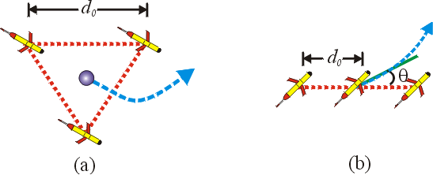

Figure 1. Formation examples for 3 gliders. Red dotted lines illustrate formations. Blue dashed arrows denotes net group direction of travel. Not to scale.
  - 3-vehicle triangle formation. Blue circle denotes group center. The triangle is an optimal formation for gradient estimation in the presence of noise.
  - 3-vehicle line formation. Green line denotes tangent to instantaneous group direction of travel. Allows computation of directional derivatives along direction of line. With frequent enough sampling, the gradient in the direction of motion can be estimated as well, making it possible to estimate the full gradient if $θ≠0\text{.}$

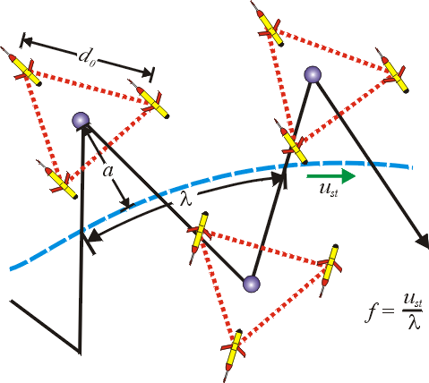

Figure 2. Triangle formation with zig-zag. Blue dashed line denotes group mean path. λ denotes zig-zag wavelength along group mean path. u_{st} denotes group speed along mean group path. Zig-zag frequency given by f = u_{st}/λ. Blue circle denotes group center. Not to scale.

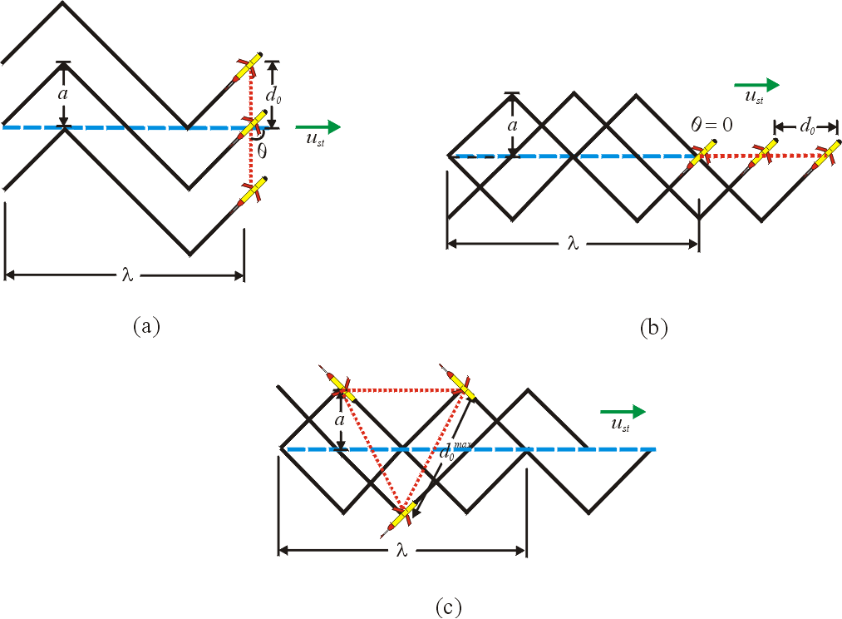

Figure 3. Line formation with zig-zag. Blue dashed line denotes group mean path. λ denotes zig-zag wavelength along group mean path. u_{st} denotes group speed along mean group path. Zig-zag frequency given by f = u_{st}/λ. Not to scale.
- Line formation with zig-zag, θ = π/2.
- Line formation with zig-zag, θ = 0.
- Out-of-phase zig-zag. Group alternates between triangle and line formations. This formation is useful for front crossing; there is at least one vehicle on either side of the front at a given time.

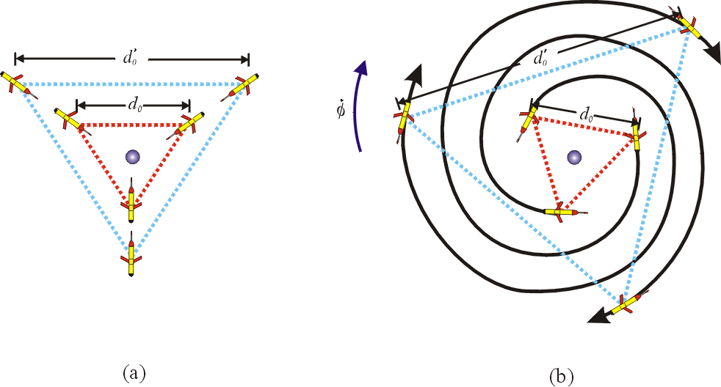

Figure 4. Group expansions. Red triangle denotes initial configuration, light blue triangle denotes resulting formation after expansion. Blue-circle denotes group center. Not to scale.

- Group expansion.
- Group expansion with simultaneous rotation. Group rotates clockwise at a rate given by dφ/dt. Note: actual trajectories will be piecewise linear since paths are discretized into segments represented by waypoints.

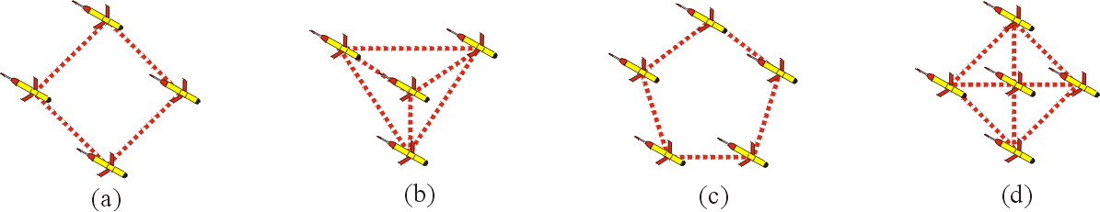

Figure 5. Formations with 4 or 5 gliders. Not to scale.
- Four-vehicle ring formation (square). Provides good gradient estimation (optimal formation).
- Four-vehicle complex triangle. Use for second-order derivative computation.
- Five-vehicle ring formation (pentagon). Provides good gradient estimation (optimal formation).
- Five-vehicle cross formation. Provides good second-order derivative computation.

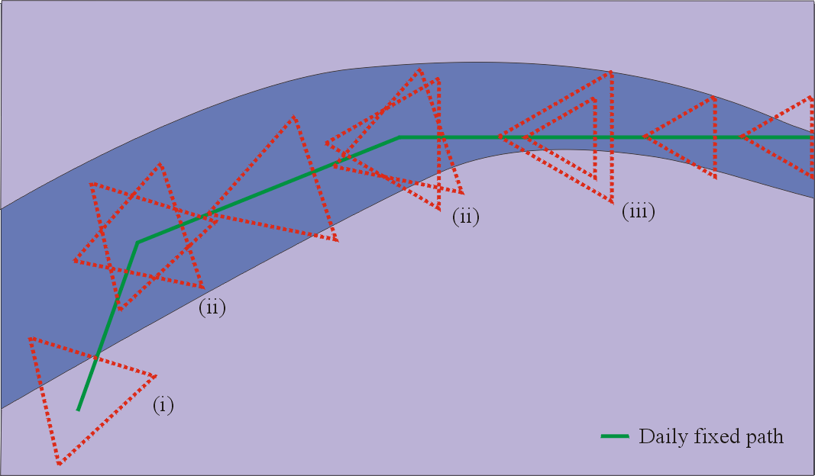

(a)

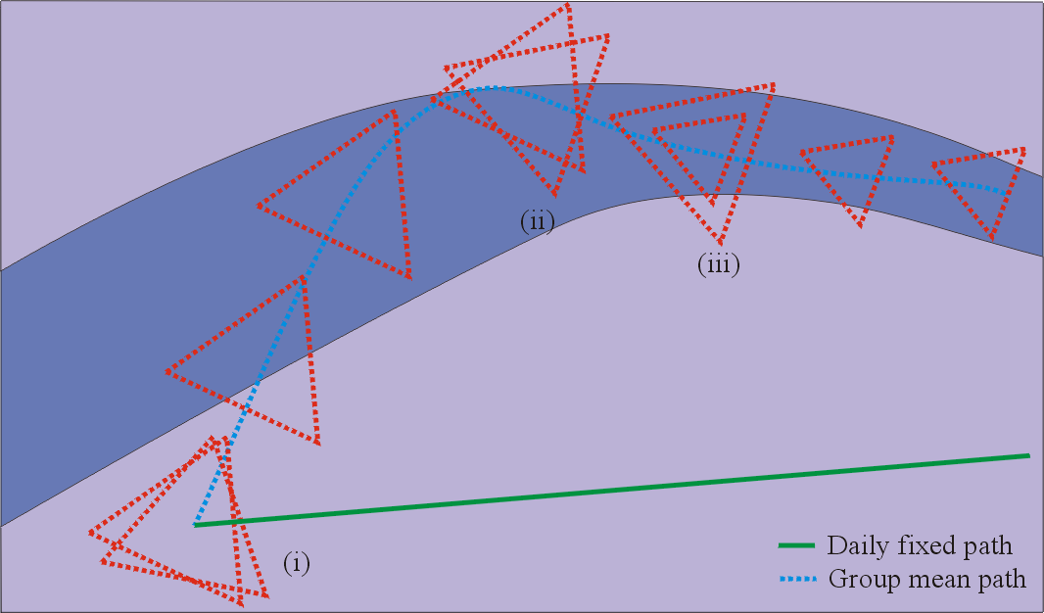

(b)
Figure 6. Adaptive sampling in a cold-water plume. (a) The gliders sample along a prescribed path planned (using daily adaptive sampling) to follow a cold-water plume. The gliders move in a triangular formation to collect gradient information. At a prescribed location, the glider formation contracts in order to collect data at a higher resolution. (b) The gliders use gradient climbing to modify the planned path in order to help locate and sample the cold-water plume. The planned path (using daily adaptive sampling) for the glider group in this case is a straight line to the right that does not pass through the plume.

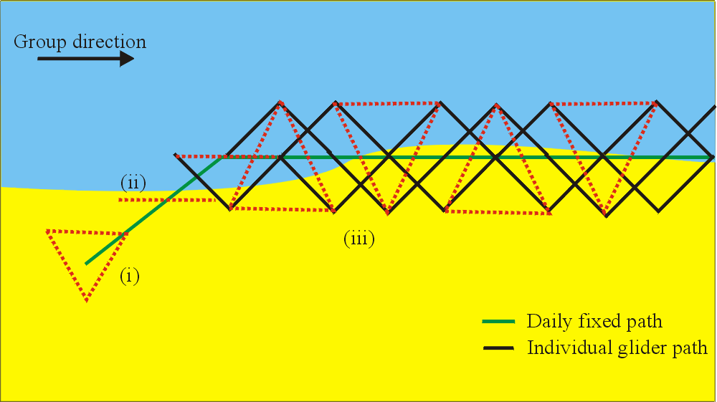
(a)

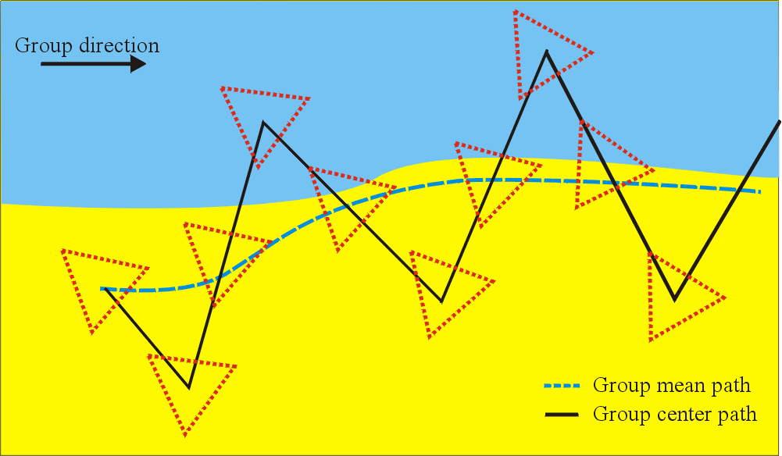

(b)

Figure 7. Adaptive sampling about a front. (a) The glider group follows a path planned (using daily adaptive sampling) to align with a front. The gliders perform the out-of-phase zig-zag about the prescribed path. Each glider passes from one side to the other of the expected front and there is always at least one glider on each side of the expected front. (b) The glider group uses temperature gradient estimates based on 2-3 hourly glider measurements to help locate and sample the front. In this case the planned path (using daily adaptive sampling) is misaligned with the front. The glider group performs a zig-zag pattern while maintaining the triangular formation. This allows for some estimate in the change in magnitude of the gradient which then can be used to help locate the front. A larger group (i.e., 4 or 5 gliders) also in a ring formation would be even more useful to estimate second derivatives.

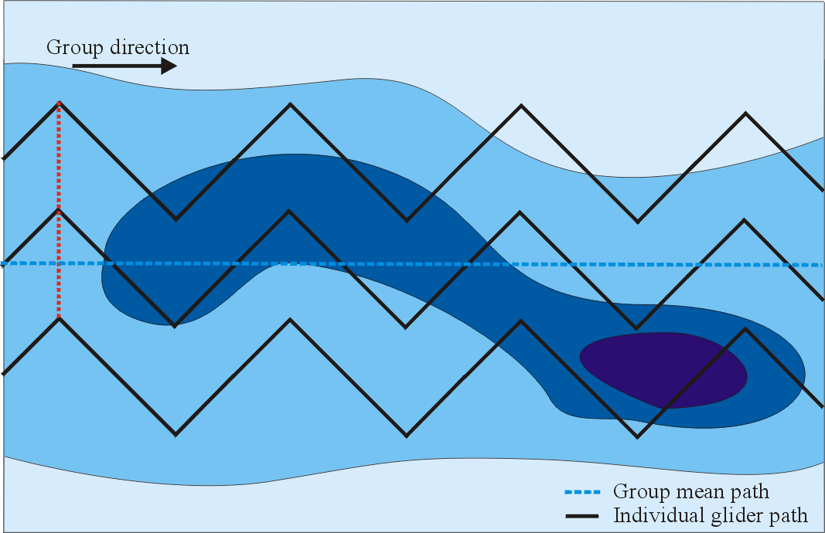
(a)

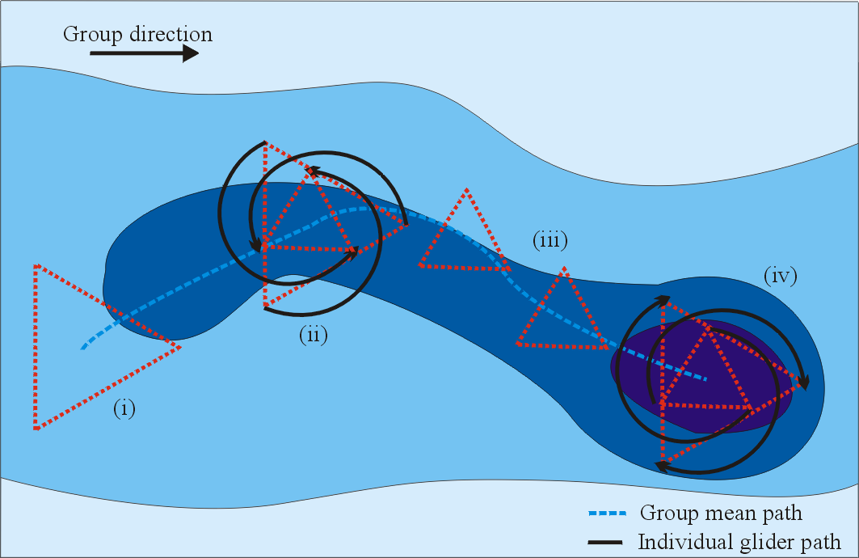

(b)

Figure 8. Adaptive sampling for coverage in region of interest. (a) The glider group performs a coordinated survey over a prescribed region of interest. The group forms a line and zig-zags in phase through the region. By staying in a line, the directional derivative of the field in the direction of this line can be computed. The orientation of this line can be changed as desired. (b) a survey of a region of interest in which gradient climbing and data-driven rotations, expansions and contractions are used to focus in on sub-regions of greatest scientific interest.

IV. Experiment Requirements and Plans for LCS Strategies

Computation of Lagrangian Coherent Structures (LCS) should improve the forecast of interesting features, such as fronts, coherent masses of moving fluid (that might have a different temperature, salinity or fluorescence) or eddies (with a scale of at least a few kilometers).

From the velocity fields forecast of the HOPS and ROMS models, LCS will be determined on a time-scale needed for the two-hourly cycle of the gliders. This knowledge will be used to help forecast the locations of interesting features. These results will then be combined with information from the modelers to decide where and what to sample, and thereby help provide accurate waypoint planning for the gliders.

Even though the modeling data may only resolve relatively large features (several kilometers) on relatively longer temporal scales (say 6-10 hours), nevertheless, having interpolated data at 30-minute intervals will enable the LCS computations to run more easily. Despite the resolution restrictions, the LCS computations should be able to locate the desired features relatively accurately. With hind casting and further analysis of the data after the experiment, one should be able to determine just how “accurately” the features that LCS identified as interesting correlate with those identified by HOPS and ROMS alone.

LCS can be computed on finer-scale observational data gathered from a group of gliders to study and predict smaller scale features (e.g., for biology and internal waves). This may be a goal for the future when more gliders are available, however, it will be useful during this summer's experiment to think about and plan the infrastructure for such a capability.

While we expect that many features of interest can be captured by 2D LCS computations, future development of LCS theory and software is needed to fully explore the connection between LCS and genuinely 3D features. This summer it is important to determine [perhaps in the RTOC] to what extent things such as upwelling plumes are captured by 2D LCS computations, representing the flow in the upper layer of the Bay. In any case, one expects that future 3D LCS computations will be of great importance for the detection and tracking of genuinely 3D phenomena.

In conjunction with the HOPS/ROMS model, we will experiment with doing LCS computations for the 2D velocity field both near the surface and at a depth of about 10 meters, which is below the mixing level. One expects that at this 10 meter depth, the dynamics are less influenced by the surface winds and more representative of the oceanography (at least in terms of the meso-scale).

The data gathered and the strategies undertaken this summer will be of great importance in determining to what extent the glider paths used are in fact optimal. We will undertake studies on optimal path planning using the software NTG (nonlinear trajectory generation). We certainly expect that rough paths developed by LCS computations---for example, paths that follow the LCS structures themselves, will already be reasonably optimal or at least provide good first guesses to insert into the optimization calculations.

Experiments to test the use of LCS to improve forecast location of interesting features.

LCS computations will be continually run during the summer experiment. The temporal output resolution of the computations will be hourly (approximately). Each day, we will analyze the LCS output history and compare the results with data reports coming from the modelers on the locations of “features of interest” (such as temperature fronts, etc.). There is convincing theoretical and experimental evidence that LCS can reveal the locations of such features. Figure 9 shows the correspondence between a cold water tongue extending down into Monterey Bay (shown in the SST plot on the left) and a LCS (shown in a DLE–Direct Liapunov Exponent–plot on the right).

Figure 9 - On the left is a SST plot for Monterey Bay for 08/17/00, 23:00 GMT. On the right is the DLE field for the Bay at the same time, computed from HF radar data. The LCS shown on the right delineates the cold tongue of water shown on the left. (Note: only LCS in the middle of the bay are meaningful since this is where reliable HF-radar data is given). The agreement is quite good and supports the contention that LCS can pick out features of interest.

Experiments to test use of LCS to provide navigation highways for efficient control of gliders.

We hope to use LCS as navigation highways for the gliders not only because they might represent desired sampling locations, but also because the currents will help propel the gliders in the direction of these structures. Figure 10 shows two gliders (Glider “A” and Glider “B”) that navigate between two fixed locations in the Bay using two methods of navigation. Vehicle “A” reaches the target region (denoted by the green triangle) by navigating along an LCS while Vehicle “B” moves to the target region by a dead-reckoning approach, where it continually redirects itself toward the target upon each resurfacing.

We propose to wait until a day where an LCS connects the inital location of a glider to a desired location where we would like to send the glider. We can use waypoint generation based on the LCS and perhaps compare a glider traveling along that trajectory with one that uses some other means for generating its waypoints. Another test consists in measuring the reduction of the surfacing frequency of the gliders by having them follow waypoints computed from predicted locations of LCS.

Figure 10 - Glider A and B start at the same location and try to reach the target region via two different methods: A follows an LCS and B proceeds via dead reckoning (treating the currents in a simple way). Glider A gets to the desired location somewhat more accurately in this example.

