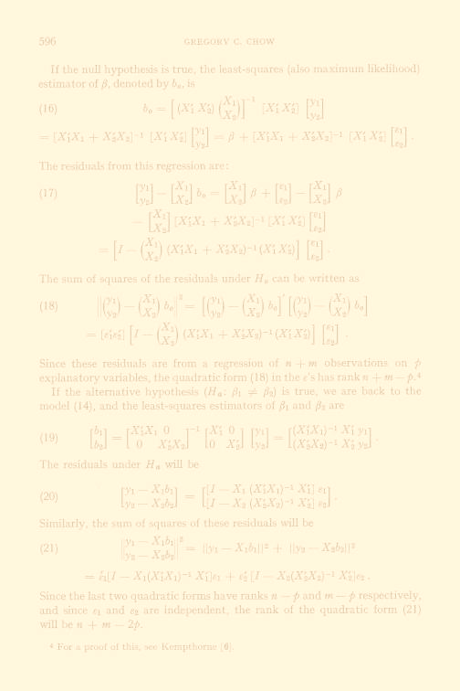
THE GREGORY C. CHOW
ECONOMETRIC RESEARCH PROGRAM
Director of Econometrics:  Bo Honoré | Oskar Morgenstern Memorial Seminar  Spring 2015  Tuesdays: 2:40 - 4:00pm  200 Fisher Hall  Speaker's Office: B13A
Mailing Address:
Princeton University - Search
Department of Economics
Princeton, NJ 08544-1021
U.S.A.
Academic Support and
Seminar Coordinator:
Annamarie Scarpati
Phone: (609) 258-6237
Fax: (609) 258-6419
ERP Related Information
ERP Archives - Working Papers
ERP Courses
ERP Faculty
ERP Home Page
ERP Resources
ERP Seminar - Archives

