Strength of weak ties on Facebook
(Assignment 5, Due: March 25, 2015)
Sociology 204: Social Networks
Matthew J. Salganik
Remember to write your name and precept on your assignment and staple it!

Short questions

1) Imagine a network where all ties are either strong, weak, or absent. Further, assume that the forbidden triad---a strong ties between A and B, a strong ties between B and C, and an absent tie between C and A---does not exist. Finally, assume that every person has two or more strong ties. Which of the following must true? [6 points]
A. All weak ties are bridges.
B. All bridges are weak ties.
C. Both A and B.
D. Neither A or B.

2) In terms of the process of spreading, what is the key difference between simple contagion and complex contagion? [2 points]

Below is a figure from Centola's (2010) paper ``The spread of behavior in an online social network experiment.'' It shows two social networks: a clustered-lattice graph (A) and a random graph (B). In both cases there are 128 nodes, each actor has degree 6, and all ties are the same strength.

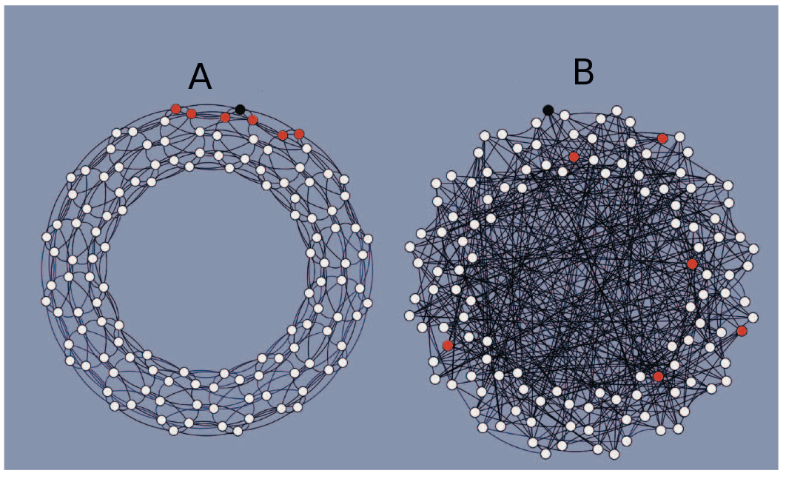

3) Based on the results in Centola (2010), in which network would you expect a simple contagion to spread faster? [5 points]
A) Network A
B) Network B
C) No systematic difference between the two networks

4) Based on the results in Centola (2010), in which network would a complex contagion spread faster? [5 points]

A) Network A
B) Network B
C) No systematic difference between the two networks

5) What is an issue that you would like to discuss in precept? [ 8 points ]

Main activity

Mark Granovetter’s paper “The Strength of Weak Ties”, published in 1973, makes a prediction about the relationship between tie strength and friend circle overlap. Could it possibly be the case that this theoretical prediction made before you were born might apply to your personal network? We are going to use the friendship data that exists in Facebook in order to test this prediction, and we should keep in mind that Granovetter had never seen (or even imagined) Facebook when he made his prediction.

On page 1361, Granovetter defines tie strength as follows: “the strength of a tie is a (probably linear) combination of the amount of time, the emotional intensity, the intimacy (mutual confiding), and the reciprocal services which characterize the tie.”

Further, on page 1362 Granovetter defines friendship circle overlap – we will call it “overlap” – between A and B to be the number of friends that A and B share divided by the total number of distinct people to whom A and B are connected. For example, if A has 100 friends, B has 120 friends, and A and B share 20 friends in common, then the overlap would be 0.10 [20/(100 + 120 - 20)].

1) Of your friends on Facebook, please complete the table for the 5 friends to whom you have the strongest tie according to Granovetter’s definition. [10 points]

First name | # of friends | # of friend in common | Overlap

2) Of your friends on Facebook, please complete the table for the 5 friends to whom you have the weakest tie according to Granovetter’s definition. [10 points]

First name | # of friends | # of friend in common | Overlap

3) Describe a procedure to randomly select 10 friends from your list of friends on Facebook. Because we are doing science here, your procedure 1) should result in a true random sample where all of your friends have an equal probability of inclusion and 2) should be described clearly enough so that another scientist could replicate it. [4 points]

4) Use the procedure in question (3) to generate a list of 10 randomly selected friends. For these 10 randomly selected friends, complete the table below. [10 points]

First name | # of friends | # of friends in common | Overlap

5) Comparing your strongest ties to your weakest ties, does your data support Granovetter’s prediction? Use numbers to support your conclusion. [5 points]

6) Comparing within your randomly selected friends, does your data support Granovetter’s prediction? Use numbers to support your conclusion. [5 points ]

7) Comparing your strongest ties, your weakest ties, and your random ties, does your data support Granovetter’s prediction? Use numbers to support your conclusion. [10 points]

8) Do any of your weak ties that have higher overlap than your strong ties? If yes, what might explain these outliers? [10 points]

9) Do any of your random ties that have higher overlap than your strong ties? If yes, what might explain these outliers? [10 points]

