Assignment 9: Emotional contagion
Sociology 204 (Social Networks)
Matthew J. Salganik
Due: April 22, 2015
Remember to write your name and precept on your assignment and staple it!

Short answer questions

1) Which better summarizes the empirical findings of the emotional contagion experiment of Kramer et al? [10 points]

a) Reducing positive words from people’s newsfeed appeared to make them happier.
b) Reducing positive words from people’s newsfeed appeared to make them sadder.

Imagine that Marvin the Martian comes to Earth, and he is able to acquire the voter turn out records from the town of Princeton during the 2012 presidential election. Marvin notices that voting seems to clustered within households. That is, there are more households where no one voted than would be expected by chance and there are more households where everyone voted than would be expected by chance. From this Marvin concludes that voting must be contagious. Based on what we have read in class, what are two alternative explanations for this observed pattern? Your answers should be clear and simple so that a Martian can understand them.
2) Alternative explanation 1 [5 points]:

3) Alternative explanation 2 [5 points]:

4) Consider these three possible relationship patterns between ego and alter.
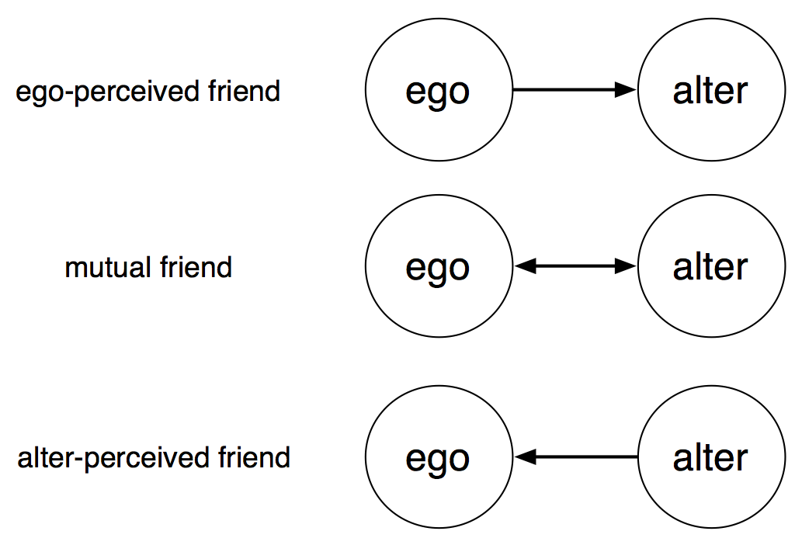

Based on the data from Christakis in Fowler, if alter becomes obese, in which case is ego most likely to become obese? [10 points]

a) ego-perceived friend
b) mutual friend
c) alter-pereceived friend

5) What is one issue or question that you would like to discuss in precept this week? [35 points]

Emotional contagion

1) Write a New York Times Op-ed in response to the Facebook emotional contagion experiment. You should follow the format that the New York Times requires, in particular the length of your op-ed should be between 400 to 1,200 words. Also, you should read this article by Trish Hall about the kind of pieces they like. Great op-ed pieces make one point clearly and convincingly [30 points].

If you are having trouble getting started, here are some op-eds that were written in response to the Facebook emotional contagion experiment.

“Should Facebook Manipulate Users?” By Jaron Lanier
http://www.nytimes.com/2014/07/01/opinion/jaron-lanier-on-lack-of-transparency-in-facebook-study.html

“Stop complaining about the Facebook study. It's a golden age for research” By Duncan J Watts http://www.theguardian.com/commentisfree/2014/jul/07/facebook-study-science-experiment-research

“The Real Reason You Should Be Worried About That Facebook Experiment” By
Janet Vertesi
http://time.com/2950699/facebook-experiment-social-science-funding/

“The test we can – and should – run on Facebook” by Kate Crawford
http://www.theatlantic.com/technology/archive/2014/07/the-test-we-canand-shouldrun-on-facebook/373819/

And, here’s one that I wrote for a more specialized audience:
“After the Facebook emotional contagion experiment: A proposal for a positive path forward” by Matthew Salganik
https://freedom-to-tinker.com/blog/mjs3/after-the-facebook-emotional-contagion-experiment-a-proposal-for-a-positive-path-forward/

Finally, here’s a complete list of op-eds on the topic: http://laboratorium.net/archive/2014/06/30/the_facebook_emotional_manipulation_study_source

When evaluating your op-ed we will use the following criteria:

Does the op-ed make one point clearly and convincingly?
10: one point is made clearly and convincingly, and this point is related to the emotional contagion experiment
8:
6: there is one point but it is not argued strongly or it is not related to the emotional contagion experiment
4:
2: the op-ed has no point or it has so many points that it essentially has no point

Is the op-ed factually correct? Obviously, factual errors weaken your credibility.
10: no factual errors
8:
6: one major factual error or so many minor factual errors that the op-ed suffers
4:
2: many major and minor factual errors

Is the op-ed logically organized and clearly written? There should not be grammatical or spelling errors, and the op-ed should avoid jargon that will not be understood by a general audience (e.g., readers of the New York Times).

10: writing is clean and crisp, much like one would see in the New York Times
8:
6: organization, grammar, spelling and general writing style interfere with the arguement
4:
2: writing interferes with the ideas being presented

2) Write a headline for your op-ed. Your headline should be clear and punchy. [5 points]

5: Great headline, captures attention and is clearly related to the op-end

4:

3: Weak relationship to op-ed and/or does not really capture attention

2:

1: No relationship to op-ed and will not capture attention

