Core discussion networks of Princeton students
Assignment 7 (Due: April 12, 2017)
Sociology 204: Social Networks
Matthew J. Salganik

Short answer questions:

1) Imagine that next year humans discover that there is life on Mars. Further, by overhearing the Martian phone calls, humans learn that the Martians actually have complex patterns of social relations. For example, it was discovered that Martians have a special relationship called occra, which is similar to friendship in human, but the precise characteristics of this relationship are still be studied. However, one thing that has been discovered is that occra is an undirected relationship; that is, you would say that Peter and Paul are occras not that Peter is Paul's occra. If not all Martians have the same number of occras, which of the following must be true about the network of occras between Martians? Please do not assume that Martian social relations look anything like human social relations. [10 points]

a) There is short average path length
b) There is high clustering coefficient
c) both (a) and (b)
d) The mean number of occras of occras will be greater than or equal to the mean number of occras of Martians
e) The number of occras of every Martian is less than the average of occras of his or her occras
f) We don't know for sure any properties of the occras network because we don't know enough about this type of relationship

2) Consider the network shown here. How does the clustering coefficient and average path length of this network compare to an Erdos-Renyi random graph with the same number of nodes and edges? (Note that this is exactly question 5 from the midterm, a question that many people did not answer correctly). [10 points]

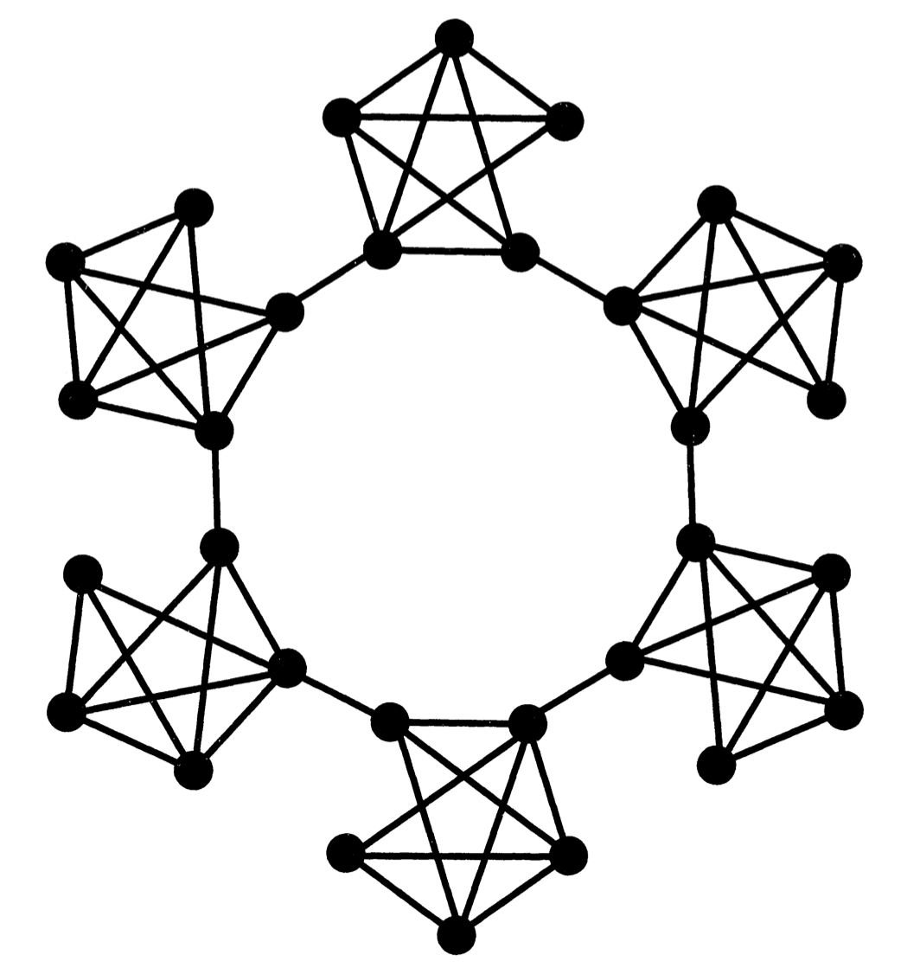

a) Erdos-Renyi random graph would have higher clustering coefficient and higher average path length
b) Erdos-Renyi random graph would have higher clustering coefficient and about the same average path length
c) Erdos-Renyi random graph would have higher clustering coefficient and shorter average path length
d) Erdos-Renyi random graph would have about the same clustering coefficient and higher average path length
e) Erdos-Renyi random graph would have about the same clustering coefficient and about the same average path length
f) Erdos-Renyi random graph would have about the same clustering coefficient and shorter average path length
g) Erdos-Renyi random graph would have lower clustering coefficient and higher average path length
h) Erdos-Renyi random graph would have lower clustering coefficient and about the same average path length
i) Erdos-Renyi random graph would have lower clustering coefficient and shorter average path length
j) Impossible to say

3) This figure was included in a paper that you read for class. What was the authors trying to illustrate with this figure? (Note that this is exactly question 16 from the midterm, a question that many people did not answer correctly). [10 points]
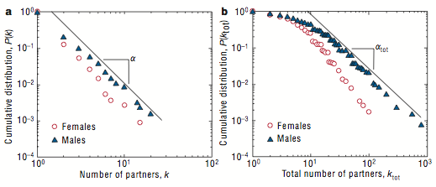
a) the networks were created by a process similar to the Watts alpha model
b) the networks were created by a process similar to the Watts-Strogatz beta model
c) the networks were created by a process similar to the Erdos-Renyi model
d) the networks were created in a setting with many large foci
e) the networks were created in a setting with many small foci
f) the network is a spanning tree
g) all of the above
h) none of the above

4) What is one question or issue that you would like to discuss in precept? [10 points]

Core discussion networks of Princeton students

This week we read about the core discussion networks of Americans, and now we are going to learn about the core discussion networks of Princeton students.

5) Please complete the “Predicted” column in the table below. These are your guesses about the core discussion networks of Princeton students. And, we will be defining core discussion networks in the same that McPherson et al did: people with whom the respondent discusses important matters. So, for example, the first row as you to predict the average size of a Princeton student’s core discussion network. The second row asks you to predict what percentage of core discussion partners of Princeton students are Princeton students. These predictions can be based on whatever you want, including your experience and the readings for the class, [10 points]

 | Predicted | Actual
Average size of core discussion network
Percentage of core discussion network that is kin
Percentage of core discussion partners of Princeton students that are Princeton students
Percentage of core discussions pairs of Princeton students (i.e. ego and alter both Princeton students) that are the same gender
Percentage of core discussions pairs of Princeton students (i.e. ego and alter both Princeton students) that are in the same eating club
Percentage of core discussions pairs of Princeton students (i.e. ego and alter both Princeton students) who lived in the same residential college freshman year
Percentage of core discussions pairs of Princeton students (i.e. ego and alter both Princeton students) who are the same race/ethnicity

Now that your predictions are made, please select 3 of your friends to be interviewed (note: you should read the entire assignment before doing your first interview). Ask them if they would like to help you complete your assignment and tell them that each interview will take approximately 10 minutes. For each friend, please complete a survey form that you can download from the Piazza. After collecting the data, please answer the following questions.

6) Based on your interviews, please complete the actual column of the table. [10 points]

7) Based on your data, do Princeton students have larger or small core discussion networks than Americans? Here core discussion networks are defined in the way that McPherson et al. did: people with whom the respondent discusses important matters. For this question, you can assume that the McPherson et al. (2006) article is correct. Be specific and cite data. [10 points]

8) How did you predictions compare to your results? For which kinds of things were your predictions most accurate? Least accurate? Be specific and cite data. [10 points]

9) Please speculate about what might explain which of your predictions were accurate and which were inaccurate. [10 points]

10) Finally input all of your survey data (not your predictions or analysis results) into the class data collection website; the link will be posted on Piazza. This aggregated data will give us a fuller picture of the core discussion networks of Princeton students and will be discussed in precept. Did you upload your data? [10 points]

a) yes
b) no

