Extron Insider Site
Extron resellers, consultants, and educators have access to a host of valuable services, including online ordering, order tracking, and more through the Extron Insider Web site. This secure-access area is just a click away from the Extron public Web site. To join Extron Insider, contact your Extron Customer Support Representative.

Who is Extron
The Extron Way

Satisfaction Guarantee and Warranties
As a leading manufacturer in the AV industry, Extron is committed to engineering and manufacturing our products to the highest standards of quality, performance, and value.
To underscore this commitment, we offer our Satisfaction Guarantee. This means we will work diligently to resolve any issue you have with your purchase until you are completely satisfied. Extron employees are prepared to do whatever it takes to make certain that the entire process of doing business with us is a positive and professionally rewarding experience for you.
Extron provides a Powered Product Warranty, Lifetime Limited Cable Performance Warranty, and Product Satisfaction Guarantee. For more information on Extron Warranties and Guarantee, please review Extron Business Policies.

Support
Extron believes in the value of educating our customers, not just selling product. We present a wide variety of training and educational programs in the USA, Europe, and Asia each year to broaden your AV knowledge and help you keep pace with new technologies and product deployments.

Who is Extron
The 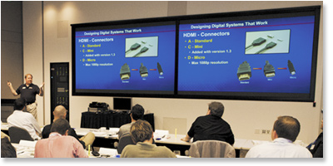
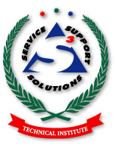
Top of Form
Bottom of Form

S³ Technical Institute
In order for AV professionals to succeed in an industry under constant change, they must have all the latest knowledge and resources available. That is why Extron Schools were founded. Our goal is to provide easy access to information needed to excel in this industry.
Extron is establishing new permanent training facilities around the world, the most extensive being the 6,600 square feet Extron West S³ Training Facility at our Corporate Headquarters in Anaheim California, and an S³ training facility at Extron East in Raleigh, North Carolina.
Other worldwide training facility locations include, Dallas, Washington DC, London, Paris, The Netherlands, Dubai, Bangalore, Tokyo, Shanghai and Singapore.
The S³ Technical Institute offers a variety of education and training services to help AV professionals keep up with new developments in the industry. These services include Extron Institute Schools and product training through distance learning (videoconferencing).


Top of Form
Bottom of Form

Extron Institute Schools
Extron Institute Schools offer classes and hands-on experience to Extron resellers and AV industry consultants. Topics range from fundamental AV concepts to the latest cutting-edge technology. Participants who successfully complete an Extron Institute School earn continuing education units. These unique schools are available with subject matter tailored to meet specific objectives.
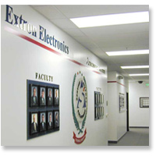

School of AV Technologies for System Designers
(not available in the United States)
The School of AV Technologies for System Designers builds upon your existing audiovisual knowledge by exploring new concepts, techniques, technologies, tools, and applications. System Designers who complete this two-day school attain a thorough understanding of various AV system design skills and knowledge. This includes digital video signal transmission, signal processing, managing the video signal, configurable control systems, and audio fundamentals. These acquired skills and capabilities are applied in hands-on simulations where you are tasked with the planning and execution of real-world AV scenarios. You are required to complete a comprehensive exam upon conclusion of the school. For the Education sector, the information in this school is also covered in our custom School of AV Technologies for Higher Education course.

Top of Form
Bottom of Form

School of Emerging Technologies
The School of Emerging Technologies provides in-depth instruction designed to allow system designers and integrators to master additional AV technologies within a short time span. The training concentrates on new as well as evolving technologies, helping to refine digital AV system design by teaching concepts and techniques for different technologies. The student-instructor ratio is kept low to ensure that each class member receives individual attention. The School of Emerging Technologies provides instructor-led training and demonstration along with hands-on experiences in real-world scenarios to reinforce understanding of the technologies.

School of Configurable Control Systems
The School of Configurable Control Systems is a one-day school that will provide you with the knowledge and hands-on skills to fully configure not only MediaLink® systems, but the new TouchLink touchpanel systems as well. Topics include Configurable Control, Configuration Software, and Real Hands-on Exercises.

Extron Distance Learning Program
Videoconferencing
Extron resellers can now take advantage of customized Extron training programs delivered through the latest videoconferencing technology. Distance learning through videoconferencing is an easy and efficient way to obtain critical product and technology training without the usual downtime and travel expense associated with professional development.
In addition, Extron videoconference training offers the following benefits:
- Training curriculum is tailored to your specific educational requirements
- Sessions are scheduled for a time that's most convenient for you
- Like other Extron training programs, this service is provided at no charge to you
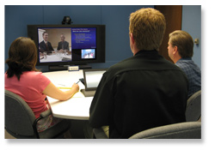
Top of Form

Extron Distance Learning Program (cont'd)
E-Training on Demand
Extron E-Training On Demand is a training service that meets the need for urgent employee training on specific topics. This training is focused on the installation process of Extron products and the use of software applications and utilities.
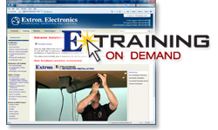
A video of the process will be presented with narration which will guide the user through specific tasks. Learners can go directly to a chapter for a specific step or move through the chapters order they appear to get a full understanding of the complete application.
E-Training On-Demand is openly available to all Extron Insiders through the Extron specialty Web site.
Top of Form
E-Training
Extron has developed online training modules that can be accessed from any computer with an Internet connection. The online courses measure knowledge of general AV concepts such as basic electricity, AV technologies such as cable, and Extron product knowledge.

Extron Distance Learning Program (cont'd)

Out of the Box videos
Extron Out of the Box videos are an instructional series that demonstrate the speed and ease with which Extron products can be installed and configured, right Out of the Box. Geared toward AV integrators and installers, Out of the Box videos provide an unedited and unvarnished view of the time saving, integration-friendly features that are engineered into every Extron product. All videos are produced in one continuous take and demonstrate how to set up an Extron product from opening the box to fully configured and operational, typically in 15 minutes or less.
Complete school details and schedules can be found at www.extron.com in the Training and Education section. For more information about any Extron training program in the USA, Europe, or Asia, contact your local Extron support representative.
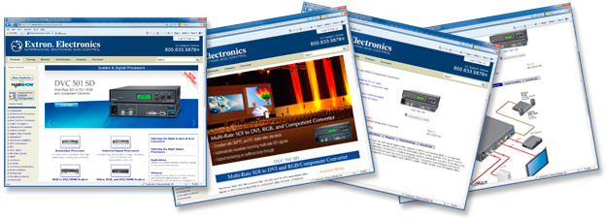

Extron Web Site
Access detailed product information, download customer support literature, and brush up on your knowledge of AV technologies at the Extron comprehensive Web site: www.extron.com.
Top of Form

Solutions

No solution is complete without the right product. That's why Extron offers a wide selection of AV products for just about any application. Each product is engineered to meet our customers' highest expectations of performance, dependability, and value. These products are useful in integrating computer, video, and audio into presentation displays for today’s boardrooms, presentation/training centers, university lecture halls, and other applications.
To maintain the highest quality and ease of use possible, Extron is continually evolving to reflect the latest technological advances. Application and end user requirements are constantly shifting, so it's important for Extron to stay ahead of the curve by developing new and innovative solutions for an ever-changing world.
The following pages will detail the categories for all of the Extron products.
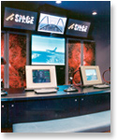
Top of Form

Interfaces
Computer video interfaces help you make the connection between a computer workstation and a video projector, plasma / LCD display or other data display. Interfaces have three main purposes. The first is to split the computer video signal so that it can drive a local display and a second large screen display at the same time. The second is to amplify, equalize, and condition the video and sync signals so that they can be sent down long cable runs while maintaining image quality. The third is to convert the computer's unbalanced stereo audio signals to balanced audio, making it easier to send these signals long distances without interference. Interfaces may also provide many other capabilities such as horizontal and vertical position control, multiple inputs, sync separation, sync combining, and test signal generation.

Twisted Pair
Extron Twisted Pair products are the electronic signal conversion devices that are used to adapt common AV signal types, including composite video, S-video, component video, RGBHV, audio, and RS-232 control, for distribution over standard Category-type twisted pair cabling.

Architectural Connectivity
The Architectural Series of Extron products accommodate the requirements of a fully integrated AV facility. The Architectural Series is designed as a system solution for permanent installation environments such as boardrooms, training facilities, and command and control centers. With products that mount in walls, shelves, in or under tables and podiums, the Architectural Series of products blend into the surrounding environment, creating a professional and manageable presentation system that's easy to operate and virtually out of sight when not in use.

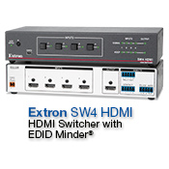

Switchers
A switcher connects to two or more input sources and allows a user to select which signal will be routed to a display device or another destination. For example, a two input RGB switcher can be used for an application where two computers with different presentations must be displayed on a single data projector. Each computer’s video signal is connected to the switcher’s inputs and the switcher’s output feeds the selected signal to the data display. The presenter can switch back and forth between the two computer signals using the switcher front panel controls or a remote control.
Extron makes the following types of switchers: audio/video, computer and RGB, MediaLink®, media presentation, seamless, and system.

PoleVault®
Extron PoleVault® Digital Systems are easy-to-use, easy-to-install, economical classroom AV systems that incorporate twisted pair technology for signal transmission. They also include network connectivity for web-based system management and control.
There are two PoleVault System packages which streamline the design and procurement process. These two- and four-input packages include all the necessary audio and video switching, audio amplification, system control, source connectivity, speakers, mounting hardware, and cabling for a complete classroom AV solution. All that remains is to add the video projector, projection screen, and sources.
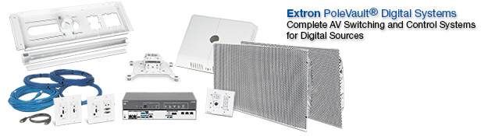
Top of Form

Matrix Switchers
Matrix switchers are a special category of switcher that offers multiple inputs and multiple outputs. Any input can be connected, or “tied” to one or more outputs. Several ties can be active at one time. For example, input one can be tied to outputs one, two, four and six, while input three is tied to outputs three and five. Such combinations can be programmed as a "preset".

MediaLink®
The Extron MediaLink® System is a family of easy-to-use and inexpensive products that work together to control A/V equipment in any small, one-projector classroom, boardroom, or auditorium. The MLC 226 IP MediaLink Controller acts as an extended remote control panel, and can be mounted on a wall, podium, or lectern. There are also a variety of MediaLink Accessories that include Architectural Adapter Plates (AAP), remotes, wall plates, mounting brackets, and junction boxes.
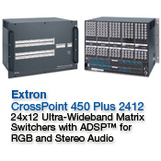
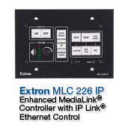

IP Link®
The Extron IP Link® Series of compact Ethernet Network Interfaces enables almost any AV device to be monitored, controlled, and managed from any computer connected to a Local Area Network (LAN), Wide Area Network (WAN), or the Internet.

Distribution Amplifiers
Distribution amplifiers (DAs) are products that distribute multiple outputs from a single source input. They provide amplification and enhancement features for signals. An example of this can be seen while standing in line for a ride at an amusement park where monitors have been installed throughout the attractions’ waiting areas in order to provide entertainment or important information for waiting guests. One video signal is distributed to multiple monitors.
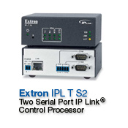
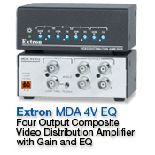
Top of Form

Configurable Control
Extron has been delivering fully configurable control systems for more than a decade. Our MediaLink Controllers have proven to be easy to configure, yet flexible and powerful enough to meet the needs of most typical AV system applications.
The development of the IP Link platform defined the next generation of Extron configurable control systems. Global Configurator software was created to make the entire configuration process straightforward and easily repeatable.
Extron TouchLink Touchpanels are the industry’s first fully configuration-based touchpanels. They provide an attractive user interface suitable for any room and offer a variety of mounting solutions.
Extron MediaLink, IP Link and TouchLink are all designed from the bottom-up to be fully configurable.
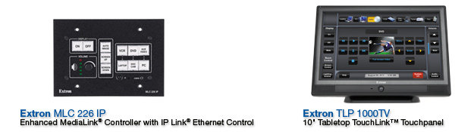
Who is Extron
The Extron Way
Top of Form

Streaming
Extron offers a variety of products for high quality streaming, recording and playback of high definition video and computer graphics, audio, and control signals over IP networks.
The Extron streaming product line employs standards-based H.264 / MPEG-4 AVC encoding or Extron PURE3® Codec, a unique wavelet-based compression technology.
Systems using Extron streaming products are highly scalable and allow distribution of signals across a city or around the world.
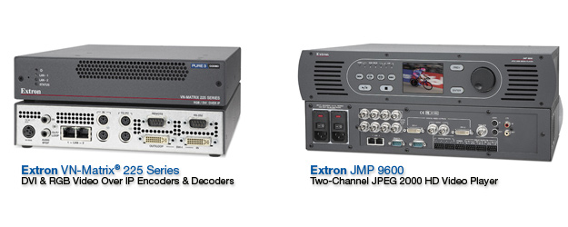
Who is Extron
Top of Form

Signal Processor
Simply put, signal processing alters a signal in a desired way. It could involve converting composite video to S-video, amplifying or peaking a signal, or completely reformatting the signal. Signal processors can improve the quality of an image, make routing and distribution easier, or allow images to be displayed in a way that would not normally be possible.
Extron offers a number of signal processing devices tailored to specific application environments.

Fiber Optics
Extron Fiber Optic products are designed for long haul transmission of audio and video as well as RS-232 control signals over fiber optic cable. In AV applications with very long distance requirements, fiber offers several important advantages including the capability to send AV signals over extreme distances — up to 30 km (18.75 miles), zero signal degradation along the cable, and immunity to outside interference. Signals sent through fiber are also inherently secure, making fiber-based transmission the preferred choice in government, military, and medical applications.Who is Extron
The Extron Way
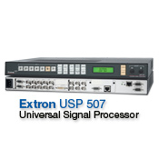
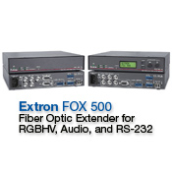
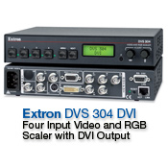

Who is Extron
The Extron Way

Scaler

Scalers take in a video or RGB signal at one resolution and then convert it up or down to a different resolution. The three categories of Extron scalers include video scalers, RGB scalers and universal scalers.
Video Scalers take a standard video signal, decode it, and uses video processing technology to scale the image up to the optimal or native resolution of a display device. Many video scalers also let you select the desired output refresh rate.
RGB Scalers accept RGsB, RGBS and RGBHV interlaced and progressive scan video signals and upscale or downscale them to the desired resolution and refresh rate to match the native or optimal resolution of the display device.
Universal Scalers combine many of the features of video scalers and RGB scalers. They may also include other features such as transcoding from one format to another (i.e. converting S-Video to composite video) or standards conversion (converting NTSC to PAL).

Scan Converters
A scan converter is a device that converts a computer-video signal into a signal that is compatible with a television. Sometimes a scan converter is referred to as a "PC to TV" converter or a "PC to video" converter because it allows you to view computer-video on a TV set. Although the concept seems simple, scan converters use complex technology to achieve signal conversion because computer signals and television signals differ significantly. A scan converter changes computer-video signals to NTSC or PAL for use in video recording, video conferencing, or viewing applications.

Audio Products
Audio Products from Extron are a wide array of solutions ideal for AV sound system installation and operation. Audio Products include switchers, distribution amplifiers, matrix switchers, power amplifiers, speakers, signal processors, bulk cables, cable assemblies and adapters.
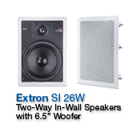
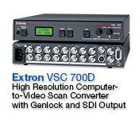

Specialized Products
Because each Extron Specialized Product has a unique use, they do not fit neatly into traditional product categories. This category includes ground loop isolators/inhibitors, VideoShift™ products, video test generators, and more.

DVI & HDMI
DVI and HDMI products from Extron enable a true digital-to-digital connection between computers or high definition video sources and displays that utilize Transition-Minimized Differential Signaling, or TMDS, digital video signals. TMDS is common to both the DVI — Digital Visual Interface, and HDMI — High Definition Multimedia Interface technologies now being implemented between computers or high definition video sources, and newer digital monitors and projectors.
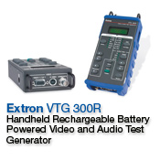
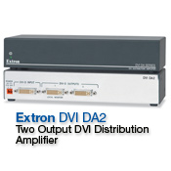
• Individual conductor
• Twisted pair
• Coaxial
Bulk cables are available in several categories and are sold in spools of 250, 500, and 1000 foot lengths.
Cable Assemblies come pre-terminated (one or both ends) with a variety of high-quality connectors and are sold in a variety of lengths ranging from 3 feet to 100 feet. Custom cable solutions are also provided.
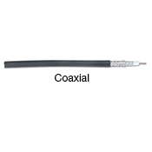

Bulk Cables & Connectors
Bulk Cables & Connectors are important, but often overlooked, components in a display system. Poorly performing cables and connectors can adversely affect an entire system, which is why they are often called the weakest link in any chain of electronic devices.
There are so many different models and types of cables available in the industry that it's easy to be intimidated when glancing through a cable catalog. However, all the various cable types aren't that different. They are simply combined variations of basic cable configurations that fall into the following main conductor groups:
Top of Form
Bottom of Form
Top of Form

Cables & Adapters
Cables and adapters form the backbone and are critical components of every AV system. Extron offers an extensive variety of pre-terminated cables and adapters that meet virtually all your AV needs. The high performance cable assemblies and adapters are fully tested to ensure consistent quality.

Mounting Hardware
Extron offers a wide selection of mounting hardware designed and engineered to integrate sophisticated AV equipment into today's business and professional environments. Products in this category provide versatile options for mounting devices discreetly into or under furniture, onto projector mounting brackets, and into racks. Mounting hardware categories include Through-Desk, Back of Rack, and Shelf Mounting Kits, Under-Desk Mounting Kits, Projector Mounting Kits, Rack Shelves, and Mounting Plates and Boxes. These hardware-mounting solutions provide additional flexibility for permanent installation environments such as boardrooms, classrooms and universities, training facilities, and command and control centers.
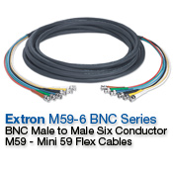
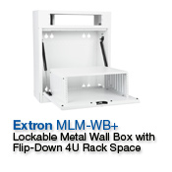

Application Solutions
Image projection is utilized in virtually every industry from business, education, government, and entertainment, to events production, and religious services. Enabling image projection typically requires an integrated system of AV devices including:
- Presentation displays – LED, DLP, Plasma, LCOS, LCD, CRT
- Sources – Computers, document cameras, video cameras, Blu-ray and DVD players, video decks, CODECs
- Audio – Projector’s speakers and/or additional audio amplification
- Control – Projector control and control of AV components and room settings
- Connection – The "glue" of AV systems: interfaces, switchers, distribution amplifiers, signal processors, and cabling
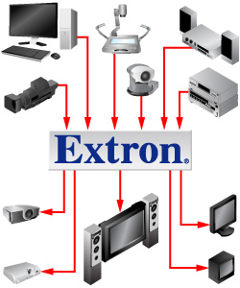

Top of Form

Toll-Free Telephone Support
Extron provides 24-hour toll-free support in the United States and Canada via our S³ Sales and Technical Support Hotline at 800-633-9876.
You can contact our Control Systems Support at 800-633-9877.
You may reach our Order Support at 800-633-9873.
These numbers allow you to contact Extron for:Extron Tools
Product ordering and status tracking | Application advice and assistance
New and existing product information | System design
Interfacing requirements | Training
Technical and troubleshooting support | Repairs
Top of Form

International Telephone Support
These S³ Sales and Technical Support Hotlines are available during regular office hours (Monday through Friday) with all phone calls answered by an Extron Customer Service Representative.
In Europe, you can reach Extron at +800.3987.6673.
In Asia, you can reach Extron at +800.7339.8766.
In Japan, you can reach Extron at +81.3.3511.7655.
In China, you can reach Extron at +400.883.1568.
In the Middle East, you can reach Extron at +971.4.299.1800.
In Korea, you can reach Extron at +82.2.334.1571.
In India, you can reach Extron at 1800.370.3777.
Extron Tools

Support-On-Call Service
For technical support issues after regular office hours, our Support-On-Call service initiates an immediate page to an experienced Extron Application Engineer who will return the call within 30 minutes or less (USA and Canada only).
Our highly trained support team provides the resources needed to simplify the task of system integration. Altogether, the Hotline and the Support-On-Call services provide 24/7 coverage for all Extron customers.

The site includes three key features for accessing information:
- High-speed search engine
- Category tabs
- Product Shortcut drop-down menu and icons
The search engine saves time and effort by allowing you to search by product name (e.g., GSS 100), by application type (e.g., videoconferencing), or by technology (e.g., CAT 5).
In addition, key words or phrases relating to a product, technology, or application can be entered to receive a list of search results. Web pages can be bookmarked for immediate retrieval or accessed directly by including the model name in the URL (e.g., http://www.extron.com/gss100).

Extron Web Site Overview
The comprehensive Extron web site, www.extron.com, provides a gateway to detailed product information, downloadable customer support literature, and a variety of technical resources for resellers, consultants, and schools and universities as well as the general public.

Category Tabs and Product Drop Down Menus
The six main category tabs — Products, Training, Markets, Tech Library, Company, and Download — allow you to navigate deeper into any given category.
The Products tab breaks down all Extron products into specific types (e.g., interfaces, switchers, etc.); the Training tab takes you to training schedules, online training resources, and certification programs; the Markets tab features real-world application profiles and is particularly helpful for new employees; the Tech Library tab accesses a wide variety of literature covering technologies integrated into Extron products, product specs and manuals, and Tech tools—all of which are helpful to new employees, especially technical staff; the Company tab links to Extron contact information, career opportunities, and the press room; and the Download tab lets you view or update the most recent application diagrams, firmware, device drivers, cross-references, specifications, or user manuals for Extron products.
The Product Shortcut drop-down menu allows quick and easy access to virtually every Extron powered product page, while icons are provided for Tech Tools and other training and educational resources.
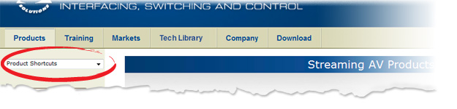

Extron Insider Web Site
Extron Resellers, Consultants, and Educators can log on to the Extron Insider Web site and access a host of valuable, specialized services. This secure-access area is bookmarkable, or at most, just a click away from the Extron public Web site. The Extron Insider home page sub-menu includes Sales Desk, Price Lists, Tools, Forms, Account Management, and Archives.
Extron Insiders are able to check product order and return status, access price lists and online tools, request Extron Institute schedules and enrollment, change user preferences and passwords, and access any past or present electronically distributed publications. Additional links include Product Highlights, New Product News, Product Availability, Training and Education for access to E-Training On Demand and Certification information, Special Announcements, and Where In The World Is Extron? featuring dates and locations for training and tradeshow exhibitions.

Top of Form

School and University Web Sites
The specialized Web sites for Schools and Universities provide access to the AV Wire Library, online publications targeted for Instructional Technology Professionals.
In addition, there are links to instructional-based application profiles, application diagrams, products, training, and trade show information. To set up an online account, contact your Extron Customer Support Representative at 800.633.9876 or submit a registration form 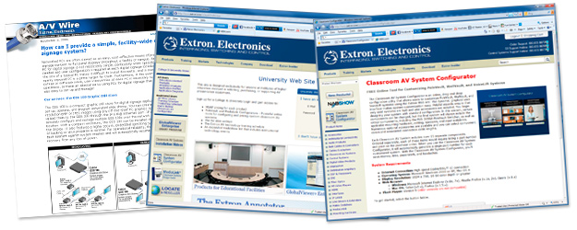

Mobile Web Site
A version of the Extron Web site optimized for mobile devices can be found at: mobile.extron.com. (English only)
This site provides quick and easy access to key product description and features, part numbers, images and specifications. Pricing information is available with an Extron Insider login.
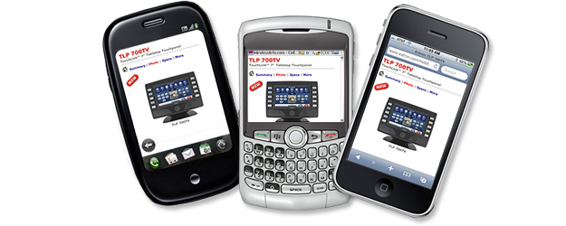
Extron Tools

Selection and Configuration Tools
The following selection and configuration tools are available online to assist in AV system integration efforts:
Calculators - A series of easy-to-use calculation tools designed to assist video and sound system designers, engineers, and technicians.
Matrix Switcher Builders - Allows users to custom configure matrix switchers and select from a variety of extender, switcher, and cable products to meet exact requirements.
Collaboration System Builder – An online tool which simplifies the process of planning, configuring, and ordering custom TeamWork systems
Engineering and System Design Resources - A variety of tools aimed at helping AV consultants, system designers and integrators with their design needs.
AV System Builders - Allows users to design AV systems and save their configuration online for reference or modification.
Architectural Connectivity Configurators – A drag-and-drop tool for designing and customizing architectural connector installations.

Staying Current
Staying up to date on new products, technical bulletins, and training opportunities is a key component of the Extron Web site. The following references and tools, some available only through subscription, will keep you current:
E-News – Monthly electronic bulletin for resellers and consultants provides new product information, shipping schedules, changes and updates, and special announcements.
NewsFlash - Timely bulletins deliver the critical information you need to keep up to date with pricing, new product announcements, and other essential information.
AVWire – E-mail newsletter describes how featured Extron products can be used to solve audio/video challenges typically encountered in educational environments.
AV Systems Design – AVSD is a technical journal from Extron that provides technical articles covering a variety of subjects, product information, case studies, application ideas, and valuable design, installation, and troubleshooting tips.
The next page will tell you how to gain access to these resources.Staying up to date on new products, technical bulletins, and training opportunities is a key component of the Extron Web site. The following references and tools, some available only through subscription, will keep you current:
E-News – Monthly electronic bulletin for resellers and consultants provides new product information, shipping schedules, changes and updates, and special announcements.
NewsFlash - Timely bulletins deliver the critical information you need to keep up to date with pricing, new product announcements, and other essential information.
AVWire – E-mail newsletter describes how featured Extron products can be used to solve audio/video challenges typically encountered in educational environments.
AV Systems Design – AVSD is a technical journal from Extron that provides technical articles covering a variety of subjects, product information, case studies, application ideas, and valuable design, installation, and troubleshooting tips.
The next page will tell you how to gain access to these resources.Top of Form

Staying Current (Continued)
To gain access to any of these resources, do one of the following:
- Subscribe through the Extron Web site
- Contact your Extron Customer Service Representative
If you miss an article or publication, there's no need to worry. An Archive section provides links to past and present Extron articles and publications.Bottom of Form
Top of Form

Printed Publications
Extron has a variety of catalogs, guides and other publications that can assist you with your AV system needs. These include:
- Full Product Catalog
- New Product Brochure
- Reseller Price Guide
- AV Systems Design Journal
- Design Guides
- Cable Guide
- Unified Software CDs
Contact your Extron Customer Service Representative or go to the Literature Request page on the Extron Web site to order any of these publications. To order the Reseller Price Guide, contact your Extron Customer Service Representative.
In addition, the Unified Software CDs provide another means of obtaining device drivers, user manuals, firmware updates and software. Each CD also contains common Extron IP Link utilities such as DataViewer, IP Link File Manager, etc. as well as other third party utilities such as such as Adobe® Reader® and Microsoft®.NET framework, which may be needed to use certain applications on the CD.

Electronic Video Signals
Electronic video signals are of two types: Analog or Digital. Video signal transmission began as analog; however, digital signal transmission is now rapidly replacing analog with the advent of new technologies.
We will now clarify the differences between the two.
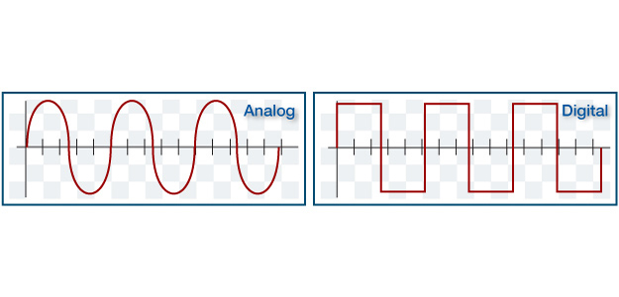

Analog Video Signals
An analog video signal consists of a low voltage signal containing the intensity information for each line, in combination with timing information that ensures the display device remains synchronized with the signal.
An analog video signal is often represented as a sine wave, where the vertical axis represents the signal amplitude, or brightness attribute of the video image, and the horizontal axis represents the changes in frequency which affects the sharpness or detail in the image. Changing the wave’s amplitude represents the different colors on the screen.
Analog signals vary in amplitude over time and can represent an infinite number of values or levels between its highest and lowest points. A typical analog video signal has a voltage range of zero to 0.7 volts peak-to-peak.
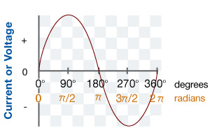

Video Fundamentals
Analog Video Scanning
An image is drawn on a TV or computer display by sweeping an electronic signal horizontally across the display one line at a time. The horizontal sync pulse at the end of each line ensures synchronization of the display to the beginning of the next line of information.
Starting at the top, all of the lines on the display are scanned in this manner. One complete set of lines forms the picture, or frame. Upon the completion of one frame, the scanning process returns vertically to the top left corner of the screen to repeat the process. The number of scanned lines determines the vertical resolution of the image and the rate at which an entire picture is formed is called the refresh rate.

Analog Video Scanning (continued)
There are two different types of scanning systems, interlaced and progressive, which differ in their technique used to format the picture on the screen. Essentially, TV signals and compatible displays are interlaced while computer signals and compatible displays are progressive (non-interlaced).
Interlaced scanning is where each frame is divided into two separate fields, with one field composed of odd-numbered horizontal scan lines and the other composed of even-numbered horizontal scan lines. The picture is displayed on the screen by scanning the lines on an alternating basis.
Progressive scanning is a method by which all the video scan lines are presented on the screen in one pass instead of two. It is typically denoted by the letter “p”, as in “480p”, which indicates a signal with 480 active lines running at 60 frames per second.

Digital Video Signals
Digital video signals are considerably different in comparison to analog signals, with specific performance and timing requirements that must be maintained throughout the entire signal path. Digital video signals are represented as square waves consisting of almost instantaneous transitions between two states: ON or OFF. There are no in-between states in digital signals as there are in analog signals.
For digital signal transmission, a digital receiver circuit needs only to determine whether each incoming bit is ON or OFF to completely reconstruct the transmitted signal.
Some early versions used a voltage level of about 3.7 to 5.0 volts to signal an ON condition and zero volts to signal an OFF condition. Most digital formats used today operate with a peak-to-peak signal level of 0.8 to 1.0 volts for signaling an ON condition.

Digital Communication
Among the benefits of digital technology is the ability for digital media and AV equipment to communicate bi-directionally with each other. This communication between content, sources, the AV system, and displays consists of the signal capabilities of devices in the system, or information related to rights and permissions associated with the transmitted content.
Three of the most important digital communication types are:
- EDID—Extended Display Identification Data
- DRM—Digital Rights Management
- HDCP—High-Bandwidth Digital Content Protection

EDID – Extended Display Identification Data
In order for a source to send a signal compatible with the capabilities of a display it is necessary for the two devices to communicate the appropriate signal information.
EDID is a data structure used to communicate video display information, including native resolution and vertical interval refresh rate requirements to a source device. The source device will then output the optimal video format for the display based on the provided EDID information, ensuring proper video image quality.
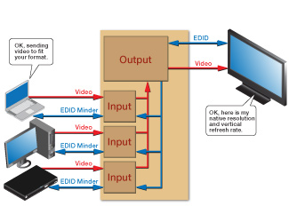

EDID Minder®
EDID Minder® is a proprietary technology from Extron which automatically manages the EDID information between a digital display device and one or more input sources. By maintaining continuous EDID communication with all sources, EDID Minder ensures that digital sources power up properly and maintain their video output, whether or not they are actively connected to the digital display device.
EDID Minder also has the capacity to hold and communicate pre-stored user-selected resolution and refresh rate information.

DRM – Digital Rights Management

Digital Rights Management is a generic term for technologies, such as content scrambling in cable or satellite television transmission, that can be used to control access to, or reproduction of copyrighted, commercially-available content. DRM is used primarily to prevent the unauthorized duplication and distribution of copyrighted material.
An AV system that is intended to support playback of protected content must be compliant with the associated DRM. Failure to do so may result in an inability to display this protected material.
DRM also governs how content can be used. Commercially-available DVDs and Blu-ray Discs, for example, are typically licensed for personal use in a residential environment. Displaying this content in a public venue without express consent of licensing by the copyright holder is in violation of the media’s license. HDCP – High-Bandwidth Digital Content Protection
The most common DRM scheme is HDCP—High-Bandwidth Digital Content Protection, developed by Intel, to prevent the copying of digital video and audio content.
HDCP-enabled video sources, such as Blu-ray Disc players, PCs, and other digital media devices, always undergo a three-step process to protect the video from unauthorized access.
- Authentication: The video source determines that all devices connected to its outputs are authorized and able to receive encrypted video. This is accomplished by means of an initial authorization handshake protocol, where cryptographic public keys and encrypted messages are exchanged between the source and the downstream devices connected to its outputs.
- Content Encryption: After the source authenticates that all downstream devices are HDCP compliant and that no system size restrictions are violated, the source sends encrypted video downstream. The source periodically revises the encryption key for the video as an additional security measure.
- Renewability: Since HDCP relies on digital encryption using secret keys, the system can be circumvented if the secret keys residing in HDCP-licensed products fall into the wrong hands. Therefore a means has to be established to revoke any compromised keys. This is done through a list of public keys of compromised products which are then compared to downstream devices.

Key Minder™
HDCP authentication is a multi-step process that can take several seconds to complete. This is the primary reason for the perceived sluggishness of some digital video systems especially during startup, or when video signals are switched or re-routed.
Key Minder™ is a proprietary HDCP key management technology developed by Extron which continuously authenticates HDCP-compliant sources and displays. This process ensures fast, reliable switching and enables simultaneous distribution of a single source to multiple displays.Video Fundamentals
Types of Video SiMPesetsky gnals

Video Signals, Formats and Connectors
There are many types of video signals, formats, and connectors that can be used when setting up an AV system. System designs may require a hybrid mix of analog and digital capabilities to provide support for legacy analog video formats while incorporating newer digital signal types.
We will now take a more detailed look at these signals, formats, and connectors.
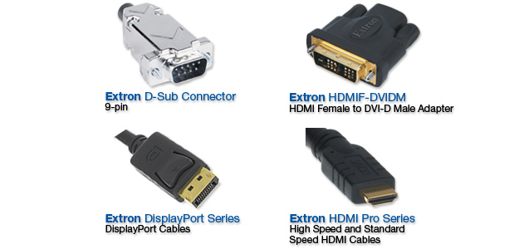

Analog Video Formats
Analog computer displays require five distinct signals to create an image: red, green, blue, H-Horizontal sync, and V-Vertical sync.
The red, green, and blue video signals are utilized in combinations to create the color values for each pixel. The H sync and V sync maintain timing between the video source and the display for a stable image. This five-connection signal format is commonly called RGBHV. The VGA—Video Graphics Array output on a computer graphics card uses the RGBHV format.
Analog signals, such as RGBHV, are easily interfaced, can drive long cable runs, and can accommodate a wide variety of displays and video equipment.

Analog Video Signal Hierarchy
Below is the hierarchy of analog video signals in descending order starting with the highest quality video signal, RGBHV.
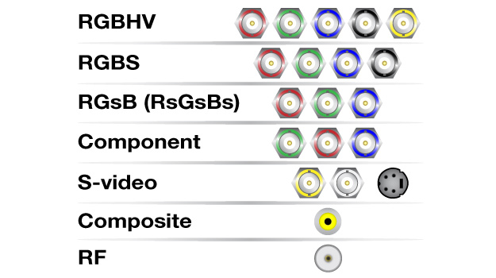

RGBHV and RGBS Signals
RGBHV
RGBHV carries Red, Green and Blue plus Horizontal and Vertical sync signals on separate conductors.
Among analog video signals, RGBHV provides the best video quality.
RGBS
RGBS carries Red, Green and Blue signals on separate conductors but combines horizontal and vertical sync signals (sometimes called composite sync) on one conductor.
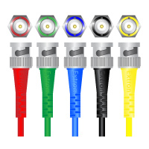
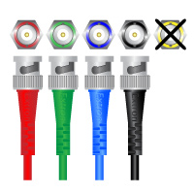
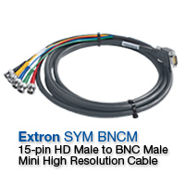

Component Video
RGsB
RGsB carries Red, Green and Blue video signals on separate lines plus the combined (composite) Sync signal is also on the Green signal line. Also called Sync on Green (SOG).
RsGsBs
RsGsBs carries the Red, Green and Blue video signals on separate lines. The composite sync signal is also carried on each line.
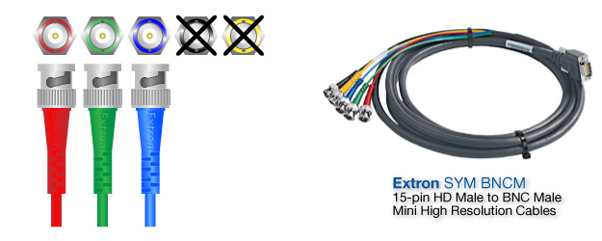

Component Video
Component video is a type of a signal that is derived from the Red, Green and Blue analog video signals being converted to the Y, R-Y, B-Y signal format.
The Luminance (Y) signal is created by mixing the Red, Green, and Blue analog video signals in the following proportions to create a grayscale otherwise known as a black and white image.
Y = .30Red + .59Green + .11Blue = 1.00
The two color difference signals R-Y and B-Y consist of the Red (R) analog video signal minus Luminance (Y) and the Blue (B) analog video signal minus Luminance (Y).
Video Fundamentals
Video Signals, Formats, and Connectors
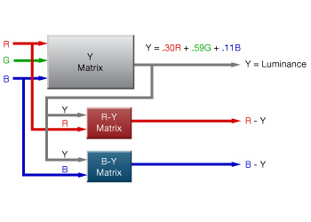
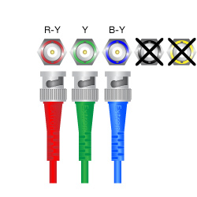

Y/C (S-Video)
Y/C is the combination of Y-Luminance and C-Chrominance, which makes S-Video.
It is produced by combining the two color difference signals, (R-Y) and (B-Y) in component video, creating another signal called Chrominance (C).
The Luminance (Y) signal remains intact. See the process below.
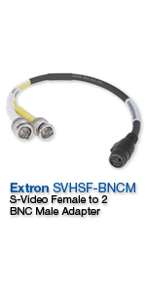
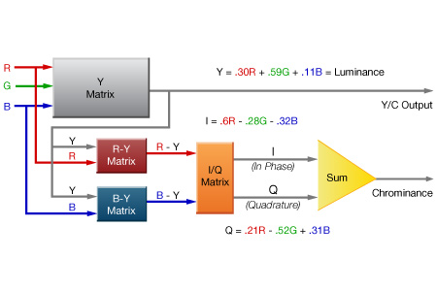

Composite Video
Composite video is the combination of Luminance and Chrominance signals forming a single wire video signal. The combining process is called Encoding. This encoded signal includes the sync elements necessary to rebuild the video image.
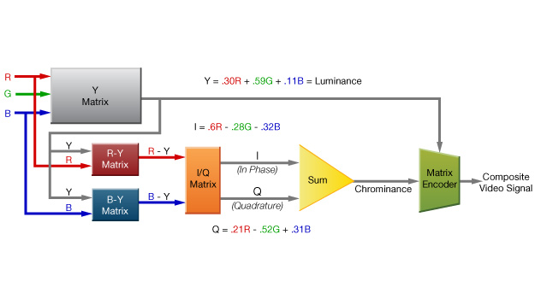

Composite Video Waveforms
Three waveforms comprise a video signal: active video, sync, and color burst.
- Active video controls the brightness of the screen and the shade or tint of a color.
- Sync, or synchronization, causes the picture to be displayed on the screen in the right place at the correct rate.
- Color Burst is used as a timing reference to control the colors hue and saturation displayed on the screen. In color TV systems, a burst of subcarrier frequency is located on the back porch of the composite video signal.
These three signals are combined into one signal to form composite video.
The illustration shows only one of 525 video lines used to comprise a complete image. Click here to enlarge the illustration.
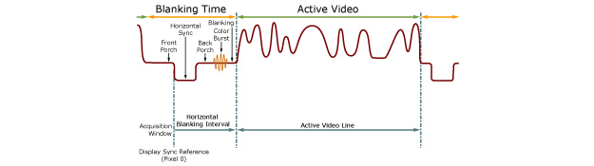

Video Fundamentals
RF—Radio Frequency Video Signals
RF signals have the lowest quality of all the video signals in the hierarchy.
Analog RF is the type of signal that comes through a cable TV connection. In standard-definition analog cable, a composite video signal and accompanying audio are mixed at the transmitting end with high-frequency radio waves (channels) and are distributed through a cable system.
To be viewed on a display, these signals have to be separated from the other channels in the line and converted to unmodulated baseband video and audio signals using a television tuner found in older televisions or VCRs.
The F-connector is the screw-on type connection used for most antenna and cable TV connections. F-connectors are rarely used for anything other than RF.

Video Signals, Formats, and Connectors
Top of Form
Bottom of Form

Fundamentals
Digital Video Signal Formats
There are several standard signal formats in use for digital transmission between sources and displays. These include:
- DVI—Digital Visual Interface
- HDMI—High Definition Multimedia Interface
- Display Port
- SDI—Serial Digital Interface
- HD-SDI—High Definition Serial Digital Interface
Let's take a closer look at each digital signal format.
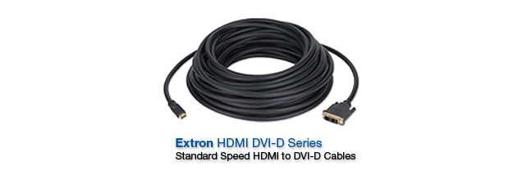

Video Signals, FormaDVI - Digital Visual Interface
DVI is the standard introduced by DDWG—Digital Display Working Group, which covers the transmission of video between a source and a display.
DVI is based on a common signaling scheme for video known as TMDS - Transition Minimized Differential Signaling. A DVI TMDS link consists of three serial data channels, one for each color – red, green, and blue – plus a fourth channel carrying a pixel rate clock which provides the timing reference that keeps the three color channels synchronized.
DVI also provides for two additional lines of communication: DDC - Display Data Channel and HPD - Hot Plug Detect. The DDC - Display Data Channel is a serial connection for EDID and HDCP communication. The HPD - Hot Plug Detect pin allows for implementation of hot plug detection, which allows a computer, for example, to detect the presence of a display.
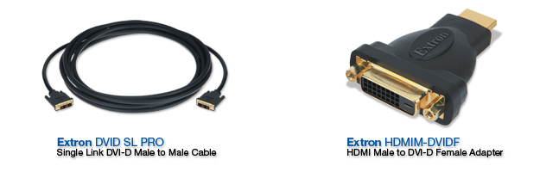

DVI Connectors
To support different resolutions, DVI provides for one or two video links per connector, commonly known as single link or dual link. DVI simplifies connectivity between computers and DVI-equipped displays, although it is limited to short cabling distances (traditionally about 15 feet) without specialized transmission equipment.
The DVI specification includes DVI-D, the standard digital-only connector, and DVI-I, which can carry either analog RGBHV or digital video signals. Each of these connectors are offered in versions supporting single link or dual link DVI signals, for a total of four available types of connectors.
The DVI-D plug has a single, wide flat pin, while the DVI-I plug has that same pin, but also four additional pins, two above and two below it. Those pins are used to carry the red, green, blue and horizontal sync (R, G, B, and H) lines of an RGBHV analog video signal (the vertical sync lies on another pin).
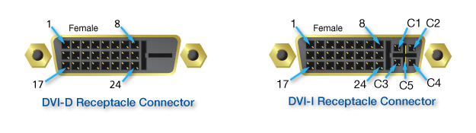

and ConnecHDMI - High Definition Multimedia Interface
HDMI is a compact AV interface for transmitting uncompressed digital data. Like DVI, HDMI is also based on TMDS.
Essentially, HDMI is a superset which includes DVI along with digital audio support, including surround sound and copyright protection—all packaged into a connector about half the physical size of the original DVI connector.
HDMI supports both computer graphics and digital television formats. HDMI 1.3 increased its bandwidth from 165MHz (4.95 gigabits per second) to 340 MHz (10.2 Gbps) to support the demands of high definition displays and included HDCP.
Additional Information


Display Port
DisplayPort is a royalty-free digital interface between sources and displays that is being positioned as a low-cost alternative to HDMI for PC equipment manufacturers. DisplayPort uses a digital video transmission scheme that differs from TMDS and is therefore not directly compatible with HDMI and DVI.
DisplayPort version 1.1a supports dual-mode devices such as DVI and HDMI display devices. There is also a capability to support VGA analog devices with an adapter. These are limited to single link specifications.
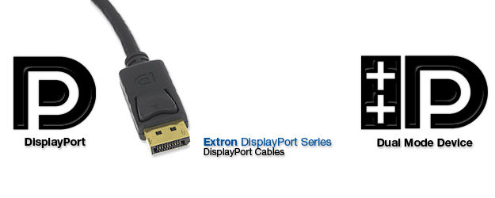

torsDisplayPort Connectors
DisplayPort uses 20 pins for external connectors on devices such as desktops, notebooks, graphics cards, monitors, etc. and has a locking mechanism. It has characteristics similar to the HDMI Type A and Type C connectors and can be used to pass HDMI signals, provided that the device supports HDMI.
If a video source only has a DisplayPort connector, but also has HDMI signaling capability, then it is possible to use a DisplayPort-to-HDMI adapter to connect the source to an HDMI-equipped display. Such DisplayPort connections, referred to as “dual-mode” or “multi-mode,” are symbolized by the DisplayPort logo and two plus signs to indicate this capability.
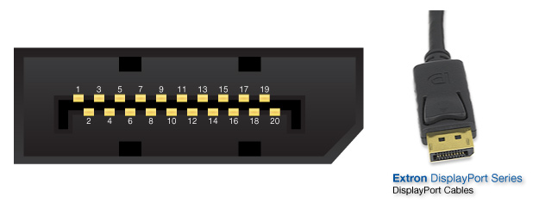

SDI—Serial Digital Interface
SDI is a set of video standards, defined by SMPTE—Society of Motion Picture and Television Engineers for serial transmission of video and audio over standard RG59 or RG6 coaxial cable. It is a way of transmitting broadcast quality component or composite digital video with four channels of embedded digital audio.
SDI is strictly a serial, one-way protocol for video, audio, and metadata such as time and date stamps or GPS coordinates, with no provisions for other auxiliary communications. An SDI-based video infrastructure is becoming increasingly popular for AV signal distribution, due to the benefits of inexpensive or existing cabling and ease of termination.
The SDI signal format is conveyed unbalanced on a single coaxial cable with amplitude of 0.800 volts peak-to-peak.
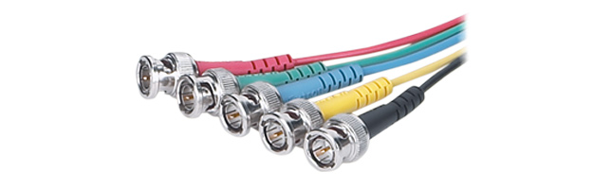

HD-SDI—High Definition SDI
HD-SDI is the high definition version of SDI, transmitting audio and video signals over a single coaxial cable. These video signals include component, 720 progressive (720p) and 1080 progressive (1080p), and 1080 interlaced (1080i) with up to 32 audio signals carried in the ancillary data.
Like SDI, HD-SDI is conveyed as an unbalanced digital signal with amplitude of 0.800 volts peak-to-peak.
3G-SDI is a newer standard for serial digital, high definition video with 1920x1080 resolution and a 50Hz or 60Hz progressive frame rate. The 3G stands for 3 gigabits per second which is twice the bit rate of a 1.485 Gbit HD-SDI signal. Up to 32 audio channels can be carried in the ancillary data.

Standards History
Historically, video signals used in analog television adhered to one of three worldwide standards: NTSC, PAL, and SECAM.
NTSC—National Television Systems Committee was responsible for setting television and video standards in the United States. This standard was used throughout North America and Japan.
The NTSC standard for television defines a composite video signal with a refresh rate of 60 fields (interlaced) per second. Each frame contains 525 lines and can contain 16 million colors.
PAL—Phase Alternation Line, was widely used in Western Europe, Australia, Africa, the Middle East, and Micronesia. PAL delivers 625 lines at 50 fields (25 frames) per second.
With PAL, the phase of the color carrier is alternated from line to line. It takes four full pictures (8 fields) for the color-to-horizontal phase relationship to return to the reference point. This alternation helps cancel out phase errors. For this reason, the hue control is not needed on a PAL TV set.

Standards History (continued)
SECAM—Sequential Couleur avec Memoire was the TV standard used in France, North Africa, Russia, Saudi Arabia, and many Eastern European countries and can be defined as a composite color transmission system that potentially eliminates a need for both a color and hue control on the monitor. SECAM uses frequency modulation to encode chrominance information on the sub carrier.
It is similar to PAL but produces color signals in a different manner. SECAM uses 625 horizontal scan lines, 50 fields per second (625/50). One of the color difference signals is transmitted on one line and the second is transmitted on the second line. Memory is required to obtain both color difference signals for color decoding.SECAM—Sequential Couleur avec Memoire was the TV standard used in France, North Africa, Russia, Saudi Arabia, and many Eastern European countries and can be defined as a composite color transmission system that potentially eliminates a need for both a color and hue control on the monitor. SECAM uses frequency modulation to encode chrominance information on the sub carrier.
It is similar to PAL but produces color signals in a different manner. SECAM uses 625 horizontal scan lines, 50 fields per second (625/50). One of the color difference signals is transmitted on one line and the second is transmitted on the second line. Memory is required to obtain both color difference signals for color decoding.Bottom of Form
Top of Form

Current Standards
In 2009, the United States terminated NTSC analog broadcasts except for a low power television stations and closed circuit applications.
ATSC, a new digital television broadcast system, replaced NTSC.
ATSC—Advanced Television Systems Committee is an international, non-profit organization developing voluntary standards for digital television. Members of ATSC represent the broadcast, broadcast equipment, motion picture, consumer electronics, computer, cable, satellite, and semiconductor industries.
The new ATSC system encompasses a fully digital television standard containing both standard definition and high definition video formats, and digital audio formats. Throughout the world several other countries are adopting the ATSC digital television format.

Bottom of Form
Top of Form

Current Standards (continued)
Another digital television standard is DVB—Digital Video Broadcast. This standard has been adapted over much of Europe, Asia and Africa. ISDB—Integrated Services Digital Broadcasting is a Japanese standard for digital television that was adopted in parts of Asia and most of South America, while DTMB – Digital Terrestrial Multimedia Broadcast is the standard for China.
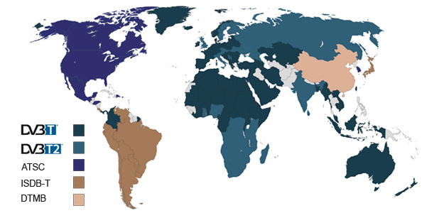
Video Fundamentals
Broadcast Video Standards

HDTV—High Definition Television Overview
HDTV provides a higher resolution (more detail) than those found in the NTSC, PAL, or SECAM video standards.
The aspect ratio for HDTV is 16:9 (1.78:1) versus the 4:3 (1.33:1) of NTSC, PAL, and SECAM.
HDTV can be found via satellite, from local broadcasts via antenna, and on various playback devices such as a Blu-Ray player.

HDTV Standards
The ATSC defined 18 formats supporting a combination of SDTV—Standard Definition Television and HDTV. Of the 18 formats, there are three fundamental nomenclatures commonly used to describe HDTV.
There are three main standards that we will take a closer look at:
- 720p
- 1080i
- 1080p
The 'p' suffix refers to progressive scan format. As described earlier in this lesson, progressive scanning is a process where each video line is transmitted sequentially to create a full image frame in one pass.
The 'i' suffix refers to interlace scan format. Interlacing is an image bandwidth compression approach accomplished by transmitting only the odd lines in an image as the first field of lines. Then, all the even lines are transmitted as the second field of lines. Two fields comprise an entire image frame.
Video Fundamentals

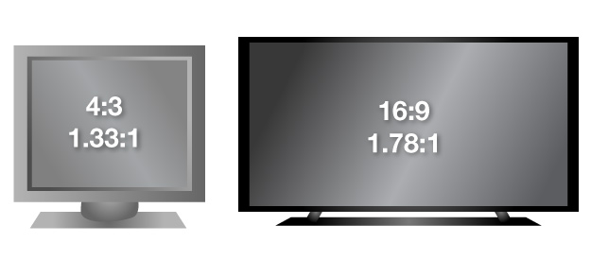

720p Video Standard
The resolution for 720p is 1280 x 720.
720p is a favored standard for action images. Progressive scanning avoids interlacing artifacts regularly seen during image movement. Transfer or conversion of 720p material to other high definition formats is easier by virtue of its progressive scan format.
These lines are progressively scanned at a horizontal frequency of about 45 kHz and total video signal frequency of about 74.25 MHz.

1080i Video Standard
The resolution for 1080i is 1920 x 1080 interlaced.
The 1080i standard has more pixel resolution per horizontal line than 720p. While the potential for higher resolution is there, 1080i has greater overall picture detail with static images only. When images move, the vertical resolution will drop to one half the total line value, or 540 lines, due to the presence of interlacing artifacts. In some applications such as sports action video, 720p appears to have superior vertical resolution.
1080i is scanned at a horizontal frequency of 33.75 kHz and the total video signal frequency is about 74.25 MHz.
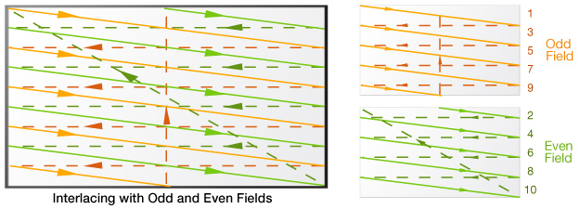

1080p Video Standard
The resolution for 1080p is 1920 x 1080 progressive.
1080p is often stated with an associated frames-per-second rate, such as: 1080p24 (24 fps, progressive), 1080p30 (30 fps, progressive) and 1080p60 (60 fps, progressive). 1080p is extremely rare in broadcasting as the ATSC standard provides bandwidth sufficient only for 1080p24 and 1080p30.
Blu-ray and other pre-recorded high definition schemes can support full 1080p60 content playback.

480p Video Standard
With the development of DVD players, the term 480p became popular. The ATSC format table includes 480p as one of its formats; however 480p video is NOT high definition video. 480p is a 4:3 aspect ratio progressive scan version of NTSC having a resolution of 720 x 480 scanned at 60 Hertz.
Today, most fixed resolution displays must scale the image to accommodate their particular screen resolution. DVD players with 480p output have already rearranged data into the progressive scanning mode which eliminates the display's requirement to de-interlace, thus increasing perceived resolution by eliminating some interlacing artifacts.

Sound
The perception of sound is a mechanical disturbance of molecules within a surrounding elastic medium, such as air. Sound energy travels through all phases of matter; i.e. gases, solids, or liquids. This molecular disturbance propagates through the given medium at a rate related to the close proximity of its own molecule structure, or density. The molecular disturbance is a type of kinetic energy known as acoustic energy.
Sound is the result of two or more objects colliding with sufficient force to direct the resultant energy as an acoustic wave from the point of contact. Some of that energy is converted to heat, not sound.
Ultimately, the portions of sound energy converted to heat become greater than the resulting transmission of force between molecules and the sound energy dissipates to an imperceptible level.
The process of hearing a sound relies on the mechanical disturbance propagating through all of those forms of matter, not only in our environment, but even within the human ear; for example, from air through a solid, through a liquid, and ultimately to the nerve endings in our ear that transmit impulses to the brain where the disturbance is interpreted as a sound.

Sound Propagation

Can sound propagate through the vacuum of space? The answer is no. Only in the presence of an acoustic energy medium will sound waves propagate. For all practical purposes, no molecules of liquid or gas exist in the vacuum of space to transfer the kinetic energy created when two solid objects collide. Therefore, in space, the collision of two objects results only in the local conversion of energy to heat. Here on Earth, our perception of sound results mostly from mechanical vibrations traveling through air. In this process, a loud rise in sound level creates an incoming positive pressure wave of air molecules much like waves rising on the ocean. The corresponding drop in sound level results in less wave pressure behind the original wave, like the valley between ocean waves. This region of low sound pressure is called a rarefaction. Successive pressure waves followed by rarefactions constitute a continuously perceived sound level.
Can sound propagate through the vacuum of space? The answer is no. Only in the presence of an acoustic energy medium will sound waves propagate. For all practical purposes, no molecules of liquid or gas exist in the vacuum of space to transfer the kinetic energy created when two solid objects collide. Therefore, in space, the collision of two objects results only in the local conversion of energy to heat. Here on Earth, our perception of sound results mostly from mechanical vibrations traveling through air. In this process, a loud rise in sound level creates an incoming positive pressure wave of air molecules much like waves rising on the ocean. The corresponding drop in sound level results in less wave pressure behind the original wave, like the valley between ocean waves. This region of low sound pressure is called a rarefaction. Successive pressure waves followed by rarefactions constitute a continuously perceived sound level.Top of Form
Video Fundamentals
It is necessary to consider the speed of sound propagation depending on the medium. In addition, temperature affects sound propagation speed. While the speed difference may be small within solids of varying temperature, air temperature has a significant impact on sound speed. Dense, cold air molecules are much closer together than warm air molecules. For this reason, the speed of sound in air must be specified with respect to temperature and altitude, which affects air pressure.

Speed of Sound
The speed at which sound vibrations travel depends on the closeness of the molecules within the medium in which they travel. Generally, where molecules are close together, or dense, vibrations travel faster because one molecule travels less distance in order to disturb the molecule next to it. Therefore, sound travels fastest through dense solids, like steel, versus gases, like air, where the distance between molecules is much greater.
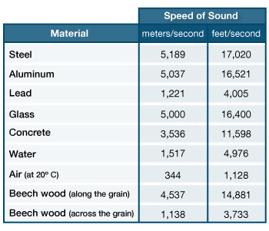

Top of Form
Bottom of Form

Top of Form
Video Fundamentals
Broadcast Video Standards

Top of Form
Bottom of Form
Video Fundamentals
Broadcast Video Standards
Top of Form
Bottom of Form

Fundamentals

Top of Form
Bottom of Form
Top of Form
Bottom of Form
Bottom of Form

Video Fundamentals
Types of Video Signals
Top of Form
Bottom of Form

Top of Form
Bottom of Form
Vo Fundamentals
Types of Video Signals
Top of Form
Bottom of Form
Types of Video Signals

Top of Form
Bottom of Form
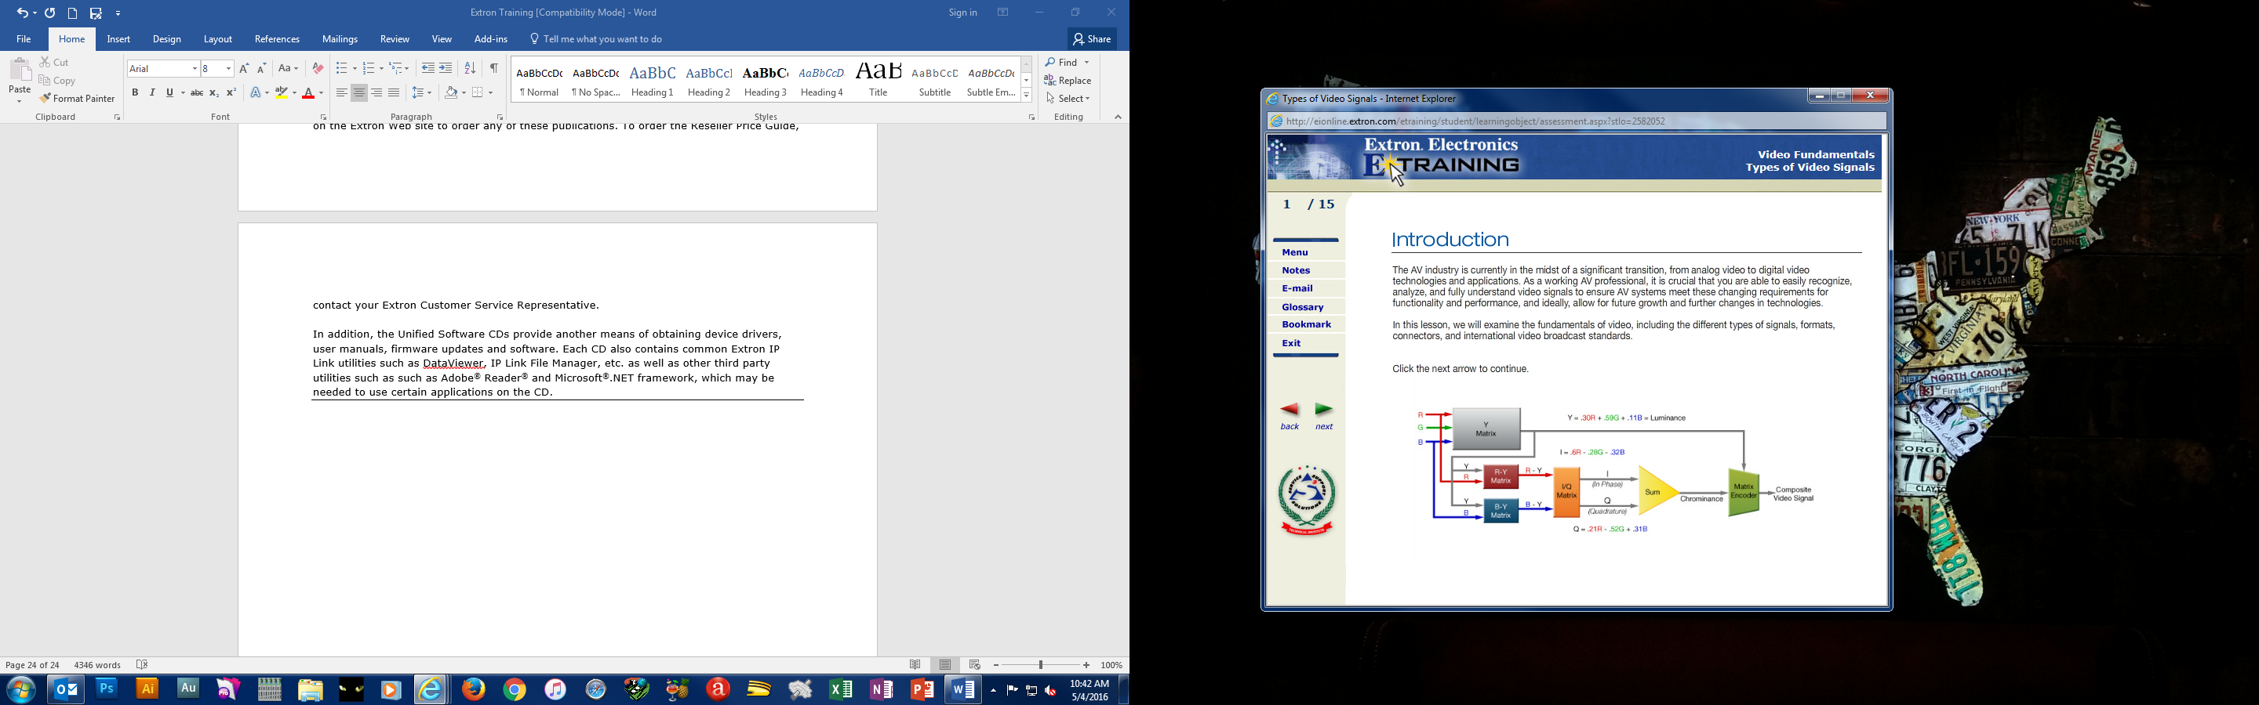Bottom of Form

Top of Form
Bottom of Form
Bottom of Form
Top of Form
Bottom of Form
Top of Form
Bottom of Form
Top of Form
Bottom of Form
Top of Form
Bottom of Form
Bottom of Form
Bottom of Form
Bottom of Form
Top of Form
Bottom of Form
Bottom of Form
Bottom of Form
Bottom of Form
Bottom of Form

The Extron MediaLink® System is a family of easy-to-use and inexpensive products that work together to control A/V equipment in any small, one-projector classroom, boardroom, or auditorium. The MLC 226 IP MediaLink Controller acts as an extended remote control panel, and can be mounted on a wall, podium, or lectern. There are also a variety of MediaLink Accessories that include Architectural Adapter Plates (AAP), remotes, wall plates, mounting brackets, and junction boxes.The Extron MediaLink® System is a family of easy-to-use and inexpensive products that work together to control A/V equipment in any small, one-projector classroom, boardroom, or auditorium. The MLC 226 IP MediaLink Controller acts as an extended remote control panel, and can be mounted on a wall, podium, or lectern. There are also a variety of MediaLink Accessories that include Architectural Adapter Plates (AAP), remotes, wall plates, mounting brackets, and junction boxes.Bottom of Form
Bottom of Form
Bottom of Form
Bottom of Form
Bottom of Form

