
Election Day - Tuesday, November 8th 2005

Districts 1, 4 & 7, Princeton Township, Mercer County, NJ

PLEASE SIGN LOG SHEET BEFORE FILLING OUT YOUR BALLOT

MARK EXIT POLL BALLOT BY FILLING IN SQUARES WITH CHOICES SELECTED ON OFFICIAL BALLOT

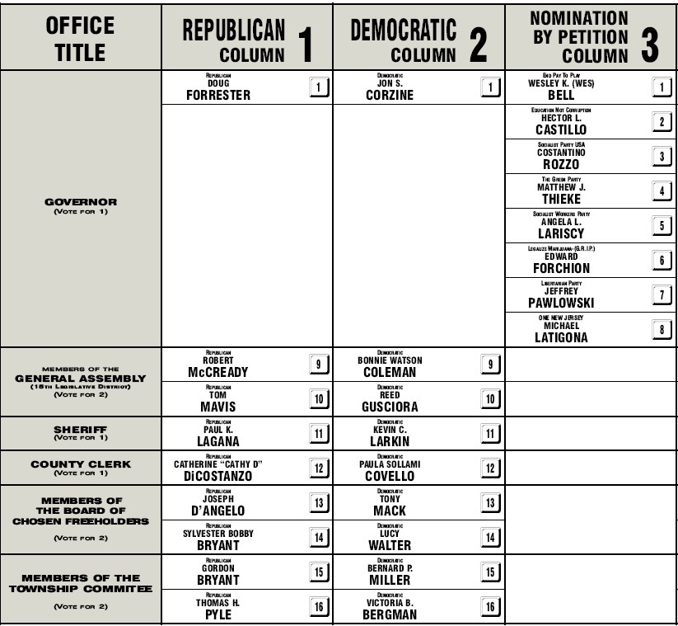
PUBLIC QUESTION NO. 1
YES NO

CONSTITUTIONAL AMENDMENT TO ESTABLISH THE OFFICE OF LIEUTENANT GOVERNOR

PUBLIC QUESTION NO. 2
YES NO

CONSTITUTIONAL AMENDMENT TO EXPAND USES OF DEDICATED TAX REVENUE TO FUND AIR POLLUTION CONTROL AND ADMINISTRATIVE COSTS OF THE UNDERGROUND STORAGE TANK PROGRAM

NAME & SIGNATURE BELOW IS OPTIONAL

I pledge that I have selected the same ballot choices on The Citizen’s Audit Election Ballot as I made on the Official Election Ballot, November 8, 2005 . I am aware that this is not the Official Election Ballot, but will be used ONLY as evidence in case there is a need for an Election Challenge. This Ballot will be used to compare the Voter’s Intent with the Voting Machine Results.

_____________________________________________ ____________________________________________
Print Name Sign

Address: _________________________________________________________________________________________

Describe problems voting in official election, if any: ______________________________________________

_________________________________________________________________________________________________

_________________________________________________________________________________________________

