Orf467F17 Final Project
Assessment of RideSharing, ‘Last-Mile” and Optimal Empty Vehicle Management of Large Regional aTaxi Operation

Groupings:
- NorthEast: ME,VT,NH, Mass, RI, CT, NY, NJ, DE, MD, PA, WV, DC, VA (14)
Group | Lead
NorthEast | Magill | Plissner | Anderson | Agbim
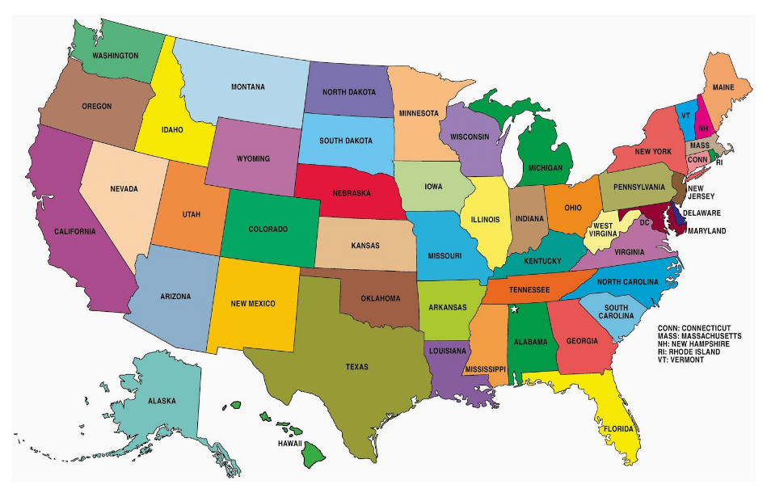

Regional aTaxi Companies:
Products:
Assessment of Population Served Based on analysis of the NN Files:
- Population total (whole region) & Geographic Distribution of population (Circle Map of county population located at {Lat,Lon} of county seat. Plot of {X,Y, Count of rows of NN File for that county}
- PersonTrips total (whole region) & Geographic Distribution of PersonTrips/county {X,Y, Count of PersonTrips in NN File for that county}
- Average PersonTripLength (whole region) & Geographic Distribution of AveragePersonTrip Length {X, Y, Sum GCD for all trips in County NN File(s) / Sum PersonTrips in County NN File(s) }
- Cumulative distributions of Trip Lengths for all trips made by Region’s residents: (Y: % of all < X, range 0->100%; X: 0 -> 100 miles)
- Cumulative distributions of Age or Region’s residents: (Y: % of all < X, range 0->100%; X: 0 -> 85 year)

Assessment of Trips Originating in the Region based on the NationWide Trip Data
- Region Totals, Total/Person and % of All for WalkTrips (GDC < 0.5 Miles); ShortTrips (0.5 < GDC < 10), NormalTrips ShortTrips (0.10 < GDC < 100), LongTrips (100 < GDC<400), ReallyLongTrips ShortTrips (400 < GDC)
- Cumulative distributions of Trip Lengths for all trips made by Region’s residents: (Y: % of all < X, range 0->100%; X: 0 -> 100 miles)
- Assessment of RideSharing Potential: AVO Analysis for the region as well as each state and rank order the county AVOs focusing on the top 10 in each region. Analyze only non-walk trips. DD = 300,420, 600; 1200 ; CD = 2x2, 3x3, 5x5, 10x10 for GD: <2,<10, <100, all else. Assume 5 passenger aTaxis.
- Create the aTaxi Trips files for the region: {oXpixel, oYpixel, aTaxiDepartureTime, dXpixel, dYpixel, aTaxiMadeEmptyTime, aTaxiDistance, aTaxiDepartureOccupancy, SumOccupantTripMiles}
- Determine SoD Demand and EoD Supply for:
  - Each pixel in your Region
  - Each 5x5 SuperPixelixels in your Region
  - Each 10x10 SuperDuperPixel in your Region
- Make a circle plot for each above where radius of circle Log (value), Demand in Red, Supply in Green (1 will show as zero which is OK/great)
- Determine the (max) Fleet size implications of each above
- Assess how important it is for you to cooperate with your neighboring region.
- Determine how many of your 5 Passenger aTaxis which are serving your customers (trips originating in your region) in each minute of the day (Increment a {1440x1} vector for all the minutes between each aTaxi’s DepartureTime and MadeEmptyTime (Be careful to deal with the wrapped trips properly). Plot the results for the region.
- If you are really ambitious, Flow your personTrips and your aTaxi trips on the ALK level 1 network

Assessment of Business Case for your Regional aTaxi Mobility-for-All System
- Capitalization:
  - You’ll purchase a Fleet of $60k 5 passenger electric aTaxis that is 1.15 times your min estimated fleet size that have a 150k miles life. Do the capitalization and the CapCost/mile. Assume empty repositioning is 30% of loaded miles (Unless you’ve done a better analysis above).
  - You’ll need to lease land for your parking of aTaxis at major pixels and nearby storage, maintenance and charging facilities as well as solar power acquisition. Figure out the needs, costs and implications on operating costs.
- Operating cost: Figure it out
- Revenue: Create a win-win pricing model that is attractive to both you and your customers. Are there other sources of revenue?
- Do a pro forma balance sheet for the business as a whole and possibly for each state.

